The Innovation Decagon
Uber, Airbnb, and a Systems Framework for the Next Ten Disruptions
A theory-building essay and practical framework drawing on systems theory, system dynamics, cybernetics, design thinking, digital transformation and artificial intelligence.
Working paper · October 2026
Thesis. Uber and Airbnb did not invent cars or homes; they invented legibility. The next generation of disruptive ventures will make newly latent capacity visible, trustworthy and transactable, and must take back the costs the first generation pushed onto cities, workers and neighbours.
Contents
Executive summary 5
How to read this document 6
Part I: The Benchmark 8
1.1 Two companies, one moment 8
1.2 The comprehensive similarity matrix 8
1.3 The six shared genes 10
1.4 The differences that matter 10
1.5 The benchmark scoreboard (FY2025) 11
Part II: The Systems Lens 13
2.1 Platforms as complex adaptive systems 13
2.2 Stocks and flows 13
2.3 Causal loop diagrams 14
Uber’s core loop structure 14
Airbnb’s core loop structure 15
2.4 System archetypes 16
2.5 Leverage points 16
2.6 Cybernetics: requisite variety and the viable system 17
2.7 A minimal system dynamics model of a ride-hailing market 18
Part III: Theory and Philosophy, or What Uber and Airbnb Really Did 20
3.1 Economics: why the platform exists 20
3.2 Innovation theory: disruption, properly understood 20
3.3 Political economy: Polanyi and the double movement 21
3.4 Philosophy of technology: standing-reserve, conviviality and the self 21
3.5 Trust: from institutions to distributed to delegated 22
3.6 The commons and its governance 22
3.7 Surveillance and extraction 23
3.8 Justice: the veil-of-ignorance test 23
3.9 Ubuntu: belonging as an operating principle 23
3.10 Synthesis: latency, liberation and enclosure 24
Part IV: The Future Potential of Uber and Airbnb (2026–2050) 25
4.1 How to think about platform futures 25
4.2 The long wave: where platforms sit in history 25
4.3 The adaptive cycle: where each company stands 26
4.4 Uber: three horizons 26
4.5 Uber: ten future innovations 27
4.6 Airbnb: three horizons 28
4.7 Airbnb: ten future innovations 29
4.8 Convergence 30
4.9 Causal Layered Analysis: the deeper story 30
4.10 Scenario matrix: the platform world in 2035 31
4.11 Dator’s four futures: 2050 32
4.12 Wildcards 32
4.13 Strategic options for Uber and Airbnb 33
4.14 What the futures teach the next generation 33
Part V: The Innovation Decagon Framework 35
5.1 From benchmark to blueprint 35
5.2 The ten vertices 36
The Engine 36
The Conscience 37
5.3 Scoring the benchmarks 38
5.4 The Systemic Design Spiral: the process 39
5.5 The digital and AI opportunity stack: 2008 vs 2026 40
5.6 The latency map: where market gaps are now 41
5.7 Ten design principles (the “decalogue”) 42
Part VI: Beyond Rides and Rooms: Where the Uber and Airbnb Models Work 44
6.1 Two models, not one 44
6.2 Which model fits? A decision guide 45
6.3 Why many “Uber for X” startups failed 46
6.4 The application map: sixteen sectors 46
1. Logistics, freight and delivery 46
2. Agriculture and food production 46
3. Healthcare 47
4. Care: elders, children and pets 47
5. Home services and skilled trades 47
6. Education, tutoring and skills 47
7. Energy and water 48
8. Space: storage, parking, offices, kitchens and venues 48
9. Equipment, vehicles and goods rental 48
10. Work and professional talent 48
11. Finance and insurance 48
12. Food beyond restaurants 49
13. Emergency and public services 49
14. Circular economy: repair, resale and recycling 49
15. Beauty, wellness and fitness 49
16. Construction and property 50
6.5 The African and Nigerian lens 50
6.6 Where these models do not work 51
6.7 Prioritizing the opportunities 51
6.8 From any pain point to a platform: an eight-step playbook 52
Part VII: The Decagon of Ventures 53
Layer A: Trust and Intelligence 53
Venture 1: COVENANT, the trust, identity and liability layer for AI agents 53
Venture 2: DATAGUILD, a cooperative that licenses human knowledge to AI on fair terms 55
Layer B: Human Capacity 57
Venture 3: GUILDHALL, apprenticeships-as-a-service to rebuild the first rung 57
Venture 4: KINGRID, an intergenerational care capacity network 59
Venture 5: AGORA, third places on demand 62
Layer C: Physical Capacity 64
Venture 6: HEARTH, the housing capacity unlocker 64
Venture 7: COMMONFLEET, driver and community co-ownership of autonomous fleets 66
Venture 8: FLUXCOMMONS, the neighbourhood energy and compute commons 68
Layer D: Planetary Resilience 70
Venture 9: HARVESTGRID, climate-smart cold chain and market logistics for smallholders 70
Venture 10: BASTION, a parametric resilience mutual and community resource network 73
Part VIII: The Future Potential of the Ten Ventures (2026–2050) 77
8.1 How to read the venture futures 77
8.2 The forces behind the next 25 years 77
8.3 Covenant: from agent passport to the trust protocol of the agentic economy 78
8.4 DataGuild: from one guild to the collective-bargaining institution of the AI age 79
8.5 Guildhall: from ten pods to the world’s largest apprenticeship system 80
8.6 KinGrid: from one neighbourhood to the care infrastructure of ageing societies 81
8.7 Agora: from one city to social infrastructure as a service 82
8.8 Hearth: from homeshare to the engine of gentle density 82
8.9 CommonFleet: from a driver co-op to the credit union of robot capital 83
8.10 FluxCommons: from 200 homes to the neighbourhood as a power plant and data centre 84
8.11 HarvestGrid: from one corridor to Africa’s perishable-food operating system 85
8.12 Bastion: from 2,000 traders to a global network of resilience mutuals 86
8.13 Combinatorial innovation: what the ventures create together 87
8.14 The 2040 end-state: the Stewardship Stack 87
8.15 Backcasting from 2040 88
8.16 The future-potential scorecard 89
8.17 The philosophy of the future: becoming good ancestors 89
Part IX: Portfolio Synthesis, Roadmap and Closing Philosophy 91
9.1 The Decagon scoreboard 91
9.2 Feasibility and sequencing 92
9.3 The decagon as an ecosystem 92
9.4 Ten more seeds beyond the Decagon 94
9.5 Implementation roadmap 94
9.6 Closing philosophy: from the sharing economy to the stewardship economy 95
9.7 Ten aphorisms for builders 95
Appendices 97
Appendix A: The Decagon Canvas 97
Appendix B: Scoring rubric 97
Appendix C: Glossary 98
Appendix D: Sources and further reading 99

Executive summary
The thesis in one sentence. Uber and Airbnb did not invent cars or homes; they invented legibility. They made idle capacity visible, trustworthy and transactable at the moment of need. The next generation of disruptive ventures will do the same for capacities that are only now becoming latent or newly valuable, such as care time, grid flexibility, apprentice potential, idle land, tacit knowledge and trust itself. To last, they will have to take back the costs that the first generation pushed onto cities, workers and neighbours.
What this document does:
- Benchmarks Uber and Airbnb across 21 dimensions. Six “shared genes” explain their success, and twelve differences explain why the two businesses behave differently.
- Models them as systems. It uses causal loop diagrams, stock-and-flow logic, Senge’s system archetypes, Meadows’ leverage points, Ashby’s law of requisite variety and Beer’s Viable System Model.
- Theorizes and philosophizes. It reads the two companies through Coase, Hayek, Schumpeter, Christensen, Polanyi, Heidegger, Illich, Ostrom, Zuboff, Rawls and the African ethic of Ubuntu. The conclusion is that they are latency compilers: they turned invisible slack into a market. They also commodified fictitious commodities (labour and land) at a finer grain than ever before, which is why society pushed back.
- Projects their futures (2026–2050). It uses five foresight tools: the futures cone, Three Horizons, Causal Layered Analysis, Dator’s four futures and Carlota Perez’s techno-economic surges. It sets out ten future innovations each company could build, three possible 2040 identities for each, a 2035 scenario matrix (Walled Gardens, Agent Bazaar, Civic Platforms, Protocol Commons), 2050 futures, wildcards and strategic options. The main forecast is that in the agentic era, aggregators of demand lose power and aggregators of trust gain it.
- Builds the Innovation Decagon. This is a ten-vertex framework for designing disruptive ventures. Five “engine” vertices create and move value: Latency, Friction, Trust, Liquidity, Intelligence. Five “conscience” vertices distribute and sustain it: Distribution, Legitimacy, Stewardship, Meaning, Antifragility. The framework comes with a 50-point scoring rubric, a seven-stage Systemic Design Spiral process, a canvas and ten design principles.
- Applies the models beyond rides and rooms. It separates the Uber model (on-demand dispatch) from the Airbnb model (idle-asset marketplace), gives a decision guide and a ten-question fit test, learns from failed “Uber for X” startups, and maps both models across sixteen sectors, from freight, farming and healthcare to energy, finance and construction, with an African and Nigerian lens and a prioritized list of opportunities.
- Proposes a Decagon of Ventures. These are ten disruptive startup concepts, each aimed at a new problem of the late 2020s, each inheriting Uber/Airbnb DNA and each inverting one of their failures:
# | Venture | New problem it solves | Latent capacity it unlocks
1 | Covenant | Nobody can trust, authorize or hold liable the AI agents that now shop and book for us | Scattered trust signals; insurer underwriting capacity
2 | DataGuild | AI needs expert, consented human data, and creators get nothing | Tacit expertise; under-represented languages
3 | Guildhall | AI is erasing the entry-level “first rung” of careers | Juniors’ time, retirees’ mentorship, SMEs’ unmet work
4 | KinGrid | The care deficit of ageing societies | The “young-old”, neighbours, time-credits
5 | Agora | Loneliness, linked to about 871,000 deaths a year (WHO, 2025) | Idle venues in off-hours; idle evenings
6 | Hearth | Housing scarcity amid under-occupied homes and land | Spare rooms, backyards, empty offices
7 | CommonFleet | Robotaxis may displace the drivers who built ride-hailing | Drivers’ operational skill; community capital
8 | FluxCommons | AI’s electricity hunger and a congested grid | Parked EVs, home batteries, compute waste-heat
9 | HarvestGrid | Perishable food loss and climate heat stress (Africa-first) | Empty backhauls, solar cold rooms, warehouse receipts
10 | Bastion | Insurers retreating from climate risk | Community spare capacity; satellite triggers; mutual traditions
- Projects the ventures’ futures (2026–2050). For each venture it gives a 2040 end-state, a three-horizon growth path, four spin-off innovations, an illustrative estimate of potential at maturity, and its probable and failure futures. It then shows ten fusions that combine ventures into new innovations, and the Stewardship Stack: a layered, interoperable infrastructure the ten could form by 2040.
The central design insight. Uber and Airbnb maximized the engine vertices and neglected the conscience vertices. The regulatory, labour and housing backlash they now face is the conscience vertices arriving with interest. The ventures in this paper are designed in the opposite order. Ex-ante, they score higher on stewardship and distribution but lower on liquidity and antifragility. That gap is the stewardship premium. Paying it deliberately, rather than discovering it in court, is the strategic opportunity of the coming decade.
A heuristic, not a law: Durable value created ≈ Latent capacity × Legibility × Trust × Liquidity − Externalities exported The first generation optimized the four multiplied terms and ignored the subtracted one. The next generation must design all five.

How to read this document
Part | Content | Use it if you want to…
I | The benchmark: anatomy of Uber and Airbnb | Understand the baseline in depth
II | The systems lens: loops, archetypes, leverage points, cybernetics | See why they worked and where they break
III | Theory and philosophy | Understand what they mean
IV | Futures of Uber and Airbnb, 2026–2050 | Anticipate where platforms are going
V | The Innovation Decagon framework | Design or evaluate a venture
VI | Beyond rides and rooms: where the Uber and Airbnb models work, across sixteen sectors | Apply the models to other services and pain points
VII | The Decagon of Ventures: ten startup concepts | Get concrete opportunities
VIII | Future potential of the ten ventures, 2026–2050 | See what the ventures could become
IX | Portfolio synthesis, roadmap and closing philosophy | Act on it
Appendices | Canvas, scoring rubric, glossary, sources | Apply the framework yourself
Companion volume. The Next Decagon (Volume II) uses this document as its baseline and benchmark. It adds a second-generation framework for 2030–2050 (the Double Decagon and the Disruption Genome) and ten further venture concepts.
A note on evidence: company figures come from published results (cited in Appendix D). Scores and scenario judgements are the author’s analytical judgement and are labelled as such. Every startup concept is a hypothesis to be tested, not a forecast.

Part I: The Benchmark

1.1 Two companies, one moment
Airbnb began when Brian Chesky and Joe Gebbia rented air mattresses on their San Francisco floor to delegates at a 2007 design conference whose hotels had sold out. With Nathan Blecharczyk they formalized it in 2008 and joined Y Combinator in early 2009. Uber was conceived by Garrett Camp and Travis Kalanick in 2008–09 and launched as UberCab in San Francisco in 2010.
The timing was not a coincidence. Both companies are children of the same enabling stack, which appeared within roughly 24 months:
Enabler (2006–2010) | What it made possible
Smartphone and App Store (2007–08) | A computer in every pocket, always on, always located
GPS in phones | Supply and demand visible on a live map
Cloud computing (AWS, 2006) | Global scale without data centres
Online payments (e.g., Braintree, Stripe) | Cashless, escrowed, frictionless settlement
Social identity and review culture (Facebook Connect, 2008) | Strangers with faces, histories and reputations
Zero-interest-rate capital | Investors willing to subsidize market creation for a decade
The Great Recession (2008–09) | Slack on both sides: people needed income, consumers needed cheaper options
The recession matters philosophically. Crisis produces slack: unused rooms, unemployed hours, underused cars. Platforms are machines for converting slack into supply. The same conditions are recurring now. AI-displaced labour, ageing populations, post-pandemic empty offices, midday solar surplus and idle GPUs at night are the slack of the 2020s (see Part V).

1.2 The comprehensive similarity matrix
# | Dimension | Uber | Airbnb | Shared principle
1 | Latent asset | Private cars, parked ~95% of the time (Shoup), and drivers’ idle hours | Spare rooms, second homes, empty homes while owners travel | Excess capacity is inventory waiting to be made visible
2 | Asset model | Owns no cars (until the autonomous era) | Owns no homes | Asset-light: other people’s capital, platform’s coordination
3 | Market structure | Riders ↔ drivers, later eaters ↔ restaurants ↔ couriers, shippers ↔ carriers, advertisers, AV fleets | Guests ↔ hosts, later experience hosts and service providers (chefs, photographers, therapists) | Two-sided market evolving into a multi-sided platform
4 | Revenue logic | Take rate on gross bookings (FY2024: revenue ≈ 27% of gross bookings, all segments) | Service fees (FY2025: revenue ≈ 13% of gross booking value) | Tax on the transaction, not ownership of the asset
5 | Network effects | Cross-side, local (city-level liquidity) | Cross-side, global demand → local supply | More of one side attracts more of the other
6 | Trust infrastructure | Two-way ratings, ID and background checks, GPS trip trace, in-app payment, insurance, safety toolkit | Two-way reviews, ID verification, payment held until after check-in, AirCover guarantees, secure messaging | Making strangers safe for each other
7 | Pricing | Algorithmic surge and upfront pricing; the platform sets the price | Hosts set prices with algorithmic “Smart Pricing” suggestions | Algorithmic price discovery replaces fixed tariffs
8 | Supply-side identity | “Driver-partners” classified as independent contractors | “Hosts” as micro-entrepreneurs | Providers are neither employees nor firms: a contested middle category
9 | Regulatory posture | Entered cities without permission; fought taxi regulators (e.g., London licence refusal 2017; California Prop 22, 2020) | Fought zoning and hotel-tax rules (e.g., NYC Local Law 18 enforced from 2023; Barcelona plans to end tourist-flat licences by 2028) | “Regulatory entrepreneurship” (Pollman and Barry): growth first, legitimacy later
10 | Legal self-definition | “A technology company, not a transport company”, rejected by the EU Court of Justice in Elite Taxi (2017) | “A marketplace, not a landlord or hotel” | Claiming to be an intermediary to avoid sector rules
11 | Externalities | Added congestion (SFCTA, 2018, attributed about half of San Francisco’s 2010–16 congestion growth to ride-hail); transit substitution; driver earnings pressure | Rent and price pressure (Barron, Kung and Proserpio, 2021: a 1% rise in listings → +0.018% rents, +0.026% prices); over-tourism; neighbourhood churn | Private assets turned commercial, costs exported to the commons
12 | Growth playbook | City-by-city launches, heavy subsidies on both sides, local “launchers” | Craigslist cross-posting, founders photographing NYC listings by hand (2009), cereal-box survival funding | “Do things that don’t scale” to seed an atomic network
13 | Experience design | One tap, a car on the map, an ETA, no cash, no tip awkwardness | Design-led founders (RISD); storyboarded guest journeys; Chesky’s “11-star experience” | Experience design as a competitive weapon
14 | Data and AI | ETA prediction, matching, routing, fraud, ML platform (Michelangelo) | Search ranking, pricing, fraud, AI customer service | Data flywheels: each transaction trains the next
15 | Capital | Tens of billions of private capital before the 2019 IPO | Large private rounds; IPO December 2020 | Patient capital subsidizes market creation
16 | Path to profit | Losses for a decade; first full-year operating profit 2023; FY2025 free cash flow ≈ $9.8bn | GAAP profitable from 2022; FY2025 free cash flow ≈ $4.6bn | Scale first, margin later (a ZIRP-era luxury)
17 | Category expansion | Eats, Freight, Uber One, advertising, Uber AI Solutions (data labelling), AV aggregation | Experiences (2016), relaunched Services and Experiences (2025), long stays, hotels, co-hosting | Single use case → platform of platforms → “super-app” ambition
18 | Crisis behaviour | COVID: mobility collapsed, delivery boomed and kept the company alive | COVID: bookings collapsed, then shifted to domestic, rural and long stays | Portfolio adaptability as resilience
19 | Brand | Became a verb (“to Uber”); 2017 culture crisis forced a CEO change | “Belong anywhere”; community and design identity | Brand as a proxy for trust
20 | Philosophy | Access over ownership: “transportation as reliable as running water” | Access over ownership, plus belonging | Rifkin’s “Age of Access” made real
21 | Scale (FY2025) | $193bn gross bookings; 202m monthly active platform consumers (Q4); ~3.8bn trips in Q4 alone | $91.3bn gross booking value; $12.2bn revenue; 533m nights and seats booked | Global infrastructure built on other people’s assets
Sources: company results for FY2024–FY2025 (Appendix D). Take-rate ratios are computed from reported revenue and bookings and are approximate.

1.3 The six shared genes
Under the 21 surface similarities lie six deeper “genes”. These are the transferable logic that Part V turns into a framework.
- Legibility. Both made latent capacity visible. Before Uber, a car three streets away was invisible to you. Before Airbnb, a stranger’s spare room in Lisbon did not exist as a market object. The map and the listing page are the founding technologies; everything else is optimization.
- Trust at a distance. Both solved the “stranger danger” problem with reputation (two-way ratings), identity (verification), guarantees (insurance, escrow) and traceability (GPS, messaging logs). Rachel Botsman calls this the shift from institutional to distributed trust.
- Algorithmic coordination. Both replaced a human coordinator (the dispatcher, the hotel front desk, the travel agent) with code. Coordination cost fell from minutes and phone calls to milliseconds.
- Liquidity engineering. Both solved the chicken-and-egg problem by seeding small, dense “atomic networks” (one city, one event) and subsidizing the hard side until the market cleared on its own.
- Regulatory entrepreneurship. Both treated existing rules as obstacles to be outgrown rather than constraints to be designed around. They grew faster than law could respond, then used their users as a political constituency.
- Experience minimalism. Both made a complex service feel like a single gesture. Every element of friction was treated as a design defect.

1.4 The differences that matter
Similar genes produce different phenotypes when the environment differs. These twelve differences explain why the two companies behave so differently, and they are design variables for any new venture.
Variable | Uber | Airbnb | Strategic consequence
Purchase frequency | High (weekly or daily) | Low (a few times a year) | Uber builds habit; Airbnb must rebuild intent on every trip
Ticket size | Small | Large | Airbnb tolerates more friction per transaction
Supply heterogeneity | Commoditized (a car is a car) | Unique (every home differs) | Uber sets the price; Airbnb lets hosts set it
Network-effect geography | Local: a London driver doesn’t help a Lagos rider | Global demand, local supply | Uber’s moat is city-by-city and contestable; Airbnb’s is harder to copy
Network-effect saturation | Saturates once pickup times reach a few minutes | Keeps growing with selection | Uber faces durable competition (e.g., Lyft, Bolt, Didi)
Disintermediation risk | Low (you won’t call the same driver again) | High (repeat guests can book direct) | Airbnb invests heavily in guarantees to keep the transaction on-platform
Automation exposure | Very high: the driver can be replaced by software | Very low: the home cannot be automated away | Uber’s future is AV aggregation; Airbnb’s is human hospitality plus AI
Multi-homing | Drivers and riders run several apps at once | Hosts list on several sites | Both face margin pressure from switchable supply
Regulatory locus | Transport and labour law (state or national) | Zoning and housing (municipal) | Uber fights labour classification; Airbnb fights city councils
Contested commodity | Labour time | Land and home | Different sides of Polanyi’s “fictitious commodities” (Part III)
Emotional content | Utility: get me there | Meaning: belong, experience, story | Airbnb can sell identity; Uber sells reliability
Christensen classification | Not classically disruptive: it started in the mainstream with premium black cars (Christensen, 2015) | Closer to new-market disruption: early users were budget travellers who would not have booked hotels | “Disruptive” in everyday speech ≠ disruptive in theory
The lesson for founders: do not copy a company; copy its genes, then work out which environmental variables your market sets. A care-network venture is high-frequency like Uber, but its supply is heterogeneous and its emotional content is high like Airbnb. It therefore needs Uber’s dispatch with Airbnb’s trust and warmth.

1.5 The benchmark scoreboard (FY2025)
Metric | Uber | Airbnb
Gross bookings / gross booking value | ≈ $193bn | ≈ $91.3bn
Revenue | ≈ $44.0bn (FY2024; on $162.8bn gross bookings) | ≈ $12.2bn (+10%)
Free cash flow | ≈ $9.8bn | ≈ $4.6bn
Usage | 202m monthly active platform consumers (Q4 2025); ~3.8bn trips in Q4 | 533m nights and seats booked
Newest growth vectors | Autonomous-vehicle aggregation (deals with 20–30+ AV companies), advertising, Uber One, AI data services | Services and Experiences, “Reserve Now, Pay Later”, AI-native app and AI customer service
Figures as reported in Q4/FY2025 results (February 2026); see Appendix D.

Part II: The Systems Lens
“A system is an interconnected set of elements that is coherently organized in a way that achieves something.” (Donella Meadows)
“The purpose of a system is what it does.” (Stafford Beer)

2.1 Platforms as complex adaptive systems
General systems theory (von Bertalanffy) treats an organization as an open system: it exchanges energy, information and matter with its environment, and its behaviour comes from structure, not from the intentions of its parts. Uber and Airbnb are open systems of an unusual kind. Their elements are mostly outside the firm (drivers, hosts, riders, guests, cities, regulators, insurers, neighbours), and the firm controls only the rules and information flows that connect them.
Beer’s dictum, POSIWID (“the purpose of a system is what it does”), gives a useful audit:
 | Stated purpose | What the system does (POSIWID)
Uber | “Move the way you want” | Converts underused cars and labour time into on-demand mobility and delivery. It transfers vehicle capital, depreciation and utilization risk to drivers while keeping pricing power centrally.
Airbnb | “Belong anywhere” | Converts residential housing stock into flexible hospitality inventory. It gives hosts income and travellers variety, and it moves housing from long-term residents to short-term visitors in high-demand areas.
Neither description is a moral verdict. Both are structural. The gap between stated and actual purpose is where the system’s future conflicts lie.

2.2 Stocks and flows
System dynamics (Forrester; Sterman) models a system as stocks (accumulations) changed by flows (rates), governed by feedback.
 | Key stocks | Inflows | Outflows
Uber | Active drivers; active riders; reputation/trust; cash; regulatory goodwill | Onboarding, promotions, referrals | Driver churn, rider churn, scandals, bans
Airbnb | Active listings; guests; reviews (trust capital); host community goodwill; the city’s long-term housing stock | New hosts, conversions of homes, marketing | Host exits, regulation, delistings, housing withdrawn from residents
Note the last stock in Airbnb’s row. It is not on Airbnb’s balance sheet, but it is in Airbnb’s system. A large part of the history of platform regulation is the story of stocks that the firm affects but does not account for.

2.3 Causal loop diagrams
Notation: an arrow marked + means “moves in the same direction”; − means “moves in the opposite direction”. A loop with an even number of − links is reinforcing (R); with an odd number it is balancing (B).

Uber’s core loop structure
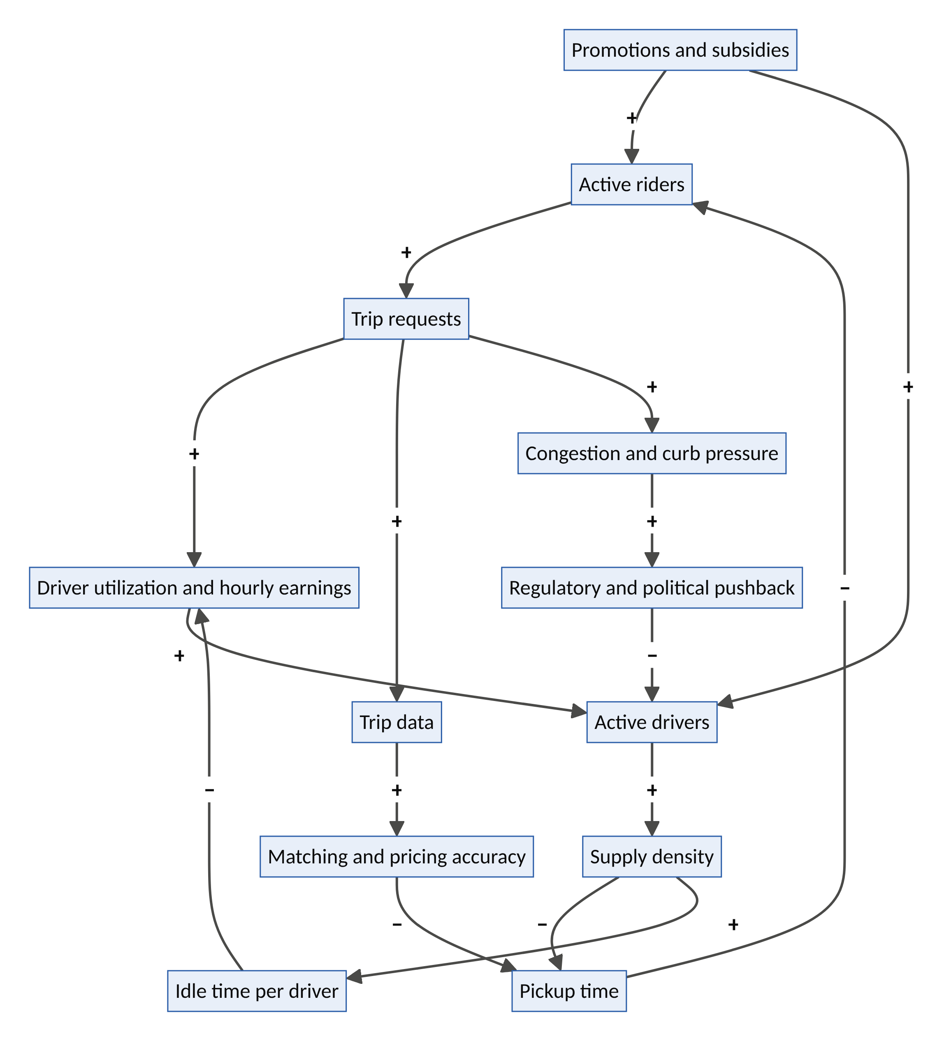
Figure 2. Uber’s core causal loop structure. + means the linked variables move in the same direction; − means they move in opposite directions.
- R1, the liquidity flywheel (David Sacks’ napkin sketch): riders → requests → driver earnings → drivers → density → shorter pickup times → more riders.
- R2, the learning loop: requests → data → better matching and pricing → shorter waits → more riders.
- B1, driver saturation: drivers → density → idle time per driver → lower hourly earnings → fewer drivers. This loop is why fare increases don’t permanently raise driver pay. Hall, Horton and Knoepfle found that after Uber raised fares, drivers’ hourly earnings rose only briefly, because more drivers entered and utilization fell. The balancing loop absorbed the change.
- B2, the political loop: growth → congestion and visible externalities → regulatory pushback → caps, licensing and classification rules → fewer drivers.
- The subsidy pathway is a Shifting the Burden structure (Section 2.4). Subsidies produce liquidity quickly but delay the fundamental fix of real unit economics.

Airbnb’s core loop structure
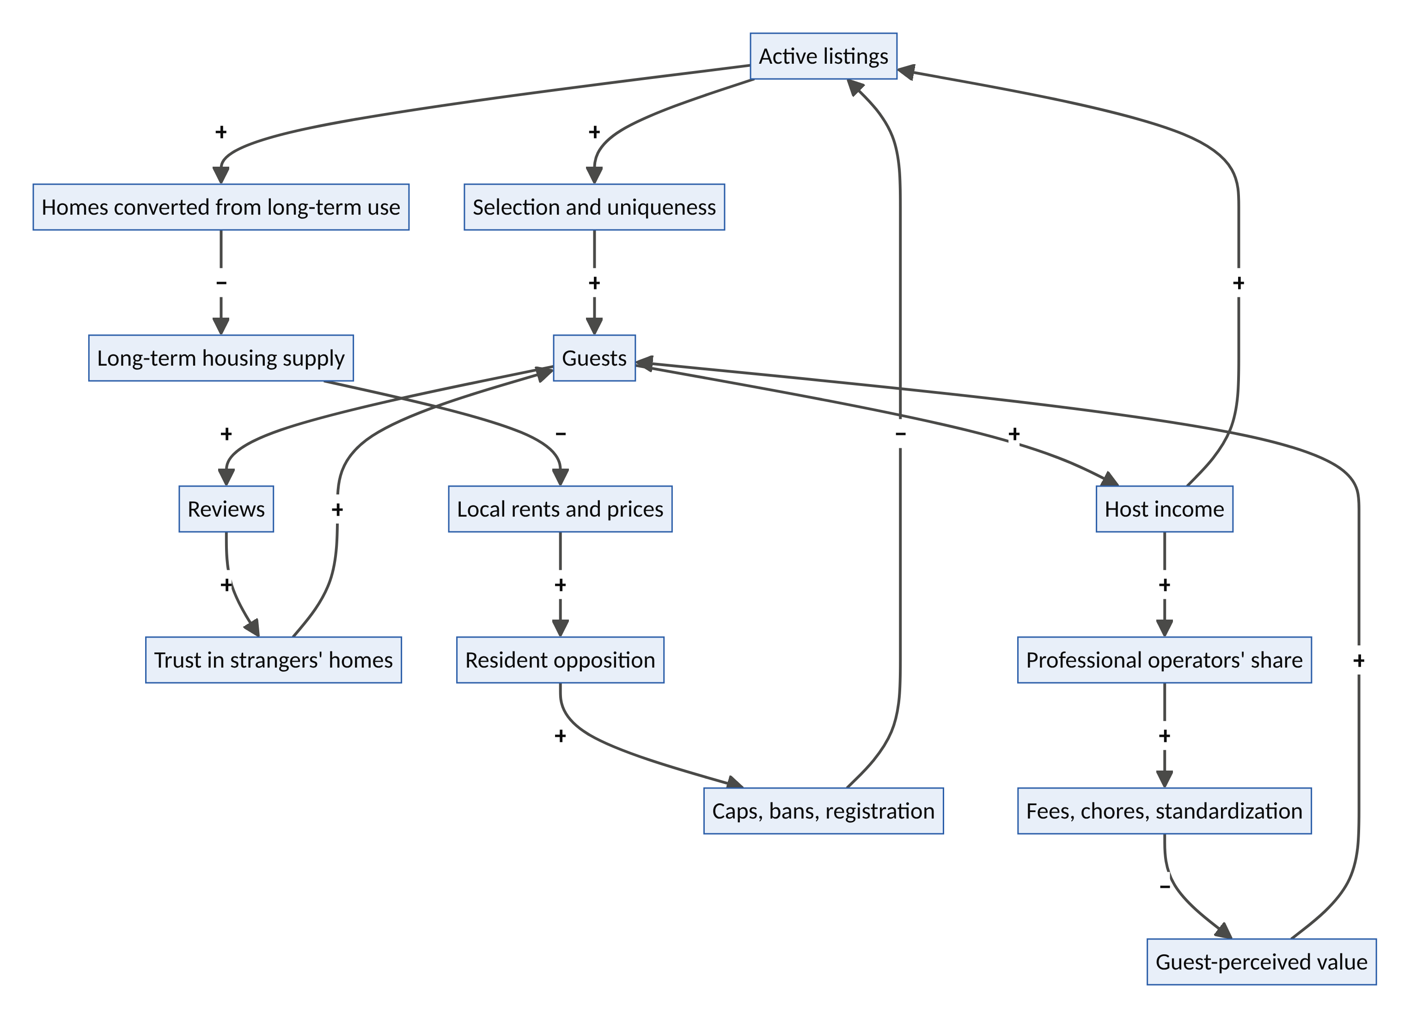
Figure 3. Airbnb’s core causal loop structure.
- R1, the supply–demand flywheel: listings → selection → guests → host income → more listings.
- R2, the trust loop: guests → reviews → trust → more guests. This loop is Airbnb’s deepest asset, because reviews of unique homes cannot be copied by a competitor.
- B1, the housing backlash: listings → conversions → less long-term housing → higher rents → resident opposition → regulation → fewer listings. This is Limits to Growth with a Tragedy of the Commons inside it.
- B2, the authenticity erosion: success attracts professional operators → more fees and standardization → the home starts to feel like a worse hotel → lower perceived value. The thing that made Airbnb special is diluted by its own success.

2.4 System archetypes
Peter Senge and Daniel Kim catalogued a small number of recurring structures (archetypes) that generate familiar failures. Both companies display almost the full set.
Archetype | Structure | Uber | Airbnb | Lesson for the next generation
Limits to Growth | Growth loop meets a constraint | Curb space, congestion, driver supply | Housing tolerance of cities | Identify the limiting resource before scaling
Tragedy of the Commons | Individually rational use depletes a shared resource | Streets, curbs and transit ridership are commons | Neighbourhood quiet, housing affordability and local identity are commons | Price or govern the commons from day one
Shifting the Burden | A symptomatic fix (subsidy) weakens the fundamental fix | A decade of subsidized rides delayed real unit economics | Regulatory ambiguity used as a substitute for compliant design | Use subsidies only to reach a self-sustaining density, with an exit plan
Success to the Successful | Winners get the resources to win more | Ride-hail duopolies; exits from China (2016) and Southeast Asia (2018) | Market leadership in short-term rentals | Winner-take-most invites antitrust and “enshittification”
Fixes that Fail | A fix creates delayed side effects | Surge pricing during emergencies (e.g., Sydney, 2014) → outrage → caps | Cleaning fees and opaque totals → guest anger → price-display changes | Model the second-order reaction to every pricing rule
Escalation | Rivals respond to each other’s moves | Uber vs Lyft and Uber vs Didi subsidy wars | Promotion wars with online travel agencies | Avoid symmetric arms races; compete on asymmetric advantages
Eroding Goals | Standards slip under pressure | Driver earnings floors and safety standards eroded until regulation intervened | Host quality standards loosened during hyper-growth | Hard-code non-negotiable standards into the platform’s rules
Growth and Underinvestment | Growth outruns capacity investment | Trust and safety and culture underinvestment → 2017 crisis | Safety and party-house incidents → global party ban (2020, permanent 2022) | Invest in trust capacity ahead of demand
Enshittification as a compound archetype. Cory Doctorow’s term describes a lifecycle: platforms are first good to users, then shift value to business customers, then extract from both. In systems terms it is Success to the Successful (lock-in) combined with Eroding Goals (quality standards slip once switching costs are high). The structural antidote is to keep exit open (data portability and interoperability) so the balancing loop of user departure stays strong.

2.5 Leverage points
Meadows ranked twelve places to intervene in a system, from least to most powerful. Mapping Uber and Airbnb onto her list explains why their impact was so large.
Rank | Leverage point | What Uber/Airbnb did there | Leverage
12 | Parameters (numbers, prices) | Surge pricing, fees, take rates | Low; balancing loops absorb it (Section 2.3, B1)
11 | Buffers | A flexible driver pool buffers demand peaks | Low–medium
10 | Stock-and-flow structure | Turned millions of private cars and rooms into a virtual fleet and hotel without owning them | Medium
9 | Delays | Cut waiting from ~20 minutes (a phoned taxi) to ~4; cut lodging search from days to minutes | Medium
8 | Balancing feedback | Ratings as fast quality correction; deactivation of poor performers | Medium
7 | Reinforcing feedback | Network effects and data flywheels | High
6 | Information flows | The car on the map; the listing with photos and reviews. Making invisible supply visible. | Very high
5 | Rules | Regulatory entrepreneurship: rewrote de facto rules before de jure ones | Very high
4 | Self-organization | Millions of micro-entrepreneurs organizing their own supply | Very high
3 | Goals | Shifted the goal from owning a car or hotel room to accessing mobility and lodging | Very high
2 | Paradigm | “Strangers can be trusted”; “the city is a shared fleet”; “a home is also a hospitality asset.” | Highest
1 | Transcending paradigms | Not reached; both remained inside the paradigm of extraction-based growth | –
Insight. Meadows’ own favourite example of an information-flow intervention was moving the electricity meter into the front hallway, which cut consumption simply by making it visible. Uber and Airbnb are that example at planetary scale. Their founding intervention was rank 6 (information) driven by a rank 2 (paradigm) shift. The later struggles all occurred at ranks 5 and 3 (rules and goals), which they treated as obstacles rather than design material. The next generation’s opportunity is to design deliberately at ranks 5, 4 and 3: rules, self-organization and goals.

2.6 Cybernetics: requisite variety and the viable system
Ashby’s Law of Requisite Variety says that only variety can absorb variety: a controller must have at least as many possible responses as the disturbances it faces. Urban mobility demand is highly variable (rain, concerts, Friday nights, airports at 5 a.m.). The taxi system, with a fixed medallion count and fixed fares, had too little variety. Uber’s elastic supply plus dynamic pricing had requisite variety. Hotels offer standardized rooms; travellers’ needs (families, groups, long stays, pets, remote work, rural stays) are highly varied. Airbnb’s heterogeneous supply matched that variety.
Disruption corollary (Ashby): disruption happens where an incumbent’s regulated or structural variety is lower than its environment’s variety, and a newcomer can supply the missing variety cheaply.
This corollary is a search heuristic. Look for sectors where demand variety is rising (ageing, climate, AI) while incumbent response variety is fixed by regulation, capital structure or culture. Care homes, insurers, universities, utilities and housing developers are all candidates, and Part VII targets each of them.
Beer’s Viable System Model (VSM) describes the five functions any system needs to remain viable:
VSM system | Function | Uber | Airbnb | Typical failure
S1: Operations | Do the primary work | Drivers, couriers, trips | Hosts, stays, experiences | Burnout, churn
S2: Coordination | Damp oscillations between operations | Dispatch, surge, routing algorithms | Calendars, pricing tools, messaging | Algorithmic opacity
**S3: Control / audit (S3*)** | Optimize the whole; audit | Ratings, deactivation, trust and safety | Reviews, verification, AirCover | Under-resourcing (Section 2.4)
S4: Intelligence | Sense the environment and future | AV strategy, new verticals | AI app, services, regulation strategy | Blind spot for externalities
S5: Policy / identity | Define purpose and values | Culture reset after 2017 | “Belong anywhere” | Gap between identity and POSIWID
The VSM points to a structural flaw. In both companies, the providers (S1) have almost no voice in S5, the system’s identity and policy. In VSM terms, the system is not fully viable, because it suppresses the variety of its own operational units. Driver protests, host revolts over fees and regulatory intervention are the system’s way of restoring the missing channel. A next-generation design would build that channel in (Part V, vertex 6).

2.7 A minimal system dynamics model of a ride-hailing market
For readers who want the mechanics, here is a compact formal model. It is illustrative, not calibrated.
Stocks: riders R, drivers D, platform cash C.
Key relationships:
- Trips per hour: T = min( λ(R, w, p), μ·D ), where λ is demand (rising in riders, falling in wait w and price p) and μ is trip capacity per driver.
- Pickup wait (the spatial square-root law): w ≈ k / √(D_idle / A), which falls with the square root of idle-driver density over area A.
- Driver hourly earnings: e = (1 − τ)·p·T / D, where τ is the take rate.
- Driver dynamics: dD/dt = onboarding(e − e) − churn(e* − e), where e** is drivers’ reservation wage.
- Rider dynamics: dR/dt = acquisition(subsidy, word of mouth) − churn(w, p).
- Cash: dC/dt = τ·p·T − subsidy − fixed costs.
Behaviours this model produces:
- Saturating network effects. Because of the square-root law, doubling drivers cuts waiting time by only ~29% (1 − 1/√2). Once waits are short, more density adds little, so the network effect saturates. That is why a second or third competitor can survive in ride-hailing, but rarely in a social network.
- Earnings convergence. With free entry, e converges to *e** whatever the fare. The parameter (price) is absorbed by the balancing loop (driver entry), which is Meadows’ point about low-leverage parameters made concrete.
- Subsidy overshoot. Subsidies inflate R and D above their self-sustaining levels. When subsidies are withdrawn, the system undershoots before finding equilibrium, the classic overshoot and collapse signature.
- Take-rate trap. Raising τ lowers e, which (after a delay) lowers D, raises w and lowers R. The delay hides the damage, so take rates tend to creep up until a balancing loop (driver exit, regulation) forces correction.
The Airbnb equivalent replaces drivers with listings and adds the city’s housing stock H: dH/dt = −conversion(yield_STR − yield_LTR) + new construction. Conversions are driven by the yield gap between short- and long-term renting. Regulation is a delayed function of rent pressure. The model generates the observed pattern: rapid growth, then a regulatory correction concentrated in the highest-demand cities.

Part III: Theory and Philosophy, or What Uber and Airbnb Really Did

3.1 Economics: why the platform exists
Coase (1937): the collapse of transaction costs. Ronald Coase asked why firms exist if markets are efficient. His answer was that using the market has costs: searching, bargaining, contracting and enforcing. Firms exist where those costs exceed the cost of internal hierarchy. Uber and Airbnb pushed transaction costs so low that markets became possible where none had existed. Nobody had ever “rented” a stranger’s car journey for six minutes or a stranger’s sofa for one night, because the transaction costs were prohibitive. The platform is a machine for making markets cheap.
The platform is also a hybrid: an algorithmic firm that coordinates through code what a firm would coordinate through managers, while keeping providers formally outside its boundary. This hybrid status is the root of the employment-classification fights, because the platform exercises firm-like control (pricing, deactivation) over market-like participants.
Williamson: asset specificity. Cars and spare rooms have low asset specificity: they can be redeployed to many users without loss. That is why market governance works for them. The heuristic for founders: platforms work best where the latent asset has low specificity and high idle time. The Latency rubric in Appendix B builds this in.
Hayek (1945): the knowledge problem, inverted. Hayek argued that prices aggregate dispersed knowledge no planner could gather. Surge pricing looks like a Hayekian price signal: it tells drivers where they are needed. But there is an inversion. The platform does gather the dispersed knowledge, every trip and every search, and shares only a filtered price with participants. The result is a Hayekian market operated by an all-seeing planner. Rosenblat and Stark (2016) documented the resulting information asymmetry in “algorithmic management”. The platform knows the whole market; the driver sees one fare. Information asymmetry is the hidden source of platform power, and a next-generation design principle is to give participants the information they need to bargain.
Rochet and Tirole (2003): two-sided markets. Platforms choose a price structure, not just a price level: which side pays and which is subsidized. Uber subsidized both sides in the launch years; Airbnb charges both. The next-generation question is subtler: which side, including third parties such as cities and neighbours, bears the externality, and should it be paid?

3.2 Innovation theory: disruption, properly understood
Schumpeter’s creative destruction. Both companies are Schumpeterian: new combinations of existing resources (cars, homes, phones, payments) that destroyed incumbent rents (taxi medallion values collapsed in several US cities; hotels lost pricing power during peak events).
Christensen’s disruption theory, applied strictly. In What Is Disruptive Innovation? (HBR, 2015), Clayton Christensen and co-authors argued that Uber is not a disruptive innovation in the technical sense. It did not start with a low-end foothold (customers over-served by incumbents) or a new-market foothold (non-consumers). It started in the mainstream with a product often better than taxis. Airbnb is closer to the theory: its first customers were budget travellers and conference overflow who would not have stayed in hotels at all, a new-market foothold. It then moved upmarket.
Why this matters for founders. The popular use of “disruption” (any big change) hides the mechanism that makes disruption hard to fight: asymmetric motivation. Incumbents rationally ignore footholds that look unattractive to them. The ten ventures in Part VII are each classified by their foothold. The strongest begin with non-consumption, people currently served by nothing: uninsured traders, smallholders without cold storage, lonely people without a “third place”, juniors with no first rung.

3.3 Political economy: Polanyi and the double movement
Karl Polanyi’s The Great Transformation (1944) is perhaps the most important book for understanding platforms, though it predates them by sixty years. Polanyi argued that market society depends on treating three things as commodities that were not produced for sale: labour (human life), land (nature and place) and money. He called them fictitious commodities. When markets commodify them too aggressively, society protects itself through regulation, unions, zoning and welfare. Polanyi called this the double movement.
Read through Polanyi:
- Uber commodified labour at a finer grain than ever before: the minute, the trip, the delivery. The double movement followed: California’s AB5 and Prop 22 battle, the UK Supreme Court’s Uber v Aslam (2021) worker ruling, and the EU Platform Work Directive (Directive (EU) 2024/2831), with its rebuttable presumption of employment and rules on algorithmic management, due for transposition by 2 December 2026.
- Airbnb commodified land and home at a finer grain than ever before: the night. The double movement followed: registration laws, night caps, NYC’s Local Law 18 and Barcelona’s plan to phase out tourist-apartment licences by 2028.
The Polanyi Prediction: Any platform that commodifies a fictitious commodity, whether labour, land, money, or (we should now add) attention, data, care and identity, will trigger a double movement. The only choice is whether to design for it in advance or to fight it afterwards.
This prediction is the single most important input to the framework in Part V. The next generation of opportunities (care, data, housing, energy, identity) are all fictitious or quasi-fictitious commodities. Those ventures must be pre-embedded: designed from the start with the protections society would otherwise impose.

3.4 Philosophy of technology: standing-reserve, conviviality and the self
Heidegger: the world as standing-reserve. In The Question Concerning Technology (1954), Heidegger argued that modern technology “enframes” (Gestell) the world, revealing everything as standing-reserve (Bestand): a resource on call, waiting to be optimized. A river becomes a power supply; a forest becomes timber stock. Uber and Airbnb extended enframing into private life. The parked car and the spare bedroom were revealed as standing-reserve, inventory on call. The home became a yield.
The danger for the next generation is clear. Applied carelessly, the same logic would reveal elders’ time, neighbours’ batteries, citizens’ data and children’s attention as standing-reserve. Heidegger’s counter-concept is poiesis, a revealing that brings forth rather than extracts. A useful design question follows: does this platform reveal the capacity as inventory or as a relationship?
Illich: tools for conviviality. Ivan Illich (1973) distinguished convivial tools, which enlarge people’s autonomy and creativity, from manipulative tools, which make people dependent and managed. A bicycle is convivial; a traffic jam is not. By Illich’s test, a platform is convivial if providers can understand, influence and leave it, and manipulative if it manages them through opaque algorithms and lock-in. Section 5.7’s principles are an attempt to operationalize conviviality.
Foucault and Han: the rated self. Five-star ratings are a soft panopticon (Foucault). Every interaction is observed, scored and stored, and a driver below the threshold can be deactivated. Byung-Chul Han’s The Burnout Society adds that late-modern power works through self-exploitation: the gig worker is told they are an “entrepreneur of the self” and so drives themselves harder than any boss would. Next-generation trust systems should be developmental rather than punitive: feedback that helps people improve, appeal rights, and scores that decay so people can recover from a bad week.

3.5 Trust: from institutions to distributed to delegated
Rachel Botsman describes three eras of trust. Local trust lived in villages. Institutional trust lived in banks, brands and governments. Distributed trust lives in networks, reviews and platforms. Uber and Airbnb were the great pioneers of distributed trust, making it rational to get into a stranger’s car or sleep in a stranger’s home.
A fourth era is now beginning: delegated trust. We will increasingly trust AI agents to act for us, and others must decide whether to trust our agents. This is the trust problem of the late 2020s, and it is unsolved. Whoever provides identity, mandate, reputation and recourse for agents will hold a position as central as Visa’s in card payments. Visa itself began as a member-owned association designed by Dee Hock as a “chaordic” organization, neither centralized nor anarchic. That governance model is directly relevant (see Venture 1, Covenant).

3.6 The commons and its governance
Elinor Ostrom showed, against the “tragedy of the commons” thesis, that communities often govern shared resources sustainably when certain design principles hold: clear boundaries, rules fitted to local conditions, participation of those affected, monitoring by accountable monitors, graduated sanctions, cheap conflict resolution, recognition by outside authorities, and nested governance.
Uber and Airbnb sit on commons (streets, housing, neighbourhood life) without governing them. Platform cooperativism (Trebor Scholz) and real examples point to alternatives. The Drivers Cooperative in New York (2021) is driver-owned. Namma Yatri in Bengaluru, built on the open Beckn/ONDC protocol, charges drivers a flat subscription instead of a per-ride commission. The future platform does not have to be a cooperative, but it does have to answer Ostrom’s questions.
Jeremy Rifkin’s Zero Marginal Cost Society and Yochai Benkler’s commons-based peer production suggest why this matters more now. As AI pushes the marginal cost of coordination, translation, design and analysis toward zero, the scarce things become trust, legitimacy, physical capacity and human meaning. Platforms that try to extract rents from coordination alone will find those rents competed away by AI agents. Platforms that steward scarce trust and physical capacity will endure.

3.7 Surveillance and extraction
Shoshana Zuboff (surveillance capitalism) and Nick Srnicek (platform capitalism) argue that platforms are primarily data-extraction apparatuses: the service is the bait and behavioural data is the catch. Both companies collect deep behavioural data, Uber on location and movement and Airbnb on travel, identity and taste. The critique sets a design constraint: data rights must be clear, and the value of data should flow partly back to those who generate it (Venture 2, DataGuild, is built on this).

3.8 Justice: the veil-of-ignorance test
John Rawls asked what rules people would choose if they did not know their place in society. This yields a simple, powerful platform-design test:
The Veil-of-Ignorance Test: Would you accept this platform’s rules if you did not know whether you would be the rider or the driver, the guest, the host or the neighbour, the shareholder or the city?
Uber’s early rules (opaque pay, unilateral deactivation, risk borne by drivers) and Airbnb’s early rules (externalities borne by neighbours) would struggle to pass. Each venture in Part VII is designed to pass it.

3.9 Ubuntu: belonging as an operating principle
Airbnb’s slogan “belong anywhere” is a commercial echo of an older idea. The Southern African ethic of Ubuntu, umuntu ngumuntu ngabantu (“a person is a person through other persons”), holds that identity and wellbeing are relational. Similar relational ethics appear across Africa. The Yoruba concept of Ọmọlúàbí describes a person of good character whose conduct honours the community. Rotating savings associations (esusu, ajo) and community labour exchanges are centuries-old platforms of mutual trust that worked without apps.
These traditions matter because the ventures with the best fit to the problems of the 2020s (care, loneliness, climate resilience, food security) are relational, not transactional. The first platform era optimized for transactions between strangers. The next era must also support relationships among neighbours. Ubuntu is not decoration. It specifies a different objective function: maximize relational wellbeing, subject to economic sustainability, instead of maximizing transactions subject to legal constraints.

3.10 Synthesis: latency, liberation and enclosure
Pulling the threads together:
- Platforms are latency compilers. Capacity is latent when it is (a) invisible, (b) untrusted, (c) untransactable, or (d) uncoordinated. A platform compiles latency into liquidity by solving all four at once: the map or listing, the trust stack, payments and contracts, and algorithmic coordination.
- The paradox of liberation. Platforms liberate latent capacity, since a spare room can now earn, and simultaneously capture the value of that liberation through take rates, data and lock-in. Historically this resembles the English enclosures, where common land was “improved” and privatized at once.
- The double movement is a design input. Society will protect fictitious commodities. Designing for that protection in advance is cheaper than fighting it in courts and city halls.
- Scarcity is migrating. AI is making coordination cheap. Trust, legitimacy, physical capacity, care and meaning are becoming scarce, and that is where the next platforms will create, and must steward, value.
The founding maxim of the next era: Liberate latent capacity without enclosing it.

Part IV: The Future Potential of Uber and Airbnb (2026–2050)
“Any useful statement about the future should at first appear to be ridiculous.” (Jim Dator)

4.1 How to think about platform futures
Forecasts about platforms tend to fail in one of two ways. They extrapolate the present (more of the same, faster), or they over-dramatize one technology (robotaxis will end Uber; AI agents will end Airbnb). This part uses five foresight tools to avoid both:
Tool | Origin | What it reveals here
The futures cone | Hancock and Bezold (1994); Voros (2003) | Separates possible, plausible, probable and preferable futures, so the most likely and the most desirable futures are not confused
Three Horizons | Sharpe and Hodgson, International Futures Forum | H1 is the dominant system in decline, H3 is the emerging future, and H2 is the turbulent transition. H2 innovations either bridge to H3 (“H2+”) or prolong H1 (“H2−”)
Causal Layered Analysis (CLA) | Inayatullah (1998) | Reads the future at four depths: the headlines (litany), the systemic causes, the worldview, and the underlying myth or metaphor
Dator’s four futures | Jim Dator, Hawaii Research Center for Futures Studies | Every society’s images of the future reduce to four archetypes: continuation, collapse, discipline (living within limits) and transformation
Techno-economic surges | Carlota Perez (2002) | Each technological revolution has an installation period (frenzy and bubble), a turning point (crash and institutional reform) and a deployment period (a “golden age” when institutions catch up)
A note on the other “three horizons”: Sections 4.4 and 4.6 use the McKinsey version (H1 core, H2 emerging, H3 transformational business lines). That describes a company’s portfolio. The Sharpe version describes a system’s transition. Both are useful, and they answer different questions.

4.2 The long wave: where platforms sit in history
Perez dates the information-and-communications revolution to 1971, with Intel’s microprocessor. Its installation period ran through the dot-com frenzy and crash (2000) and ended in the financial crisis of 2008, the turning point. History suggests that what follows a turning point is a deployment period: a potential “golden age” in which the technology spreads through the whole economy. Perez stresses that this happens only if institutions are recomposed: regulation, finance, welfare and labour rules are rebuilt for the new technology.
Uber and Airbnb were born exactly at the turning point (2008–2010). They are deployment-era businesses: they spread ICT into everyday mobility and lodging. But for a decade they were financed in the style of the installation era, with zero-interest-rate capital, blitzscaling and indifference to institutions. Their regulatory battles are best read as the institutional recomposition Perez describes, and as Polanyi’s double movement (Part III) seen from the economics side.
Two implications follow for the next 25 years:
- The platform settlement is still being written. The EU Platform Work Directive, short-term-rental registration rules, data-sharing mandates and AV regulation are the institutional recomposition of the deployment age. Firms that help write the settlement (co-regulation) will shape the golden age. Firms that resist it will be shaped by it.
- AI may be a new installation period inside the old deployment period. The AI capital-expenditure boom of 2023–2026 has frenzy characteristics: concentrated investment, extreme valuations, infrastructure built ahead of proven demand. If Perez’s pattern holds, a correction and a new institutional settlement for AI (liability, data rights, agent accountability, energy) will follow. Ventures positioned for that settlement, such as Covenant and DataGuild, are positioned for the golden age that follows.

4.3 The adaptive cycle: where each company stands
Ecologists C.S. Holling and Lance Gunderson describe complex systems as moving through an adaptive cycle (panarchy). Exploitation (r) is rapid growth into open niches. Conservation (K) is efficiency, connectedness and rigidity. Release (Ω) is creative destruction. Reorganization (α) is novelty and recombination.
Phase | Uber | Airbnb
r: exploitation (2009–2016) | City-by-city land grab | Global supply explosion
K: conservation (2017–2025) | Discipline, profitability, multi-vertical efficiency | Profitability, brand, regulatory accommodation
Ω: release (2025–2032, emerging) | Autonomy releases the driver-based structure that built the company | Agentic AI releases the search-and-browse structure that built demand aggregation
α: reorganization (2030s) | Uber as a utilization engine for autonomous capital or a commoditized dispatcher | Airbnb as a trust-and-identity layer for human hospitality or a supply feed for AI agents
Systems in a mature K phase are efficient but fragile: highly connected and optimized for current conditions. Both companies are entering the release phase of their founding structure, and their futures depend on how they reorganize.

4.4 Uber: three horizons
Horizon | Time | Opportunities
H1: extend the core | 2026–2028 | Mobility and delivery growth. Uber One passed 50 million members in Q1 2026, and members now drive about half of Mobility and Delivery gross bookings. Advertising (reported at above a $2bn annual run rate). Grocery and retail; Uber for Business; financial services for earners
H2: build the emerging | 2027–2032 | Autonomous-vehicle aggregation. Uber has struck deals with 20–30+ AV companies across robotaxi, delivery and freight. Robotaxi rides are offered through the Uber app in cities including Phoenix, Austin, Atlanta and Abu Dhabi, and a Lucid–Nuro robotaxi programme targets 20,000+ vehicles over six years. Uber AI Solutions (data labelling and AI-training work by its gig network, launched 2024). Autonomous freight; drone delivery
H3: create the transformational | 2030+ | A city mobility operating system integrating transit, micromobility, AVs and air taxis. A “physical-world API” that AI agents call to move people and goods. Fleet financing; EV and AV fleets as grid batteries
The strategic tension: aggregator or dispatcher? In the AV era, the scarce resource is no longer drivers but demand density and fleet utilization. A robotaxi is expensive capital that must never sit idle, which is an ironic reversal of Uber’s founding insight about idle cars. Uber’s bet is that fleet owners will want the largest pool of demand to maximize utilization, so Uber becomes the “Booking.com of robotaxis”. The counter-scenario is vertical integration: Waymo’s rapid growth (around 500,000 paid rides a week by early 2026, with a stated target of 1 million) and Tesla’s own robotaxi service show that AV makers may sell directly. The systems view suggests both will co-exist by city. Where an AV operator has density, it goes direct; where it lacks density, it rents Uber’s demand.
The human question. Millions of drivers worldwide earn a living through ride-hail and delivery. The release phase threatens their livelihoods. How that transition is handled is a Polanyi double movement waiting to happen, and Venture 7 (CommonFleet) is designed around it.

4.5 Uber: ten future innovations
The innovations below are concepts Uber is structurally well placed to build. Some extend existing initiatives; most are new.
# | Innovation | What it would be | Why Uber can win | Horizon
1 | AV Utilization Exchange | A real-time market where AV fleet owners sell capacity and Uber routes demand across fleets to maximize every vehicle’s paid hours | The largest multi-city demand pool; multi-partner AV strategy | H2
2 | Mobility-as-a-Utility | Flat monthly subscriptions bundling rides, transit passes, micromobility and delivery, priced like a phone plan | Uber One’s 50m members are the base | H1–H2
3 | Physical-world API for AI agents | A standard interface any AI agent can call to move a person or parcel, with verified identity, mandate and liability | Global logistics network plus payments and trust stack | H2–H3
4 | Fleet-to-grid | Aggregating parked EV and AV fleets into virtual power plants that sell flexibility to grids | Fleet scheduling data; depots; scale | H2
5 | Driver-to-owner transition fund | Giving long-serving drivers equity stakes or fractional ownership in the AV fleets that replace them | Unique access to the affected workforce; political licence to operate | H2
6 | Curb and city data partnership | Paid curb-space management and anonymized mobility data shared with cities for planning | Data on billions of trips | H1–H2
7 | Health and care logistics | Non-emergency medical transport, prescription delivery, home-care visit logistics | Existing health partnerships; dispatch expertise | H1–H2
8 | Autonomous freight network | Linking autonomous long-haul trucks with human-driven last-mile, coordinated through Uber Freight | Freight marketplace plus AV partnerships | H2–H3
9 | Earner financial services and portable benefits | Savings, insurance, pensions and credit for gig earners, portable across platforms | Earnings data; regulatory pressure makes this valuable | H1
10 | Human-in-the-loop workforce for AI | Scaling Uber AI Solutions into a global marketplace for AI evaluation, supervision and remote AV assistance | Large flexible workforce already onboarded and verified | H2
Uber in 2040: three possible identities
- The Utilization Utility. Uber becomes the operating layer for autonomous capital, the system that keeps millions of robotaxis, delivery robots and trucks busy. Margins are modest but stable, like a utility’s.
- The Physical-World API. AI agents become the main source of demand, and Uber becomes the default service they call to move atoms, as cloud platforms became the default for computation. This is the highest-value identity.
- The Commoditized Dispatcher. AV makers go direct in dense cities, AI agents compare prices across every network, and Uber competes on price as one supplier among many. This is the lowest-value identity.
Which identity emerges depends less on technology than on who owns demand (the app or the agent) and who owns the vehicles (manufacturers, Uber, or third parties).
Illustrative growth arithmetic (not a forecast). Uber’s gross bookings were about $193bn in FY2025, growing around 20%. At a 15% compound annual rate they would roughly double to about $390bn by 2030; at 10%, they would reach about $310bn. The spread between those paths depends mostly on AV unit economics and agentic demand, the two release-phase forces in Section 4.3.

4.6 Airbnb: three horizons
Horizon | Time | Opportunities
H1: extend the core | 2026–2028 | Core stays; “Reserve Now, Pay Later”; co-hosting network; long stays; growth in under-penetrated markets. Q2 2026 revenue grew 17% to about $3.6bn, and app bookings were 64% of nights. Hotels are growing about three times faster than homes, though still a single-digit share of nights
H2: build the emerging | 2027–2032 | AI-native app. Its AI customer-service agent now resolves about a third of issues without a human in North America; AI cut customer-service cost per booking by about 16% (Q2 2026); Airbnb is building its own AI pricing model and an AI concierge. Services and Experiences (relaunched 2025) now include car rental, airport pickup, luggage storage, grocery delivery and hotel resort passes, making Airbnb an “everyday” app. Identity and trust as a platform
H3: create the transformational | 2030+ | A living platform: housing-as-a-service, co-living, nomad infrastructure. A portable trust passport for the agent economy. Community and civic hosting (e.g., Airbnb.org for disaster housing)
The strategic tension: agentic disintermediation. If travellers ask a general-purpose AI assistant to “find me a quiet two-bedroom near the beach in Lisbon under €200,” the assistant becomes the aggregator of demand, and every lodging platform becomes a supply feed ranked by the agent. Booking.com and Expedia were among the first travel apps inside ChatGPT (October 2025), while Airbnb chose to prioritize its own AI-native app.
Airbnb’s defensible assets in that world are the things an agent cannot easily reproduce:
- unique supply;
- millions of verified reviews;
- identity verification of hosts and guests;
- payment escrow and guarantees (AirCover);
- a community of hosts.
In short, its defensible asset is the trust layer.
Forecast: In the agentic era, aggregators of demand lose power and aggregators of trust gain it.

4.7 Airbnb: ten future innovations
# | Innovation | What it would be | Why Airbnb can win | Horizon
1 | Personal travel agent | An AI concierge that plans, books, adapts and supports an entire trip, across stays, services, experiences and transport | Preference, review and identity data; Services catalogue | H1–H2
2 | Trust passport (identity-as-a-service) | Portable verified identity and reputation that guests and hosts can present to other services, and that AI agents can verify | Fifteen years of two-sided reviews and ID verification | H2
3 | Airbnb for living | Medium- and long-term furnished housing, co-living and “live anywhere” subscriptions | Long-stay demand; flexible-work trends | H2
4 | Home-services marketplace | Chefs, cleaners, carers, photographers and repairers booked into any home, not only rentals | Services relaunch; trusted provider vetting | H2
5 | Host business OS | Pricing, cleaning, maintenance, accounting and compliance tools that make hosting a professional micro-business | Millions of hosts; co-hosting network | H1
6 | Housing-positive hosting | In high-pressure cities, a share of fees funds new homes, and listings are capped or prioritized for primary-residence hosts | Turns the housing backlash loop into an alliance loop (see Hearth) | H2
7 | Disaster and displacement hosting as a service | Formalizing Airbnb.org into a standing capability that governments and insurers contract for emergency housing | Proven host willingness; global supply | H2
8 | Experiences as learning | Experiences that teach crafts, languages and skills, with credentials that travel | Experience hosts; global reach | H2–H3
9 | Nomad infrastructure bundle | Visas, coworking, insurance, banking and community for remote workers in one package | Long-stay data; partner network | H2
10 | Belonging index for destinations | Data and tools that help cities manage tourism load, distribute visitors and measure resident wellbeing | Booking data; regulatory goodwill | H2–H3
Airbnb in 2040: three possible identities
- The Trust and Belonging OS. Airbnb becomes the identity, reputation and guarantee layer for human hospitality, the infrastructure agents rely on to decide whom to trust. This is the highest-value identity.
- The Everyday Concierge. Airbnb becomes a high-frequency life app for stays, services and experiences at home and away, closing its old frequency gap with Uber.
- The Supply Feed. General-purpose AI agents own the traveller relationship, and Airbnb supplies inventory ranked by price and rating. This is the lowest-value identity.
Illustrative growth arithmetic (not a forecast). Airbnb’s gross booking value was about $91.3bn in FY2025. At a 12% compound annual rate it would reach about $160bn by 2030; at 8%, about $134bn. The upper path requires the Services, hotels and AI bets to succeed while housing regulation stays manageable.

4.8 Convergence
Uber and Airbnb are converging on the same five strategic assets:
- A “life logistics” super-app: moving, staying, eating, services.
- Membership and subscription: recurring relationships instead of one-off transactions.
- Advertising: monetizing first-party intent data.
- AI agents as the front door: conversational booking and support.
- Identity and trust: verified people, verified providers and guarantees.
The fifth is the most important. Both companies spent fifteen years building the world’s largest repositories of stranger-to-stranger trust data. In a world where AI-generated fraud and synthetic identities are becoming cheap, that trust is worth more than the matching algorithms that produced it. A partnership or bundle between the two (rides plus stays, a shared trust passport) is plausible in the 2030s, and so is competition as both expand into services and travel.

4.9 Causal Layered Analysis: the deeper story
CLA reads a future at four depths. Surface changes (the litany) are easy to make and easy to reverse. Changes at the level of worldview and myth are slow but durable. The table compares today’s story with a transformed one.
Layer | Uber today | Uber transformed | Airbnb today | Airbnb transformed
Litany (headlines) | “Robotaxis will replace drivers”; “gig workers win employment rights” | “Drivers become fleet owners”; “the city runs on a shared mobility utility” | “Airbnb drives up rents”; “cities ban short-term rentals” | “Airbnb funds new homes”; “hosts become stewards of their neighbourhood”
Systemic causes | Labour classification; AV unit economics; take-rate pressure; congestion | Shared ownership of autonomous capital; public data partnerships; congestion pricing | Yield gap between short- and long-term renting; zoning; over-tourism | Housing-positive fee structures; registration and caps; visitor distribution
Worldview | Markets allocate best; efficiency and convenience come first | Mobility as a shared public good delivered by markets under civic rules | The home as an investment asset; access over ownership | The home as a place within a community; access with belonging
Myth / metaphor | “The city as a vending machine”: press a button, a ride appears | “The city as a commons we co-steward” | “Belong anywhere” (as a guest) | “Belong somewhere” (as a neighbour, even when visiting)
Insight. Most corporate strategy works at the litany and systemic layers. The durable transformations happen when the metaphor changes. The shift from “vending machine” to “commons” and from “belong anywhere” to “belong somewhere” is where the stewardship economy begins.

4.10 Scenario matrix: the platform world in 2035
Two critical uncertainties drive the future:
- Who mediates demand? Humans using apps, or AI agents acting for humans.
- How is the platform economy governed? Extractive and laissez-faire, or embedded and commons-governed (Polanyi’s double movement successfully absorbed).
 | Human-mediated demand | Agent-mediated demand
Extractive governance | A. Walled Gardens. Super-apps dominate; take rates creep; enshittification; regulatory whack-a-mole. Uber and Airbnb thrive financially but face continuous political conflict. | B. Agent Bazaar. AI assistants owned by a few tech giants intermediate everything. Platforms become API supply feeds competing on price; margins compress; value moves to whoever owns the agent.
Embedded governance | C. Civic Platforms. Cities license platforms, mandate data sharing (e.g., mobility data standards), cap externalities, enforce worker standards. Slower growth, high legitimacy. | D. Protocol Commons. Open protocols for identity, payments, trust and discovery (in the spirit of Beckn/ONDC, verifiable credentials and agent-to-agent standards). Agents negotiate across interoperable networks; value accrues to whoever provides verified trust and quality supply; cooperatives and public digital infrastructure flourish.
Signposts to watch:
Signpost | Points toward
Share of bookings initiated by AI agents rises fast | B or D
Open agent-payment and agent-identity standards gain adoption (e.g., agent payment protocols from major payment and AI firms, 2025 onward) | D
EU Platform Work Directive transposed strictly across member states | C or D
Platforms block AI agents or demand exclusivity | A
City data-sharing mandates and short-term-rental caps spread | C
Digital public infrastructure (UPI, Pix, ONDC, EU Digital Identity Wallet) extends to services marketplaces | D
Strategic implication for new ventures: build for Protocol Commons (D) while surviving the Agent Bazaar (B). Be agent-native, interoperable and trust-rich. Do not depend on owning the user interface, because the interface may belong to someone’s AI agent.

4.11 Dator’s four futures: 2050
Looking further out, Dator’s four archetypes give a fuller range of 2050 outcomes. None is a prediction; each is internally consistent and worth preparing for.
 | Continuation (growth) | Collapse | Discipline (living within limits) | Transformation
The world | AI and autonomy drive strong growth; markets stay dominant | Climate shocks, conflict or financial crisis break global supply chains and travel | Carbon budgets, housing caps and labour protections strictly bound platform activity | Abundant clean energy, autonomous systems and AI make coordination nearly free; ownership and work are redefined
Uber | A global autonomous-mobility utility with very high volume and thin margins | Fragmented local services; fleets nationalized or idle; mobility re-localizes | A licensed public-interest mobility operator under concession contracts | One protocol among many in a mobility commons; value accrues to fleet owners and trust providers
Airbnb | Global trust-and-belonging OS; travel volume grows strongly | International travel collapses; hosting turns to local displacement housing | Strict quotas on tourist homes; Airbnb as a licensed, housing-positive operator | Hospitality as gift-and-reciprocity networks verified by portable trust; Airbnb as a steward of place
Drivers and hosts | Drivers largely displaced; hosts professionalize | Informal work rises; hosting becomes survival income | Strong protections; fewer but better-paid roles | Co-owners and members of the networks they serve
Cities | Congestion solved by autonomy; housing pressure persists | Cities shrink or fragment | Cities set binding limits and capture value | Cities co-own data and infrastructure as commons
Preferable future. This paper argues for a blend of Discipline and Transformation: binding limits on externalities, combined with ownership and governance innovations that share the gains of automation. That is the territory the ten ventures are designed for.

4.12 Wildcards
Wildcards are low-probability, high-impact events that would bend every trajectory above. Each should be monitored, not predicted.
Wildcard | Impact on Uber | Impact on Airbnb | Early signals
A fatal multi-vehicle AV failure causing a national pause | AV strategy delayed by years; human drivers temporarily more valuable | Minor | Recalls; regulator investigations
A dominant AI assistant blocks or taxes platform APIs | Becomes a supply feed overnight | Becomes a supply feed overnight | Exclusive deals; changes to assistant app policies
A pandemic-scale health event | Mobility collapses, delivery booms (as in 2020) | Travel collapses, local and long stays rise | Outbreak surveillance; travel advisories
A global ban on independent-contractor platform work | Business model rebuilt around employment or co-ops | Limited (hosts are not workers) | Court rulings; EU and US labour reforms
A large cyberattack or identity breach | Trust crisis in payments and safety | Trust crisis in identity and reviews | Breach disclosures; regulator alerts
A climate-migration shock (tens of millions displaced in a decade) | Demand for evacuation and logistics services | Hosting becomes humanitarian infrastructure | Disaster displacement data
An energy price shock | Higher operating costs; EV and AV economics improve relative to fuel | Travel costs rise; domestic travel shifts | Oil and gas markets
Public digital infrastructure mandates open marketplaces (national open networks) | Take rates compressed; must compete on service | Discovery opened to all; trust layer becomes the moat | ONDC-style policies spreading

4.13 Strategic options for Uber and Airbnb
Using real-options logic, each company’s choices fall into three groups: no-regret moves (valuable in every scenario), big bets (valuable in some scenarios, decisive if right) and options (small investments that keep doors open).
 | Uber | Airbnb
No-regret moves | Build agent-ready APIs; invest in trust and safety ahead of demand; portable benefits for earners; city data partnerships | Make the trust layer agent-verifiable; AI customer service and pricing; host business tools; registration compliance everywhere
Big bets | AV Utilization Exchange; physical-world API for agents | Personal travel agent; trust passport; Airbnb for living
Options | Fleet-to-grid pilots; driver-to-owner transition fund; autonomous freight | Housing-positive hosting pilots; disaster hosting contracts; destination belonging index
The stewardship move | A driver-to-owner transition fund answers the coming double movement over AV displacement before it begins | Housing-positive hosting turns the housing backlash loop into an alliance loop

4.14 What the futures teach the next generation
- The founding structure always gets released. Design for the release phase of your own model from the beginning (Antifragility, vertex 10).
- Trust compounds; matching commoditizes. Invest in the trust layer more than the matching layer.
- Automation flips the scarce input. When labour becomes software, capital utilization becomes the game. Ask early who will own the robots.
- Agents are the new users. Every venture must be legible to and transactable by AI agents.
- The double movement is coming either way. Design for embedded legitimacy.
- Change the metaphor, not just the product. The deepest layer of CLA is where durable futures are made.
- Golden ages are institutional. Perez’s lesson: technology alone does not deliver broad prosperity; the institutional settlement does. Ventures that help build that settlement inherit the golden age.

Part V: The Innovation Decagon Framework

5.1 From benchmark to blueprint
Parts I–IV yield two lists. The six shared genes (legibility, trust at a distance, algorithmic coordination, liquidity engineering, regulatory entrepreneurship, experience minimalism) explain why Uber and Airbnb won. The systemic failures (exported externalities, captured value, suppressed provider voice, the double movement, fragility to automation and agents) explain where they are vulnerable.
The Innovation Decagon combines both into ten vertices, each a design obligation that a disruptive venture must meet. They form two pentagons:
- The Engine (vertices 1–5) creates and moves value. These are the vertices Uber and Airbnb mastered.
- The Conscience (vertices 6–10) distributes and sustains value. These are the vertices they neglected, and where the double movement struck.
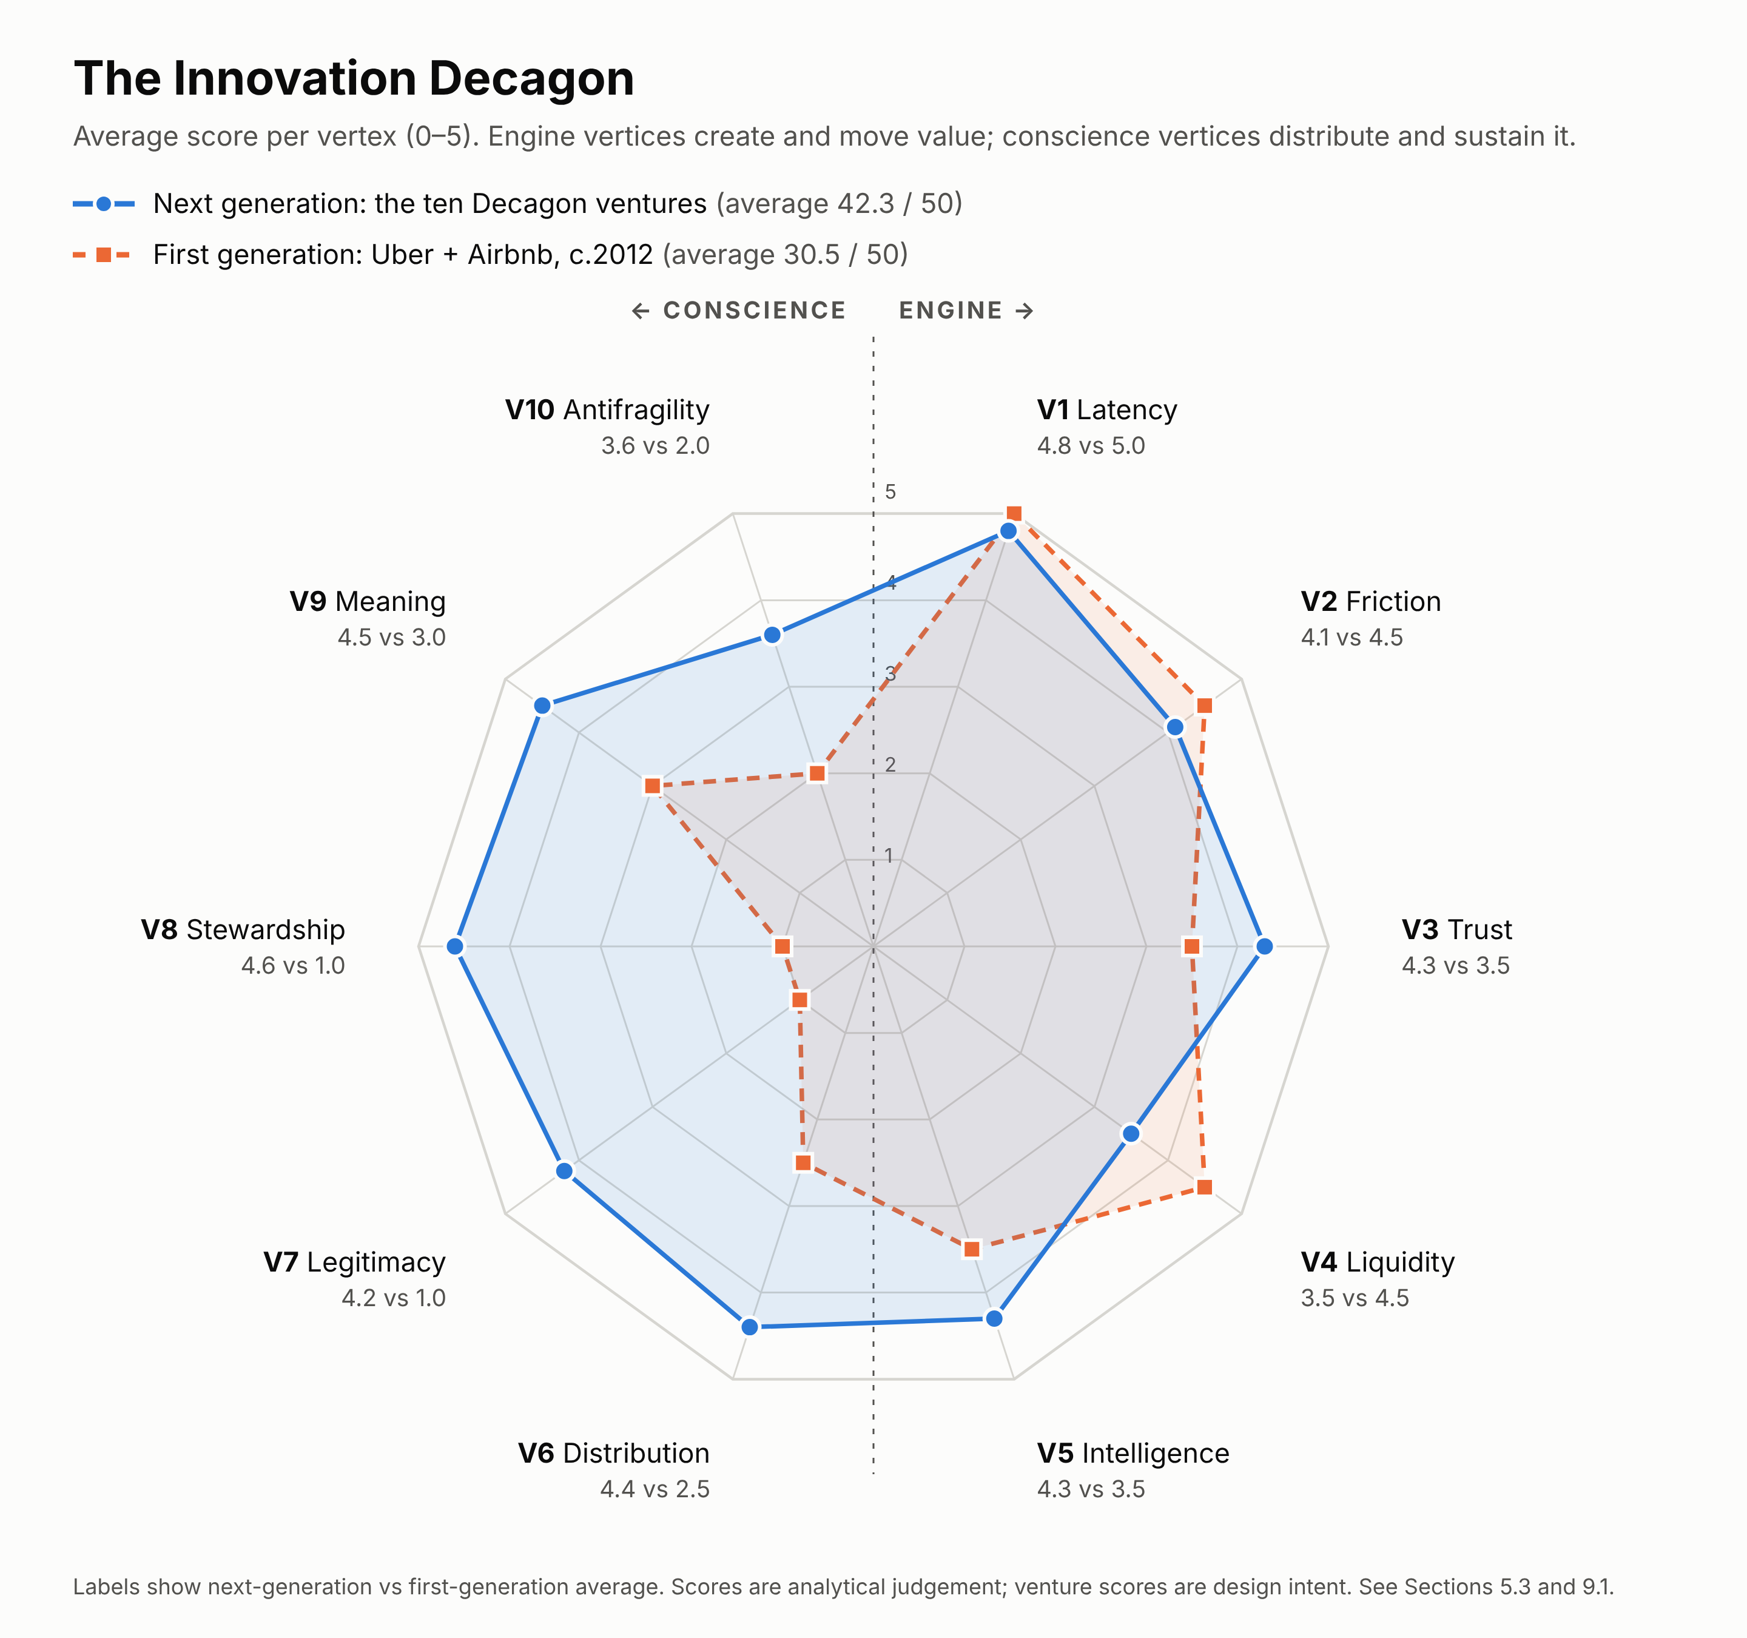
Figure 1. The ten vertices of the Innovation Decagon, scored 0–5. The first-generation profile is the average of Uber and Airbnb at launch (c. 2012). The next-generation profile is the average design-intent score of the ten ventures in Part VII. Full scores are in Sections 5.3 and 9.1.

5.2 The ten vertices

The Engine
# | Vertex | Core question | Uber benchmark | Airbnb benchmark | Typical metrics
V1 | Latency | What capacity is idle, invisible, untrusted or uncoordinated, and how much of it exists? | Cars parked ~95% of the time | Spare rooms and empty homes | Utilization gap; size of the latent pool; growth of the pool
V2 | Friction | Which transaction costs (search, trust, bargaining, contracting, enforcement, coordination) collapse, and by how much? | From phone-and-wait to one tap | From classifieds and wire transfers to instant booking | Time-to-transaction; cost-to-transact as % of value
V3 | Trust | How do strangers, and now AI agents, trust each other? Identity, reputation, guarantees, escrow, recourse? | Ratings, background checks, GPS trace | Reviews, ID verification, AirCover | Incident rate; dispute-resolution time; “trust leap” distance
V4 | Liquidity | What is the atomic network? Is the network effect local, global or clustered? When does it saturate? What is the multi-homing risk? | One city; local; saturates at short waits | One city of demand, global pull; does not saturate easily | Fill rate; time-to-match; atomic-network size; retention by cohort
V5 | Intelligence | What data and AI loops improve matching, pricing, prediction and personalization? Is the venture agent-ready (legible to AI agents)? | ETA and pricing ML | Search ranking, AI service agent | Model lift per cohort; automation rate; agent-transaction share

The Conscience
# | Vertex | Core question | Uber benchmark | Airbnb benchmark | Typical metrics
V6 | Distribution | Who captures the surplus? Do providers share in upside (equity, not only earnings)? Is the take rate legitimate? Do providers have voice? | Opaque pay; no provider voice in governance | Hosts set prices; fee controversies | Provider share of value; income stability; provider voice mechanisms
V7 | Legitimacy | Is there a licence to operate? Is the strategy co-regulation rather than arbitrage? Is data shared with public authorities? | Arbitrage first, legitimacy later | Arbitrage first; now registration-compliant in many cities | Jurisdictions with clear legal status; regulator relationship quality
V8 | Stewardship | What are the second-order effects on commons (streets, housing, grid, climate, community)? Are they modelled, measured and internalized? | Congestion, transit substitution | Housing and over-tourism | An externality ledger (e.g., housing units added or removed, emissions, congestion); Ostrom-principle coverage
V9 | Meaning | Does the venture enhance dignity, agency, belonging and accessibility for every participant, including non-users? Does it pass the veil-of-ignorance test? | Strong rider experience; weak driver dignity | Strong guest and host experience | Two-sided NPS; provider dignity index; accessibility compliance
V10 | Antifragility | Does the venture gain from shocks (pandemic, regulation, automation, AI agents)? Is it modular and optionality-rich? Has it planned for the release phase of its own model? | Delivery saved it in COVID; AV transition uncertain | Pivoted to local and long stays in COVID; agentic threat | Revenue concentration; stress-test survival; adaptation lead time

5.3 Scoring the benchmarks
Each vertex is scored 0–5 using the rubric in Appendix B, giving a maximum of 50. The scores below are the author’s analytical judgement.
Vertex | Uber c.2012 | Uber 2026 | Airbnb c.2012 | Airbnb 2026
V1 Latency | 5 | 5 | 5 | 5
V2 Friction | 5 | 5 | 4 | 4
V3 Trust | 3 | 4 | 4 | 5
V4 Liquidity | 5 | 5 | 4 | 4
V5 Intelligence | 4 | 5 | 3 | 4
Engine subtotal (/25) | 22 | 24 | 20 | 22
V6 Distribution | 2 | 2 | 3 | 3
V7 Legitimacy | 1 | 3 | 1 | 2
V8 Stewardship | 1 | 2 | 1 | 2
V9 Meaning | 2 | 3 | 4 | 4
V10 Antifragility | 2 | 4 | 2 | 4
Conscience subtotal (/25) | 8 | 14 | 11 | 15
Total (/50) | 30 | 38 | 31 | 37
The imbalanced decagon. Both companies launched with near-perfect engines (20–22 of 25) and weak consciences (8–11 of 25). Fourteen years of regulatory conflict, lawsuits and reputational crises raised their conscience scores. The improvement was forced from outside by the double movement, not designed from inside. The framework’s proposition is that designing the conscience in from day one is cheaper, faster to legitimacy and more defensible than having it imposed.

5.4 The Systemic Design Spiral: the process
The Decagon is what to design for. The Systemic Design Spiral is how. It combines design thinking (the Design Council’s Double Diamond; IDEO and Stanford d.school), Checkland’s Soft Systems Methodology, system dynamics and lean experimentation. It is a spiral rather than a line because every turn re-scores the Decagon with new evidence.
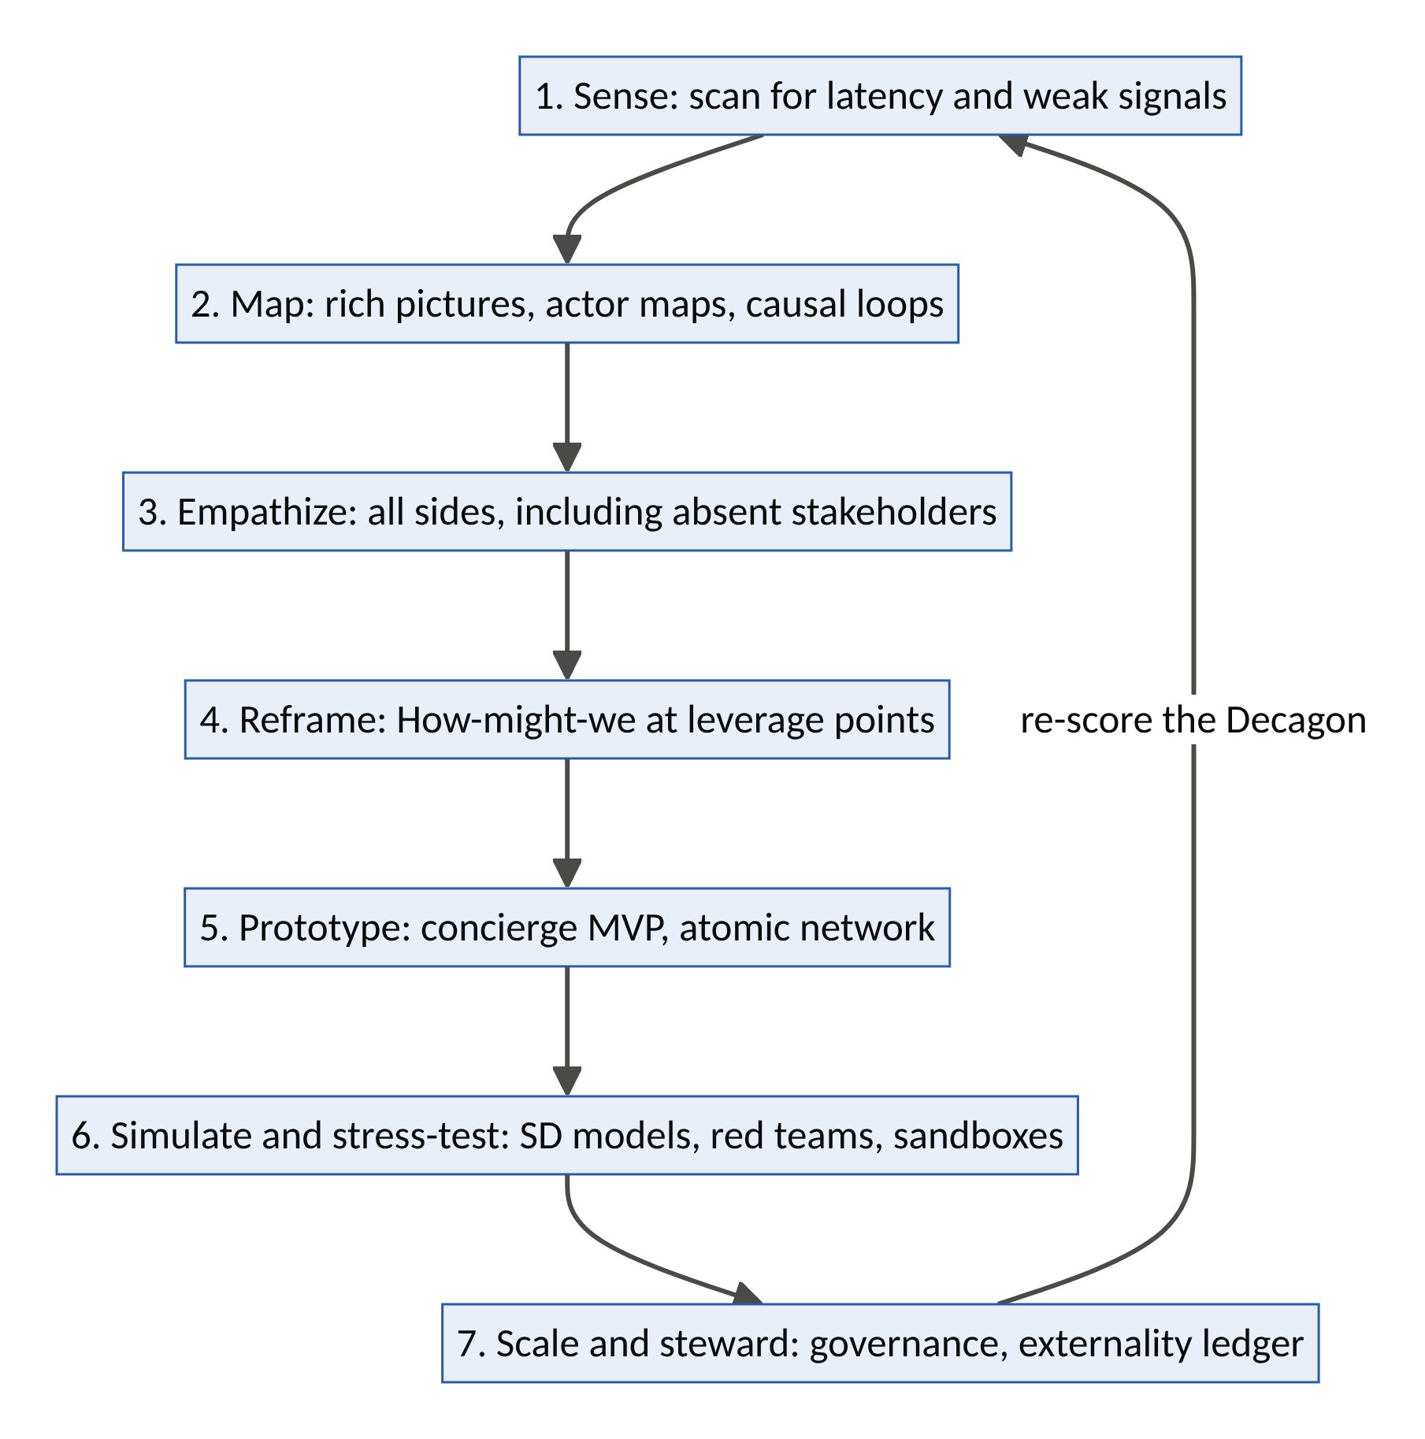
Figure 4. The Systemic Design Spiral: seven stages, re-scoring the Decagon on every turn.
Stage | Purpose | Methods and tools | Decagon vertices informed | Output
1. Sense | Find where latent capacity and unmet need are accumulating | STEEP horizon scanning; weak-signal tracking; the Latency Audit (invisible? untrusted? untransactable? uncoordinated?); Ashby variety-gap analysis | V1, V10 | A shortlist of latency pools
2. Map | Understand the system before intervening | Checkland’s rich pictures and CATWOE; stakeholder and actor maps; causal loop diagrams; the iceberg model (events → patterns → structures → mental models) | V4, V8 | System map with candidate loops and commons
3. Empathize | Understand needs, fears and dignity of every actor | Ethnography, shadowing, jobs-to-be-done interviews; absent-stakeholder interviews (neighbours, regulators, future generations, non-users); journey maps for both sides | V3, V6, V9 | Personas, journey maps, pain/gain maps
4. Reframe | Turn insight into a high-leverage opportunity | “How might we…” questions placed on Meadows’ leverage points; Christensen foothold analysis (non-consumption first); veil-of-ignorance test | V2, V7 | A reframed problem statement and value hypothesis
5. Prototype | Test the core loop at the smallest viable scale | Concierge MVP (Airbnb’s founders photographing listings by hand); Wizard-of-Oz AI (humans behind the AI); service blueprints; one atomic network | V2, V3, V4 | Evidence that one loop turns on its own
6. Simulate and stress-test | See consequences before scaling them | System dynamics models of reinforcing and balancing loops; agent-based simulation; red-teaming (fraud, abuse, prompt injection); pre-mortems; regulatory sandboxes; an externality ledger prototype | V5, V7, V8, V10 | Scaling plan with guardrails
7. Scale and steward | Grow while keeping the conscience strong | Governance design (Ostrom principles, provider councils, data trusts); public data-sharing agreements; continuous Decagon re-scoring | V6–V10 | Durable, legitimate growth

5.5 The digital and AI opportunity stack: 2008 vs 2026
Uber and Airbnb rode the 2008 stack. The next generation rides a new one. Every venture in Part VII is built on at least four of these layers.
2008 enabler | 2026 successor | What becomes possible
Smartphone | Agentic AI (large language models with tool use, memory, planning) | Agents as users: software that searches, negotiates, books and supports on behalf of people. Every marketplace gets a second kind of user.
GPS / location | Ubiquitous sensing: IoT, smart meters, EV telematics, wearables, satellites, earth observation | Physical capacity (battery charge, cold-room temperature, river level, an elder’s activity) becomes machine-readable in real time
Social login and reviews | Verifiable credentials and digital identity wallets (e.g., the EU Digital Identity Wallet under eIDAS 2.0, due to be offered by member states by end-2026) | Portable trust: credentials and reputations that travel across platforms, privacy-preserving with zero-knowledge proofs
Card and online payments | Instant and programmable money: real-time rails (UPI, Pix, mobile money), regulated stablecoins (e.g., the US GENIUS Act, 2025), agent payment protocols | Micro-settlement, automatic parametric payouts, royalties streamed per use, payments initiated by agents under signed mandates
Cloud computing | AI compute everywhere, from hyperscale to the edge, plus confidential computing | Distributed, privacy-preserving AI; compute as a flexible load on the grid
Proprietary APIs | Open protocols and digital public infrastructure (Beckn/ONDC, agent-to-agent and model-context protocols, open banking) | Interoperable networks where no single platform owns the user
Human drivers and hosts | Autonomy and robotics (AVs, drones, warehouse robots) | Labour-free supply, so capital utilization becomes the game
Spreadsheets and dashboards | Digital twins and simulation | Model a city, grid or care system before deploying into it
Cheap capital (ZIRP) | Expensive capital (higher interest rates) | Ventures must be capital-efficient, cash-generating earlier, and less dependent on subsidy wars
Recession slack | New slack: AI-displaced entry-level labour; healthy retirees; post-pandemic empty offices; midday solar surplus; idle GPUs at night; under-occupied homes | The latent pools of Part VII
The new design rule: agent-native by default. Every next-generation platform should treat AI agents as first-class users. That means machine-readable inventory, verifiable claims, programmatic negotiation within human-set mandates, and clear liability rules for agent actions. A platform that can only be used through its own app risks being left out when demand starts arriving through agents.
Digital transformation, reframed. Uber and Airbnb did not undergo digital transformation. They were born digital and forced it on taxi companies and hotels. The ventures in Part VII will likewise force transformation on insurers, care agencies, utilities, universities, housing developers and food wholesalers. For incumbents, the right response is to become a participant in the protocol before a newcomer becomes its owner.

5.6 The latency map: where market gaps are now
The table below scores twelve latency pools on four criteria (1–5):
- Severity: how serious the problem is.
- Latency: how much idle capacity exists.
- Tech readiness: how ready the enabling technology is.
- Incumbent inability: how structurally unable incumbents are to respond (low variety, asymmetric motivation).
The product is an opportunity index (maximum 625). These are judgement scores to prioritize exploration, not measurements.
Latency pool | Problem | Severity | Latency | Tech readiness | Incumbent inability | Index | Venture
Trust signals for AI agents | Agentic commerce without accountability | 5 | 4 | 4 | 5 | 400 | Covenant
Tacit expertise and consented data | AI data scarcity and consent crisis | 4 | 5 | 4 | 4 | 320 | DataGuild
Junior talent and retired experts | AI erasing the first career rung | 5 | 5 | 4 | 4 | 400 | Guildhall
Care time of the “young-old” and neighbours | Care deficit in ageing societies | 5 | 4 | 4 | 4 | 320 | KinGrid
Idle venues and evenings | Loneliness epidemic | 4 | 5 | 4 | 4 | 320 | Agora
Spare rooms, backyards, empty offices | Housing scarcity | 5 | 4 | 3 | 4 | 240 | Hearth
Drivers’ skills and community capital | Automation displacement | 4 | 4 | 3 | 4 | 192 | CommonFleet
EVs, batteries, compute heat | Grid stress from electrification and AI | 5 | 5 | 4 | 3 | 300 | FluxCommons
Backhauls, cold rooms, receipts | Food loss and climate heat stress | 5 | 4 | 4 | 4 | 320 | HarvestGrid
Community spare capacity and satellite data | Climate protection gap | 5 | 4 | 4 | 5 | 400 | Bastion
Diaspora capital and trust | Fraud in long-distance building and investing | 4 | 4 | 4 | 3 | 192 | (seed list, §9.4)
Products’ remaining useful life | Waste and repair barriers | 3 | 5 | 3 | 3 | 135 | (seed list, §9.4)

5.7 Ten design principles (the “decalogue”)
- Make latency legible, not extractable. Reveal capacity as a relationship to be honoured, not inventory to be strip-mined (Heidegger’s test).
- Price the externality at the moment of the transaction. If a booking removes a home from the housing stock, or a trip adds congestion, the price should say so.
- Share the upside, not just the wage. Give providers equity, dividends, royalties or ownership pathways, not only per-task pay.
- Design for the double movement. Build in the protections society would otherwise impose: classification clarity, data rights, caps and safety floors.
- Treat trust as infrastructure, not as a feature. Identity, reputation, guarantees and recourse are the platform; matching is a commodity.
- Build for agents and humans. Be legible to AI agents while protecting humans from manipulation by them.
- Start with an atomic network you can serve by hand. Do things that don’t scale until one loop turns on its own.
- Model the loops before you scale them. Every reinforcing loop has a balancing loop waiting; find it in simulation, not in court.
- Measure dignity. What gets measured gets designed. Measure provider dignity, belonging and agency alongside GMV.
- Keep the exits open. Data portability, interoperability and transparent rules keep the platform honest and keep enshittification in check.

Part VI: Beyond Rides and Rooms: Where the Uber and Airbnb Models Work
Uber is known for transport and Airbnb for accommodation. But neither is really “about” cars or homes. Each is a general-purpose model for turning idle or hard-to-find capacity into a service people can trust and book in seconds. This part asks where else those models work, which pain points they solve, and how to apply them. It also covers where they fail.

6.1 Two models, not one
“Uber for X” and “Airbnb for X” are often used interchangeably, but they are different machines. Choosing the wrong one is a common cause of failure.
 | The Uber model: on-demand dispatch | The Airbnb model: idle-asset marketplace
What is matched | A service performed by a person (or machine) at a time and place | An asset (space, equipment, vehicle) that sits unused
Supply | Fairly standardized: one driver is much like another | Unique: every home, venue or tool differs
How matching works | The platform assigns the nearest available provider in real time | The customer searches, compares and chooses
Who sets the price | The platform (dynamic, surge pricing) | The owner, guided by platform suggestions
What the customer values most | Speed and reliability (“a car in four minutes”) | Selection, fit and trust (“the right place for me”)
Frequency | High (daily or weekly) | Lower (occasional, larger purchases)
Key trust tools | Ratings, background checks, live tracking, insurance | Reviews, verified identity, photos, guarantees, escrow
Biggest risk | Thin margins; worker-classification disputes | Disintermediation (repeat users go direct); neighbourhood externalities
A third, hybrid pattern sits between them: the skills marketplace (e.g., TaskRabbit, Thumbtack, Upwork, Urban Company). Providers have profiles and reviews like Airbnb hosts, but the service is performed like an Uber trip, often scheduled rather than instant.

6.2 Which model fits? A decision guide
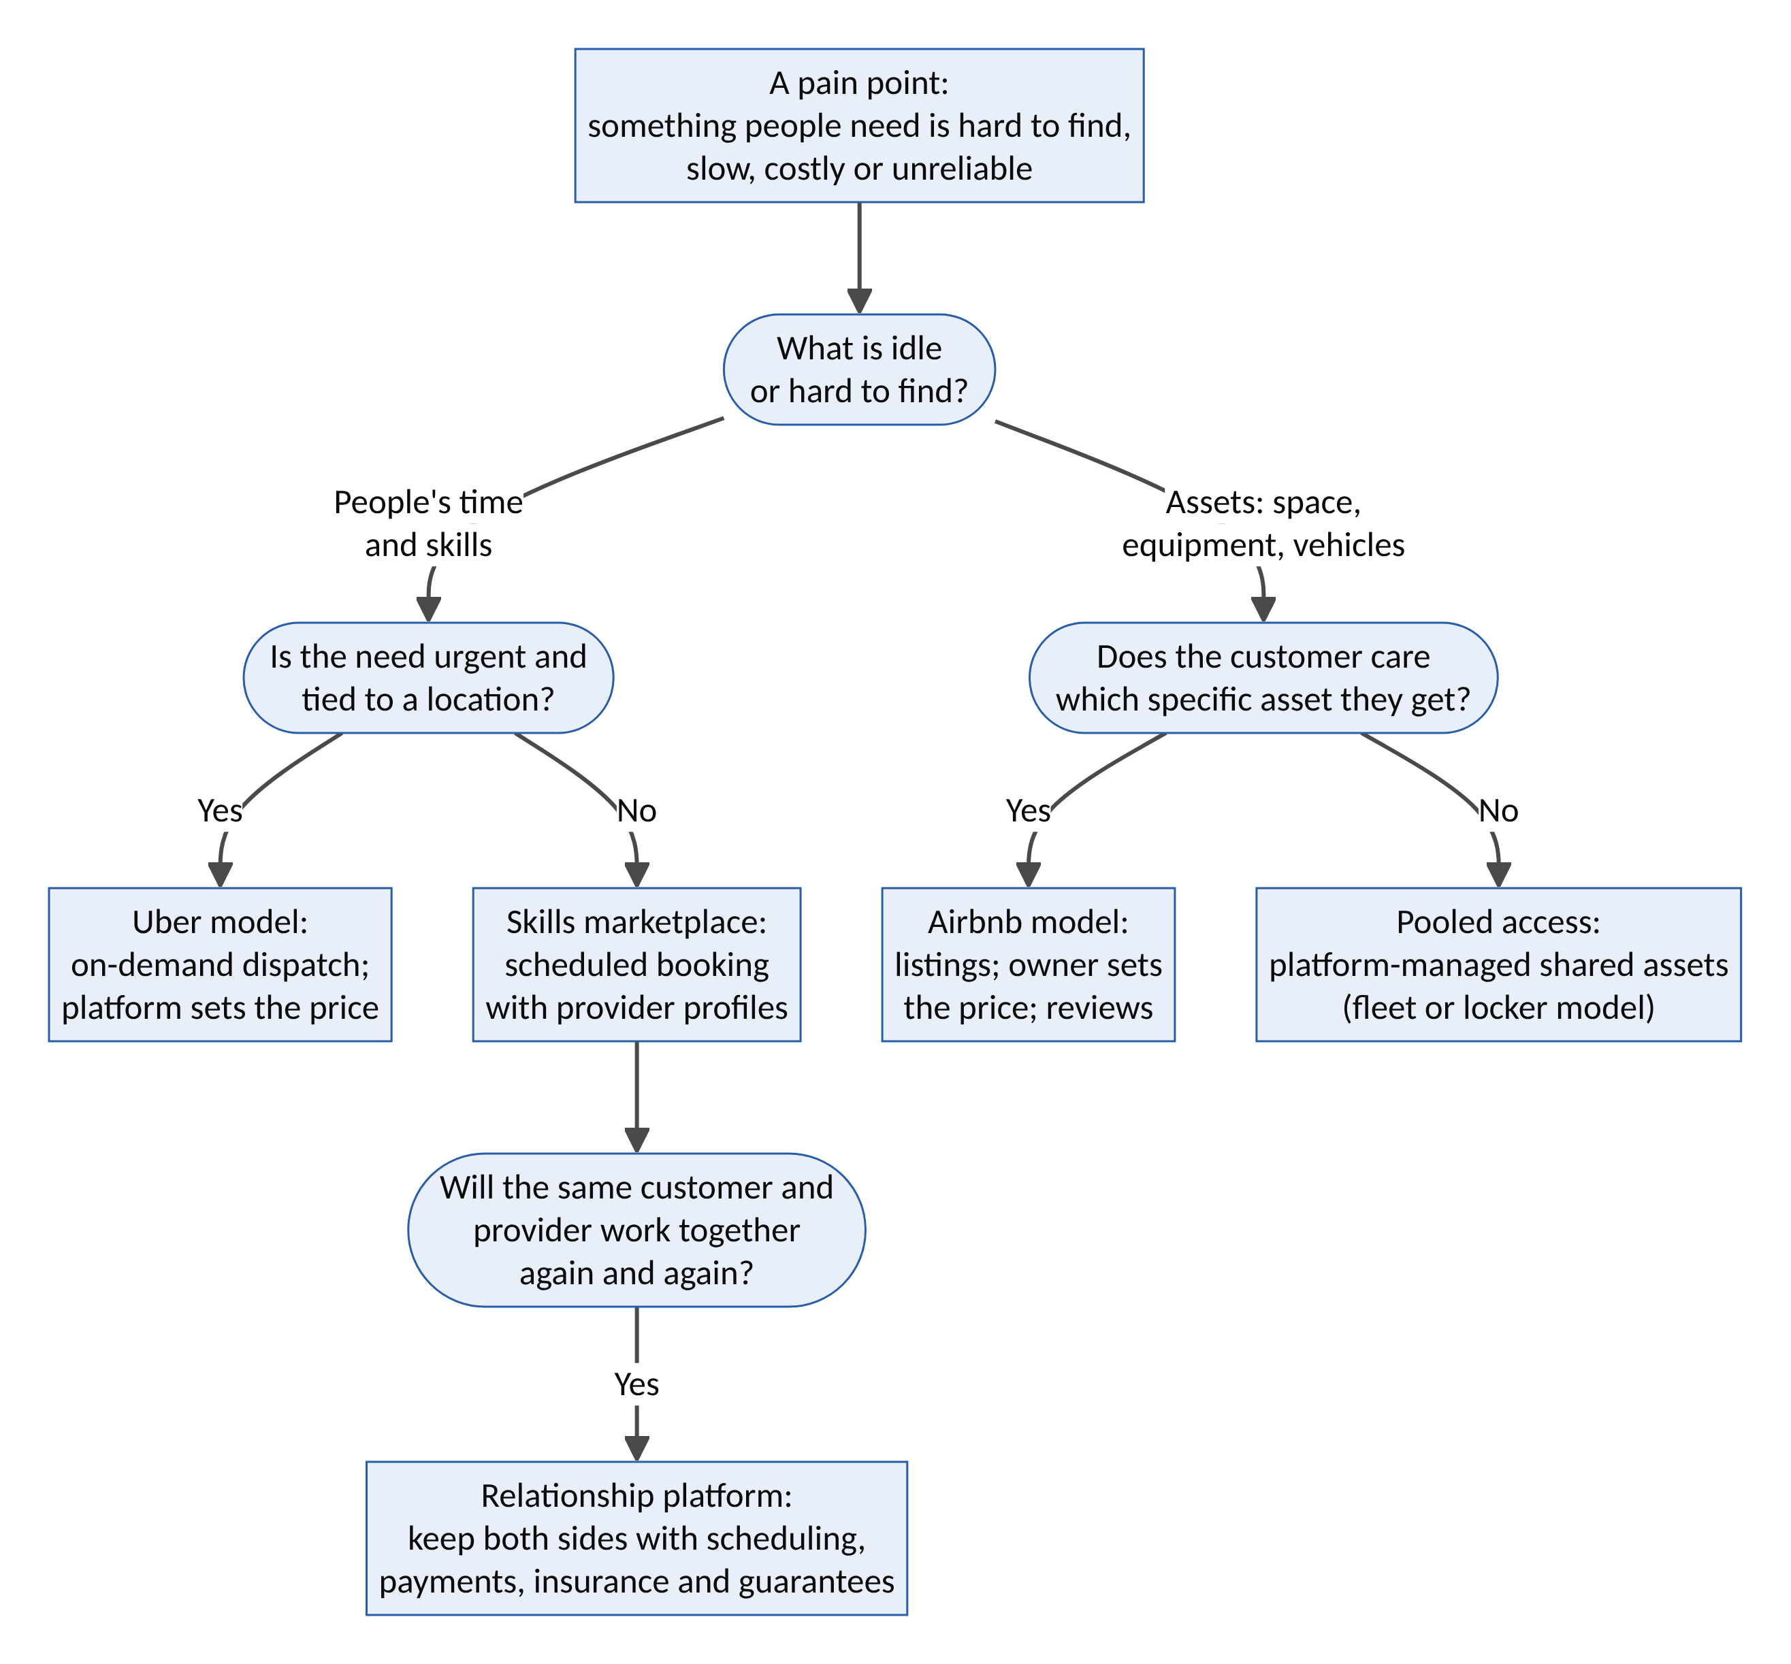
Figure 5. Choosing between the Uber model, the Airbnb model and their hybrids.
The ten-question fit test. A sector suits these models when most answers are “yes”:
- Is supply fragmented? Many small providers or owners, none dominant.
- Is there idle capacity? Time, skills or assets that sit unused for long periods.
- Is demand fragmented and recurring? Many customers with a repeated need.
- Is finding and trusting a provider the main pain, more than the price itself?
- Can quality be standardized or reliably reviewed?
- Is frequency high enough, or the ticket large enough, for the platform’s fee to cover its costs?
- Can trust be engineered through identity checks, reviews, insurance, escrow or tracking?
- Does the platform keep adding value after the first match (payments, scheduling, guarantees), so users don’t simply go direct?
- Do providers earn more, or more flexibly, than in their alternatives?
- Does regulation allow it, or can it be negotiated with regulators?

6.3 Why many “Uber for X” startups failed
Between 2012 and 2018, hundreds of startups pitched themselves as “Uber for X”. Many failed, and their failures teach as much as Uber’s success.
Startup (sector) | What happened | Lesson
Homejoy (home cleaning, US; closed 2015) | Cited worker-classification lawsuits; customers also kept the same cleaner and could book them directly | Recurring relationships leak off-platform unless the platform keeps adding value (fit-test question 8)
Washio (laundry pickup, US; closed 2016) | Low order values could not cover two trips plus the cleaning | Physical handling with small tickets rarely works (question 6)
Shyp (parcel pickup, US; closed 2018) | Expensive in-house couriers and packing; thin margins | Asset-light only works when the platform does not take on the heavy physical work
Sendy (logistics, Kenya; wound down 2023) | Ran short of funding after costly expansion, including fulfilment operations, then entered administration | Capital discipline matters; expand corridor by corridor, as in HarvestGrid
The successful applications described below share one thing: the platform removes a real pain repeatedly, and keeps earning its fee after the first match.

6.4 The application map: sixteen sectors
For each sector: the pain points, how each model applies, real examples where they exist, and the factor that decides success.

1. Logistics, freight and delivery
Pain points | Trucks return empty after deliveries; shippers can’t find reliable carriers; opaque pricing; slow payment for truckers; last-mile delivery is costly
Uber model | Load matching: shippers post loads, nearby trucks or motorbikes are dispatched; tracking, proof of delivery and fast payment for drivers
Airbnb model | Renting idle warehouse space, cold rooms and loading bays by the day
Examples | Uber Freight (US, Europe); Kobo360 (Nigeria); Lori Systems (Kenya); Trella (Egypt); Gokada, which pivoted from passenger motorbike taxis to delivery after Lagos restricted okadas in 2020
Make-or-break | Backhaul matching (filling the empty return trip) and paying truckers quickly

2. Agriculture and food production
Pain points | Smallholders can’t afford tractors or machinery; equipment sits idle most of the year; harvest losses for lack of storage; poor price information
Uber model | On-demand tractor, harvester, spraying-drone and transport services booked by phone, SMS or USSD
Airbnb model | Owners of tractors, cold rooms and storage list them for rent; farmers pay per use
Examples | Hello Tractor (founded in Nigeria in 2014, now in many countries): GPS-equipped tractors that owners rent to nearby smallholders, with booking by SMS and payment by mobile money; ColdHubs (Nigeria): pay-as-you-store solar cold rooms
Make-or-break | Pooling demand across many small farms so a machine’s route is efficient; mobile-money payment

3. Healthcare
Pain points | Long waits; clinicians and nurses in short supply in some places and under-used in others; patients missing appointments for lack of transport; emergency supplies (blood, oxygen) hard to locate
Uber model | Home visits by doctors, nurses and phlebotomists; dispatch of emergency supplies; non-emergency medical transport; nurse shift-filling apps that fill hospital gaps the same day
Airbnb model | Renting idle clinic rooms, scan slots and lab capacity to independent practitioners and patients
Examples | LifeBank (Nigeria): locates and delivers blood and oxygen to hospitals; Flare by Rescue.co (Kenya): ambulance dispatch, often described as “Uber for ambulances”; Uber Health (US): medical transport; Clipboard Health (US): nurse shift marketplace
Make-or-break | Clinical safety, licensing and liability. Trust tools must meet medical standards, not consumer standards

4. Care: elders, children and pets
Pain points | Families can’t find trustworthy carers; care is expensive; older people are isolated; parents need flexible childcare; pet owners travel
Uber model | On-demand companionship visits, errands and respite care
Airbnb model | Carers and sitters with detailed profiles, reviews and verified background checks; families choose
Examples | Care.com (childcare, eldercare); Papa (US): companionship visits for older adults; Rover (pet sitting, often called “Airbnb for dogs”)
Make-or-break | Safeguarding: background checks, two-way reviews, insurance and incident escalation. This is where Venture 4 (KinGrid) extends the model

5. Home services and skilled trades
Pain points | Finding a plumber, electrician, mechanic or cleaner who is competent, honest and on time; no price transparency; poor-quality work with no recourse
Uber model | Instant dispatch for urgent jobs (burst pipe, lock-out, generator failure)
Airbnb / skills-marketplace model | Verified artisans with portfolios, reviews and fixed-price menus; scheduled jobs
Examples | Urban Company (India and other markets): standardized home and beauty services with trained professionals; it listed in India in 2025 and reported an average of about 54,000 monthly active service professionals in mid-2025. TaskRabbit and Thumbtack (US)
Make-or-break | Standardizing quality (training, tools, fixed prices) and a guarantee that work is redone if poor. Urban Company’s success came from standardization, not just matching

6. Education, tutoring and skills
Pain points | Good tutors are hard to find and expensive; schools and classrooms are empty in evenings and holidays; young people lack practical experience
Uber model | On-demand homework help and tutoring sessions, online or in person
Airbnb model | Teachers and experts list courses; schools rent idle classrooms and labs; skill “experiences” taught by craftspeople
Examples | Preply (online tutoring marketplace); Outschool (online classes); Airbnb Experiences (skills and crafts)
Make-or-break | Verified outcomes, not just ratings. Venture 3 (Guildhall) extends this into paid apprenticeships

7. Energy and water
Pain points | Unreliable grid power and costly generators; solar and batteries too expensive to buy outright; water shortages; EV charging gaps
Uber model | On-demand fuel, gas-cylinder or water-tanker delivery with transparent prices; mobile battery delivery
Airbnb model | Homeowners rent their EV chargers; neighbours share batteries and solar on mini-grids; households sell flexibility to the grid
Examples | Pay-as-you-go solar companies (e.g., M-KOPA, Lumos, d.light) apply the “access over ownership” principle; virtual power plants aggregate home batteries
Make-or-break | Metering and safety standards; regulatory permission to sell energy. Venture 8 (FluxCommons) extends this

8. Space: storage, parking, offices, kitchens and venues
Pain points | Storage and parking are scarce and costly; offices and halls sit empty much of the week; food entrepreneurs can’t afford their own kitchens
Uber model | Rarely the right fit, since space is not dispatched
Airbnb model | Spare rooms, garages and driveways listed for storage or parking; idle offices, meeting rooms and halls rented by the hour; commercial kitchens shared between food businesses
Examples | Neighbor (US) and Stashbee (UK): storage; JustPark (UK) and SpotHero (US): parking; Peerspace: venues and meeting space
Make-or-break | Insurance and access control (smart locks, verified renters)

9. Equipment, vehicles and goods rental
Pain points | Expensive items (cars, cameras, tools, generators, construction equipment, formal clothes) are used rarely but must be bought
Uber model | Delivery and pickup of the rented item
Airbnb model | Owners list items; renters book by the day; deposits and insurance protect owners
Examples | Turo and Getaround (peer-to-peer car rental, “Airbnb for cars”); Fat Llama (peer-to-peer rentals); Outdoorsy (campervans); Rent the Runway (clothing)
Make-or-break | Damage protection and identity verification; the item must be valuable enough to justify the logistics

10. Work and professional talent
Pain points | Businesses need short-term staff or specialist skills quickly; workers want flexible income; hiring is slow and costly
Uber model | Same-day shift filling for hospitality, warehouses and events
Airbnb / skills-marketplace model | Freelancers with portfolios and reviews hired by the project
Examples | Instawork (shifts); Upwork and Fiverr (freelance projects); Uber AI Solutions (AI data work)
Make-or-break | Fair pay and classification; portable benefits. The Polanyi double movement applies directly here

11. Finance and insurance
Pain points | Small businesses and individuals can’t get affordable credit or insurance; savings earn little; informal savings groups lack records and protection
Uber model | Not a natural fit
Airbnb model | Idle capital matched with borrowers (peer-to-peer lending, crowdfunded microloans); digitized rotating savings groups (ajo, esusu); peer-to-peer and mutual insurance pools
Examples | Kiva (crowdfunded microloans)
Make-or-break | Licensing and consumer protection. Finance is heavily regulated, so platforms usually partner with licensed institutions. Venture 10 (Bastion) applies this to climate insurance

12. Food beyond restaurants
Pain points | Good home cooks have no route to market; restaurants and bakeries throw away surplus food; travellers want authentic local meals
Uber model | Delivery of home-cooked and surplus meals
Airbnb model | Home cooks list meals or dinners in their homes; shops list end-of-day surplus at a discount
Examples | Too Good To Go (surplus food); Shef (home cooks, US); EatWith (dinners in hosts’ homes)
Make-or-break | Food-safety certification and kitchen inspection

13. Emergency and public services
Pain points | Slow ambulance response; irregular waste collection; poor public transport outside main routes
Uber model | Dispatching the nearest available ambulance, including private ones; on-demand waste pickup; on-demand minibuses that pool riders on flexible routes (microtransit)
Airbnb model | Registries of private assets (boats, trucks, generators, rooms) pledged for use in emergencies
Examples | Flare by Rescue.co (Kenya): ambulances; Wecyclers (Lagos): household recycling collection; Via: microtransit for cities
Make-or-break | Partnership with government. These services are public goods, so the platform must work with the state, not around it

14. Circular economy: repair, resale and recycling
Pain points | Products are thrown away while still repairable; second-hand selling is slow and untrusted; recyclables are not collected
Uber model | On-demand repair technicians and recyclable pickup
Airbnb model | Peer-to-peer resale marketplaces with buyer protection; repair cafés and workshop space
Examples | Vinted (second-hand clothing); Wecyclers (recycling)
Make-or-break | Buyer protection and logistics cost per item

15. Beauty, wellness and fitness
Pain points | Salons are busy at peak times; mobile beauticians and trainers struggle to find clients; gyms are empty at off-peak hours
Uber model | At-home beauty, massage and personal training
Airbnb model | Gyms and studios sell their empty class slots
Examples | Urban Company (beauty at home); ClassPass (spare class capacity at gyms and studios)
Make-or-break | Hygiene standards, provider safety and quality consistency

16. Construction and property
Pain points | Finding reliable builders and artisans; cost overruns and fraud, especially for diaspora families building at home; costly equipment
Uber model | On-demand verified artisans and equipment with operators
Airbnb model | Contractors and equipment with portfolios and reviews; escrowed payment released at each verified building stage
Examples | This is a large gap. The BuildBridge seed (Section 9.4) and Venture 6 (Hearth) are designed for it
Make-or-break | Verified milestones (photos, drone footage, independent inspection) before each payment

6.5 The African and Nigerian lens
Many of the strongest applications are in African cities, where infrastructure gaps create both severe pain and large amounts of informal, fragmented supply. That is the classic setting for these models.
Pain point | Platform response | Local design requirements | Examples
Unreliable power | Battery and solar sharing; generator and inverter rental; pay-as-you-go solar | Pay-as-you-go pricing; local technicians | Pay-as-you-go solar companies
Water scarcity | Water-tanker dispatch with transparent prices and quality testing | Cash and mobile money; water-quality verification | Tanker-dispatch apps in several cities
Informal transport | Booking, safety and fair pricing for okadas, kekes and danfos | Regulatory volatility (bans on okadas in parts of Lagos); rider safety training | Gokada (pivoted to delivery); SafeBoda (Uganda)
Untrusted artisans | Verified artisans with guarantees | Community vouching; training and certification | Urban Company-style standardization is an open opportunity
Healthcare access | Emergency supply delivery; ambulance dispatch; home visits | Integration with hospitals; cold chain | LifeBank (Nigeria); Flare (Kenya)
Farm mechanization and storage | Tractor sharing; pay-as-you-store cold rooms | Booking by SMS or USSD; mobile money | Hello Tractor; ColdHubs
Freight | Load matching and backhaul | Fast payment to truckers; route security | Kobo360; Lori Systems
Land and building fraud | Verified building and land records; escrowed stage payments | Diaspora access; satellite and drone verification | An open gap (BuildBridge seed)
Design rules for African markets
- Work offline and on any phone. USSD, SMS and voice in local languages, not just smartphone apps.
- Accept every way of paying. Cash, bank transfer, cards and mobile money.
- Use agent networks. Trusted local agents onboard users who are not yet digital.
- Build trust through community. Vouching, cooperatives and local leaders complement ratings.
- Design for regulatory volatility. Rules can change quickly (as the Lagos okada restrictions showed), so keep the business able to pivot.
- Manage currency risk. Earn in local currency and avoid dollar-denominated costs where possible.
- Assume weak infrastructure. Plan for power cuts, poor roads and patchy connectivity.

6.6 Where these models do not work
The models are powerful but not universal. They tend to fail when:
- The relationship is the product. Long-term therapy, family doctors and trusted advisers depend on continuity; a marketplace that keeps rematching adds little.
- The stakes need deep accountability. Surgery, structural engineering and childcare in the home require licensing and supervision far beyond star ratings.
- The margin cannot carry the logistics. Low-value items that need two trips (the Washio lesson).
- Customers will go direct. If the first match is all the value, repeat users leave (the Homejoy lesson).
- The capacity is not really idle. If “spare” supply is actually taken from someone else, such as homes taken from residents, the externality returns as regulation (the Airbnb housing lesson in Part II).
- The service is a public good. Emergency response, water and public transport need government partnership, not regulatory arbitrage.

6.7 Prioritizing the opportunities
The table rates sixteen applications on four criteria (1–5) and adds them up (maximum 20):
- Pain: how severe the problem is.
- Idle supply: how much unused capacity exists.
- Frequency: how often people need the service, or how valuable each transaction is.
- Ease of trust: how easy it is to engineer trust (5 = easy).
These are analytical judgements to guide exploration, especially for African and other emerging markets.
Application | Model | Pain | Idle supply | Frequency | Ease of trust | Total
Freight load matching and backhaul | Uber | 5 | 5 | 5 | 3 | 18
Shift work and freelancing | Uber / skills | 4 | 5 | 5 | 4 | 18
Verified artisans and home repairs | Skills marketplace | 5 | 5 | 4 | 3 | 17
Tractor and farm-equipment sharing | Airbnb / Uber | 5 | 5 | 3 | 4 | 17
Cold storage by the day | Airbnb | 5 | 4 | 4 | 4 | 17
Tutoring and skills | Skills marketplace | 4 | 5 | 4 | 4 | 17
Solar, battery and energy sharing | Airbnb | 5 | 4 | 4 | 3 | 16
Water-tanker dispatch | Uber | 5 | 3 | 5 | 3 | 16
Waste and recycling pickup | Uber | 4 | 4 | 4 | 4 | 16
Elder companionship and care | Skills marketplace | 5 | 4 | 4 | 2 | 15
Storage and parking | Airbnb | 3 | 5 | 3 | 4 | 15
Emergency supplies and ambulances | Uber | 5 | 3 | 3 | 3 | 14
Equipment and vehicle rental | Airbnb | 3 | 5 | 3 | 3 | 14
Surplus and home-cooked food | Airbnb | 3 | 4 | 4 | 3 | 14
Home healthcare visits | Uber | 4 | 3 | 3 | 2 | 12
Verified diaspora building | Airbnb / escrow | 5 | 3 | 2 | 2 | 12
Reading the table. The highest totals combine severe pain, abundant idle supply and high frequency: freight, shift work, artisans, tractors, cold storage and tutoring. Lower totals are not bad opportunities. Healthcare and diaspora building score lower mainly because trust is hard, which also means a venture that solves trust there builds a strong moat.

6.8 From any pain point to a platform: an eight-step playbook
- Find the friction. Observe where people wait, search, overpay or are let down. Write the pain in the customer’s own words.
- Find the idle supply. List who or what could solve it but sits unused: people’s hours, skills, rooms, machines, vehicles, capital.
- Choose the model. Use the decision guide in Section 6.2: on-demand dispatch, idle-asset marketplace, skills marketplace or pooled access.
- Engineer trust first. Identity checks, reviews, guarantees, escrow and insurance, designed before launch.
- Seed one atomic network by hand. One neighbourhood, one corridor or one trade. Serve it manually until the loop works (Airbnb’s founders photographed listings themselves).
- Price for both sides. Make sure providers earn more than in their alternatives, and keep the fee justified by ongoing value so neither side goes direct.
- Design the conscience in. Score the idea on the Innovation Decagon (Part V), especially distribution, legitimacy and externalities.
- Expand to adjacent services. Once trusted, add neighbouring services for the same users, as Uber added food and freight and Airbnb added experiences and services.
The principle in one sentence: Wherever something valuable sits idle while someone else urgently needs it, and trust is the missing link, the Uber or Airbnb model can work. Design the trust and the fairness first, and the market follows.

Part VII: The Decagon of Ventures
Ten disruptive startup concepts, each designed with the Innovation Decagon. They are arranged in four layers, from the most abstract (trust and intelligence) to the most physical (planetary resilience):
Layer | Ventures | What is latent
A. Trust and intelligence | 1 Covenant · 2 DataGuild | Trust signals, knowledge, data
B. Human capacity | 3 Guildhall · 4 KinGrid · 5 Agora | Time, skill, care, companionship
C. Physical capacity | 6 Hearth · 7 CommonFleet · 8 FluxCommons | Space, vehicles, energy, compute
D. Planetary resilience | 9 HarvestGrid · 10 Bastion | Food systems, community resilience
Every venture follows the same template: thesis → new problem → latent capacity → inherited DNA and inversion → mechanism → digital and AI stack → system dynamics → design thinking → business model → disruption logic → risks → first 100 days → Decagon score. Scores are design-intent scores (what the concept is designed to achieve), not achieved results. They should be discounted for execution risk.

Layer A: Trust and Intelligence

Venture 1: COVENANT, the trust, identity and liability layer for AI agents
Thesis. As AI agents begin to shop, book, negotiate and pay on our behalf, the economy needs for machines what Uber’s ratings and Airbnb’s AirCover gave strangers: identity, authority, reputation, guarantees and recourse. Covenant is “Know Your Agent” infrastructure, a neutral trust network that lets any merchant say yes to a stranger’s AI agent in milliseconds.
Layer | Foothold | Inherits from | Inverts
A: Trust | New-market (no agent-trust market exists yet) | Uber ratings; Airbnb guarantees and escrow | Trust locked inside one platform → portable, cross-platform trust for non-human actors
The new problem (why now)
- Agentic commerce is arriving. In 2025 major AI and payments firms launched agent checkout and payment protocols (for example, OpenAI and Stripe’s Agentic Commerce Protocol, Google’s Agent Payments Protocol, and card-network agent programmes).
- Automated traffic already exceeds human traffic on the web. Imperva’s 2025 Bad Bot Report estimated 51% of web traffic in 2024 was automated, much of it malicious. Merchants cannot tell a legitimate shopping agent from a scraper, a fraud bot or a hijacked agent.
- Liability is undefined. If an agent books the wrong non-refundable flight, or a prompt-injection attack makes it overspend, who pays: the user, the agent developer, the model provider or the merchant?
- Mandates are unverifiable. A merchant cannot check that “this agent is allowed to spend up to €300 on refundable hotels in Lisbon for Mrs Okafor”.
The latent capacity. Trust signals already exist but are scattered: identity verification (banks, telcos, governments, platforms), payment histories, review records, and insurers’ risk-pricing capacity. Insurers are willing to underwrite agent risk but have no data. Covenant compiles this scattered trust into a portable, machine-readable form.
How it works
- Agent passport. Each agent gets a cryptographic identity bound to a verified principal (person or organization) through verifiable credentials. It declares its operator, model provenance and capabilities.
- Signed mandates. The human principal issues scoped, time-limited, revocable permissions, e.g. “spend ≤ $300, refundable only, these categories”. Merchants verify them automatically.
- Behavioural reputation. Cross-platform reliability scores record mandate compliance, dispute rates and resistance to adversarial tests. Covenant runs continuous red-team probes against certified agents.
- Guarantees and liability cover. Certified agents are bonded. Covenant and insurer partners underwrite an “agent errors and omissions” cover, the AirCover of agents. Disputes are resolved AI-first, with human appeal.
- Merchant gateway. One API call returns verified principal? valid mandate? risk score? guaranteed? in milliseconds. Merchants display “Agent-ready” status and accept agent traffic without CAPTCHAs.
- Neutral governance. A member-owned foundation sets the rules and a company operates the network, the way Visa began as a member-owned association. Merchants, agent developers, consumer advocates and insurers sit on the governing council.
Digital and AI stack. W3C verifiable credentials and decentralized identifiers; passkeys; zero-knowledge proofs (prove “authorized adult with valid mandate” without revealing identity); interoperability with agent protocols (model-context, agent-to-agent and agent-payment standards); anomaly detection; automated red-team harnesses; insurance pricing models.
System dynamics
- R1, the acceptance loop: more merchants accept Covenant → agents need passports to transact → more agent data → better risk scores → lower guarantee premiums → more merchants accept.
- R2, the underwriting learning loop: more claims data → more accurate pricing → cheaper cover → more certified agents.
- B1, adversarial adaptation (Goodhart’s law): as scores matter, attackers game them → scores degrade → continuous red-teaming and decaying, behaviour-based scores are required.
- B2, platform enclosure: large AI firms may build closed trust systems for their own agents → neutral governance and interoperability are the counter-strategy.
- Leverage point: rank 6 (information flows) and rank 5 (rules). Covenant writes the rules of agent commerce.
Design thinking
- Personas: Amaka, owner of a 20-room boutique hotel in Lagos whose booking engine is overwhelmed by bot traffic. Daniel, 72, whose daughter set up an agent to pay his bills and who fears being scammed. Priya, a developer building a travel agent who cannot get merchants to accept it.
- How might we let a merchant safely say yes to a stranger’s robot in 50 milliseconds?
- Moment of truth: the first time an agent makes a mistake and the user is made whole within hours.
Business model. Per-verification micro-fees (fractions of a cent, at very high volume); share of guarantee premiums; certification fees for agent developers; enterprise subscriptions for merchants and banks.
Who is forced to transform. Fraud-prevention vendors, card-network dispute systems, identity-verification providers and CAPTCHA-style bot defences.
Risk | Safeguard
Standards war, with large firms building rival systems | Open standards; neutral foundation; interoperability with every major protocol
Surveillance: tracking every agent action | Privacy by design; zero-knowledge proofs; data minimization; independent audits
Exclusion of people without formal ID | Multiple identity routes (community vouching, telco, bank)
Regulatory overlap (e.g., EU AI Act transparency duties, payments regulation) | Co-design with regulators; sandbox participation
First 100 days. Choose one vertical: agent-made bookings for independent hotels and short-term rentals, where no-shows and fraud are costly. Issue mandates and guarantees for the first 1,000 agent bookings and review each one manually (concierge MVP). Sign one insurer partner and three agent developers.
Decagon score: 41/50. V1 4 · V2 5 · V3 5 · V4 3 · V5 5 · V6 4 · V7 4 · V8 4 · V9 3 · V10 4

Venture 2: DATAGUILD, a cooperative that licenses human knowledge to AI on fair terms
Thesis. Uber unlocked idle cars. DataGuild unlocks idle knowledge: the tacit expertise, consented data and under-represented languages of professionals and communities. It licenses them to AI developers and returns ownership and royalties, not just piece-rate gig pay, to the people who teach the machines.
Layer | Foothold | Inherits from | Inverts
A: Intelligence | New-market (under-represented languages and domains); low-end vs. labelling vendors | Uber’s on-demand task matching (including Uber AI Solutions); Airbnb hosts monetizing what they own | Contributors as disposable labour → contributors as member-owners earning recurring royalties
The new problem (why now)
- The data wall. Researchers (e.g., Epoch AI) estimate that the stock of high-quality public human text could be largely used up by AI training between roughly 2026 and 2032. Further gains increasingly depend on expert, curated, consented data and on expert evaluation.
- Model collapse. Training on AI-generated data degrades models over generations (Shumailov et al., Nature, 2024). That makes verified human data more valuable, not less.
- The consent crisis. Litigation over unconsented training (e.g., New York Times v. OpenAI; the US$1.5bn Bartz v. Anthropic class settlement in 2025) shows the legal and moral cost of the extract-first model.
- Linguistic exclusion. Thousands of languages, including many of Africa’s 2,000+, are barely represented in AI systems. Their speakers will be underserved by AI unless their data is contributed on fair terms.
The latent capacity. Professionals’ tacit knowledge (nurses, midwives, engineers, farmers, artisans, lawyers); retirees’ decades of expertise; speakers of under-represented languages; personal data sitting unused in silos (health records, transaction histories), which individuals have rights to but no way to pool.
How it works
- Guilds. Members join domain guilds (e.g., Clinical Practice, African Agriculture, Yorùbá–Hausa–Igbo Language, Construction Trades), each with an elected council.
- Contribution modes. Members contribute in three ways: tasks (evaluating model outputs, writing expert demonstrations, red-teaming); datasets (consented records from personal data stores); and knowledge interviews (an AI interviewer draws out tacit know-how, which the member reviews and approves).
- The data trust. A legal trust with fiduciary duty to members holds the licensing rights. Licences are use-limited, auditable and time-bound, with no outright sale.
- Compute-to-data. Where possible, buyers’ models train on the data inside secure enclaves, so raw data never leaves the trust.
- Provenance and valuation. Every contribution is fingerprinted. Royalties are distributed by contribution value, estimated with data-valuation methods (e.g., Shapley-style approximations) and peer-reviewed quality scores.
- Governance. One member, one vote on licensing policy (Ostrom’s principle of participation). Guild councils can veto uses that conflict with members’ values.
Digital and AI stack. Personal data stores; federated learning; differential privacy; confidential computing; AI interviewers for knowledge capture; automated quality assurance plus peer review; data-provenance standards; royalty ledgers paid through instant payment rails.
System dynamics
- R1, the quality loop: better experts → higher-value licences → higher royalties → more and better experts join.
- R2, the bargaining-power loop: more members → stronger collective bargaining → better terms → more members (the union dynamic applied to data).
- B1, synthetic substitution: better synthetic data → lower demand for human data. This is weakened by model collapse and by the need for human evaluation.
- B2, quality dilution: rapid growth → low-quality contributions → buyer distrust → peer review and reputation tiers required.
- Leverage point: rank 5 (rules: property and consent rights over data) and rank 4 (self-organization).
Design thinking
- Personas: Mama Funmilayo, a retired midwife in Ibadan with 35 years of tacit knowledge of obstetric emergencies. Dr Priya, a radiologist who wants to improve AI diagnostics without giving away her life’s work. Kofi, a Twi-speaking student who notices that voice assistants don’t understand him.
- How might expertise earn like an asset rather than a shift?
- Moment of truth: the first royalty payment that arrives months after the work, because a model is still using it.
Business model. A modest platform fee (target 10–15% of licence revenue, well below typical gig take rates); enterprise licensing contracts; expert evaluation-as-a-service for AI safety testing; government contracts for public-interest language datasets.
Who is forced to transform. Data-labelling vendors, data brokers, and AI developers’ data-acquisition practices.
Risk | Safeguard
Privacy breach | Compute-to-data; differential privacy; no raw-data export; independent audits
Buyer monopsony (few large AI buyers) | Diversify to enterprises, governments and research; collective bargaining
Valuation disputes | Transparent formulas; member-elected valuation committee; appeal process
Legal uncertainty on training rights | Explicit licences that hold up under any copyright outcome
First 100 days. Launch one guild, a West African Languages and Agriculture Guild: 500 speakers and farmers produce evaluation and instruction datasets in Yorùbá, Hausa and Igbo. Sign licences with three buyers, pay the first royalties within the quarter, and publish the full royalty formula.
Decagon score: 41/50. V1 5 · V2 4 · V3 4 · V4 3 · V5 5 · V6 5 · V7 4 · V8 4 · V9 4 · V10 3

Layer B: Human Capacity

Venture 3: GUILDHALL, apprenticeships-as-a-service to rebuild the first rung
Thesis. AI is automating the entry-level tasks through which juniors traditionally learned their professions. Guildhall turns the unmet needs of small businesses into paid, mentored, AI-augmented apprenticeship projects: “Airbnb for experience”, where the product is not completed tasks but growing capability.
Layer | Foothold | Inherits from | Inverts
B: Human capacity | New-market (SMEs that never hire consultants); low-end vs. agencies | Uber’s task dispatch; Airbnb Experiences (hosts teaching skills); two-way reputation | Workers as interchangeable task-completers → apprentices as appreciating assets with portable, verified portfolios
The new problem (why now)
- The broken first rung. Early evidence suggests AI is reducing entry-level hiring in exposed occupations. A 2025 Stanford Digital Economy Lab study (Brynjolfsson, Chandar and Chen) found a relative employment decline of about 13% for 22–25-year-olds in the most AI-exposed jobs since late 2022.
- The apprenticeship paradox. If juniors cannot get junior jobs, where will tomorrow’s seniors come from? The career ladder is losing its bottom rungs.
- Youth bulge. Africa has the world’s youngest population, and youth unemployment and under-employment are among the region’s defining challenges. Globally, roughly one in five young people is not in employment, education or training (ILO).
- SME digital deficit. Millions of small businesses need websites, digital operations, data and AI adoption but cannot afford consultancies.
- Expertise retirement. Retiring baby-boomer professionals take tacit knowledge with them.
The latent capacity. Juniors’ time and energy; retired and semi-retired experts’ mentoring capacity; SMEs’ backlog of unmet projects; and AI copilots that let a supervised junior work like a mid-level professional.
How it works
- Problems, not tasks. SMEs post business problems (“we need online ordering and inventory tracking”). An AI scoping agent turns them into a project brief with deliverables, budget, and learning objectives.
- Pods. Each project gets a pod of 3–4 apprentices, 1 paid mentor (often a retired or semi-retired professional) and AI copilots.
- Learning sprints. Work proceeds in structured sprints. An AI tutor gives instant feedback; the mentor reviews quality and coaches judgement.
- Proof of work. Completed projects become verifiable credentials: client-validated, mentor-attested portfolios mapped to skills frameworks such as ESCO and O*NET.
- Earnings and ownership. Apprentices earn stipends; mentors earn fees; SMEs pay below agency rates. Pods that win ongoing maintenance contracts share them, a small “guild equity”.
- Graduation. Apprentices graduate into employment (placement fees), freelancing or new pods, and later become mentors themselves.
Digital and AI stack. AI scoping and estimation agents; AI tutors; a skills graph; verifiable credentials; project management with learning analytics; work-sample assessment models; matching of apprentices, mentors and projects.
System dynamics
- R1, the reputation loop: successful projects → SME referrals → more projects → more apprentices trained → stronger pods.
- R2, the alumni loop: graduates become mentors and employers → more capacity and demand.
- B1, the quality risk: junior errors → SME dissatisfaction → fewer projects. Mentor ratios and staged responsibility contain it.
- B2, the exploitation drift: SMEs may treat pods as cheap labour (Eroding Goals). Hard-coded learning ratios and wage floors are the safeguard.
- Leverage point: rank 3 (goals). It redefines the purpose of junior work from output to learning, the original purpose of apprenticeship.
Design thinking
- Personas: Tunde, 23, a graduate in Lagos with 140 applications and no offers. Margaret, 66, a retired CFO in Manchester who misses meaningful work. Chidi, owner of a three-branch pharmacy who needs digital inventory.
- How might a first job be replaced by a first portfolio of real outcomes?
- Moment of truth: Tunde’s credential gets him hired, and the employer can see exactly what he built.
Business model. Project fees from SMEs (about a 20% platform share, split with mentors); employer placement fees; outcome-based contracts with workforce funds and training levies (e.g., apprenticeship or industrial-training levies); corporate “talent pipeline” subscriptions.
Who is forced to transform. Universities and bootcamps (credential monopoly), staffing agencies, small consultancies and corporate graduate programmes.
Risk | Safeguard
Exploitation of apprentices | Wage floors; learning-time ratios; apprentice council with veto rights
Poor project quality | Mentor sign-off; staged responsibility; satisfaction guarantee
Credential inflation | Credentials tied to verified client outcomes, not course completion
Legal status of apprentices | Work with apprenticeship regulators; formal trainee contracts
First 100 days. Ten pods in one city (e.g., Lagos or Manchester), in one domain (AI-enabled digital operations for SMEs), on 12-week cycles. Measure SME satisfaction, apprentice skill gain and placement within 90 days.
Decagon score: 41/50. V1 5 · V2 4 · V3 4 · V4 3 · V5 4 · V6 4 · V7 4 · V8 4 · V9 5 · V10 4

Venture 4: KINGRID, an intergenerational care capacity network
Thesis. The care deficit is the defining shortage of ageing societies. KinGrid turns the latent care time of the “young-old”, neighbours and students into a trusted, AI-coordinated care network: Uber’s dispatch with Airbnb’s warmth. It is backed by time-credits that pay forward into your own old age.
Layer | Foothold | Inherits from | Inverts
B: Human capacity | Low-end vs. home-care agencies; new-market for families using no formal care | Uber’s on-demand dispatch; Airbnb’s profiles, reviews and verification | Anonymous one-off transactions → persistent circles of care, with two currencies (money and time)
The new problem (why now)
- Demographic ageing. By 2030, one in six people worldwide will be aged 60 or over (WHO).
- Workforce shortage. WHO projects a global health-worker shortfall of around 10–11 million by 2030; long-term care is among the hardest roles to fill.
- Family carer burnout. Unpaid family carers, disproportionately women, carry most care, often at the cost of their own health and careers.
- Eroding extended families. In Africa and elsewhere, urban and international migration is weakening the extended-family care that once supported elders. Diaspora children worry about parents thousands of miles away.
- Loneliness among older people compounds health decline (see Venture 5).
The latent capacity. Healthy, recently retired people (roughly 60–75) with time and a desire for purpose; neighbours; students; and proven time-banking models such as Japan’s Fureai Kippu care-credit system (since the 1990s) and the time-provision scheme (Zeitvorsorge) in St. Gallen, Switzerland.
How it works
- A care circle per elder. Family, neighbours, professional carers and volunteers form a circle, coordinated by an AI care coordinator and overseen by a human care manager.
- Ambient sensing, with consent. Smart plugs, medication dispensers, wearables and a daily voice check-in let the AI notice needs early: a missed meal, unusual inactivity, a lonely voice.
- Right-helper dispatch. The system routes each need to the right level of care: a neighbour for a check-in visit, a trained helper for shopping, a professional carer for personal care, a clinician for health concerns.
- Two currencies. Helpers are paid in money or time-credits they can redeem for their own future care or transfer to a parent in another city. The credits are backed by a reserve and a municipal or insurer guarantee.
- Care ladder. Helpers progress from companion to helper to certified care assistant through micro-credentials, with a training pathway linked to Guildhall.
- Safeguarding. Background checks, two-way reviews, incident escalation, and clinical oversight for anything medical.
- Payers. Families (subscriptions), insurers and health systems (prevention reduces hospital admissions), and municipalities (outcome-based contracts).
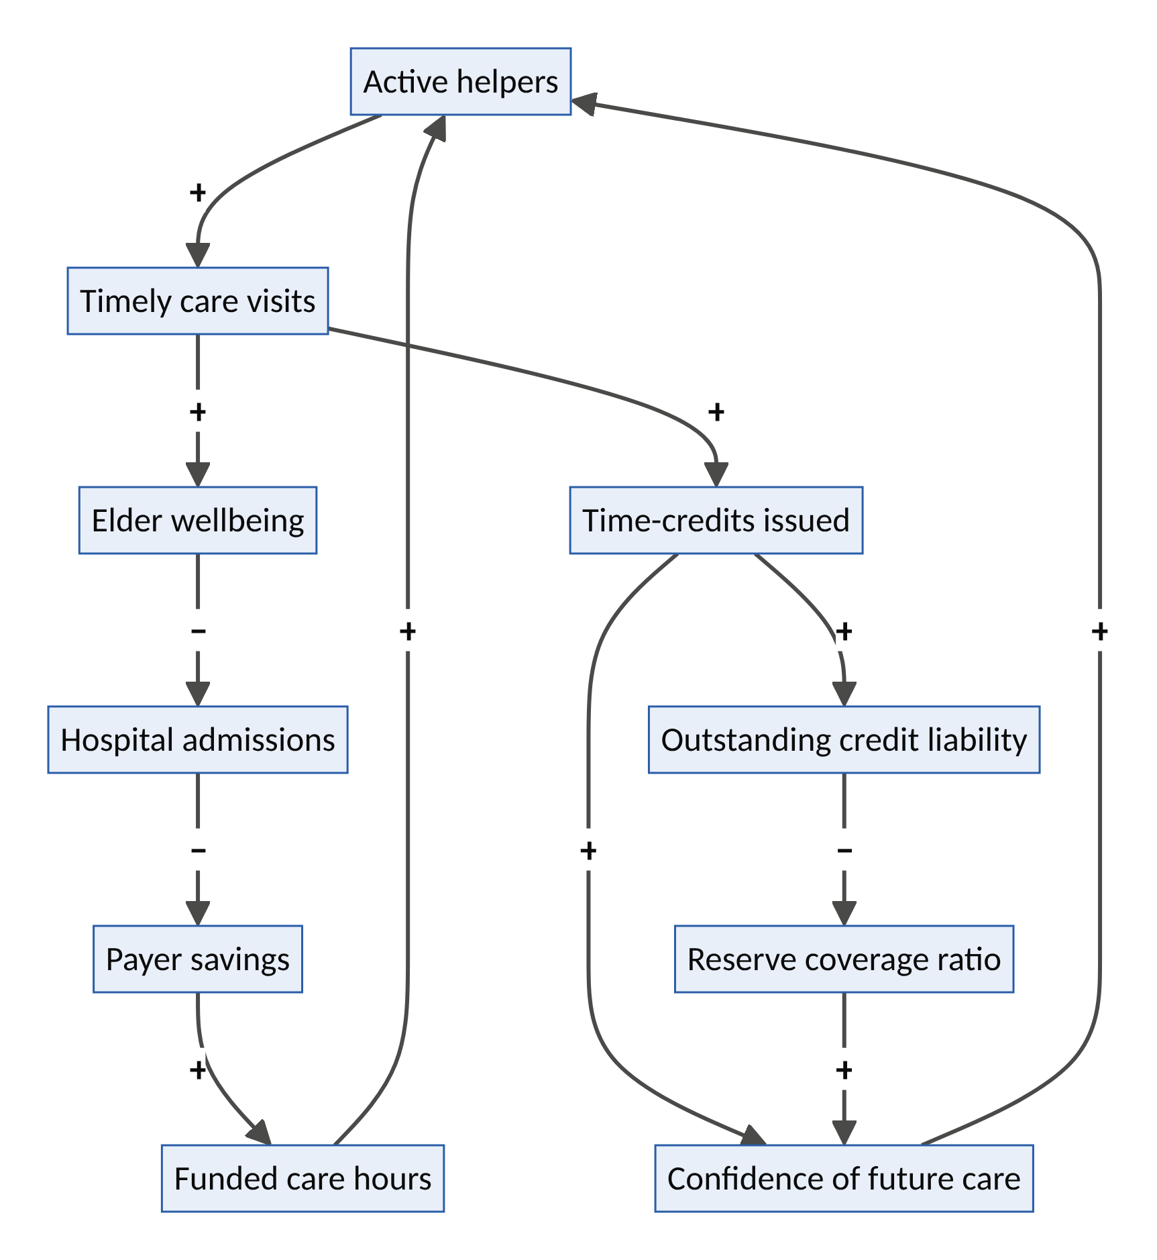
Figure 6. KinGrid’s prevention, reciprocity and credit-liability loops.
System dynamics
- R1, the prevention loop: more helpers → timely visits → better wellbeing → fewer hospital admissions → payer savings → more funded care hours → more helpers.
- R2, the reciprocity loop: visits → credits → confidence of being cared for oneself → more helpers.
- B1, the credit-liability loop: credits issued → outstanding liability → falling reserve coverage → falling confidence. This is a stock risk like an unfunded pension. If participation shrinks, credits cannot be honoured (a “demographic Ponzi”). Reserves, guarantees and caps on unredeemed credits are mandatory.
- B2, surveillance discomfort: too much sensing → loss of dignity → opt-outs. Minimum-necessary sensing, under the elder’s control.
- Leverage point: rank 9 (delays: catching needs days earlier) and rank 3 (goals: care as mutual obligation, not a commodity).
Design thinking
- Personas: Mama Ronke, 78, in Abeokuta, whose daughter Kemi lives in London and worries constantly. Harold, 81, a widower in Leeds. Grace, 64, a recently retired teacher who wants purpose.
- How might caring for someone today become insurance for being cared for tomorrow?
- Moment of truth: Kemi gets a voice note from the neighbour who just visited her mother, with a photo of them laughing over tea.
Business model. Family subscriptions; platform share of paid care (target ~15%); outcome-based contracts with municipalities and health systems; insurer partnerships (long-term-care products that pay in time-credits); diaspora “care-from-abroad” plans.
Who is forced to transform. Home-care agencies with high overheads, long-term-care insurers, and municipal adult-social-care departments.
Risk | Safeguard
Abuse or neglect of vulnerable adults | Background checks; tiered roles; clinical oversight; incident escalation; independent safeguarding board
Credit liability not honoured | Funded reserve; municipal or insurer guarantee; actuarial oversight
Labour classification | Clear separation between volunteer, credit and employed tiers
Digital exclusion of elders | Voice-first, no-screen interfaces; family or neighbour proxies
First 100 days. One neighbourhood, 50 elders, 150 helpers. Coordination starts manually (Wizard-of-Oz AI). Measure wellbeing, avoided admissions and helper retention. Run a parallel diaspora pilot: 30 families abroad, parents in one Nigerian city.
Decagon score: 44/50. V1 5 · V2 4 · V3 5 · V4 4 · V5 4 · V6 4 · V7 4 · V8 5 · V9 5 · V10 4

Venture 5: AGORA, third places on demand
Thesis. Loneliness is now a measurable public-health crisis. Agora converts idle spaces (restaurants on quiet weeknights, empty offices, community halls, libraries, places of worship) and idle evenings into small, recurring, AI-curated gatherings, funded in part by health systems through social prescribing. Its success metric is connection, not engagement.
Layer | Foothold | Inherits from | Inverts
B: Human capacity | New-market (people unserved by dating apps, Meetup or social media) | Airbnb Experiences; Uber’s matching | Optimizing one-off consumption → optimizing repeated encounters that become friendships; success = users need the app less
The new problem (why now)
- The WHO Commission on Social Connection (June 2025) estimated that about one in six people worldwide is lonely and that loneliness is linked to roughly 871,000 deaths a year, about 100 every hour. Rates are highest among adolescents and young adults and in low-income countries.
- Third places (Ray Oldenburg’s term for the cafés, pubs, barbershops and halls between home and work) are eroding, and remote work has removed the office as a social anchor.
- Commercial space is under-used: many cities have elevated office vacancy, and restaurants have predictable dead hours early in the week.
- Social media promises connection but is optimized for attention.
The latent capacity. Venue “dead hours”; people’s willingness to meet when the format is safe and structured; trained facilitators (a Guildhall pathway); and research suggesting friendship needs repeated time together (Jeffrey Hall’s 2019 study estimated roughly 50 hours to move from acquaintance to casual friend and about 200 hours to close friend).
How it works
- Onboarding conversation. An AI conversation captures interests, availability, social energy and values. No swiping or profile photos.
- Cohort matching. Small groups of 6–8 are matched for compatibility and some diversity (to build Putnam’s “bridging” social capital), and meet six times at the same time and place.
- Venue inventory. Venues list idle slots; Agora fills them; venues earn on food and drink plus a space fee.
- Facilitation. A trained host runs the first sessions with light structure (shared tasks, conversation prompts, skills swaps), then gradually steps back.
- Social prescribing. Clinicians and link workers refer patients. Outcomes are measured with validated loneliness scales, and health payers fund places.
- Graduation. Successful groups become self-organizing clubs. The platform’s job is to make itself unnecessary for them.
Digital and AI stack. Conversational onboarding; group-compatibility algorithms; venue scheduling and dynamic space pricing; safety verification; outcome measurement; facilitator support tools.
System dynamics
- R1, the belonging loop: good gatherings → friendships → retention and referrals → more cohorts.
- R2, the venue loop: filled dead hours → venue revenue → more venues → more convenient slots.
- B1, graduation by design: successful users leave. The business model must therefore earn from venues, health payers and employers, not from attention. That is a deliberate inversion of the attention economy.
- B2, safety incidents: a bad incident → loss of trust. Verification, facilitators and public venues contain it.
- Leverage point: rank 3 (goals: measure connection, not time-on-app).
Design thinking
- Personas: Ifeoma, 29, who moved from Enugu to Toronto for work and knows no one. Brian, 70, recently widowed. Lola, owner of a restaurant that is empty on Tuesdays.
- How might a city’s empty hours become its warmest rooms?
- Moment of truth: week five, when the group makes plans without the app.
Business model. Modest per-cohort fees (subsidized for referred patients); venue revenue share; social-prescribing and public-health contracts; employer wellbeing contracts; university contracts for student wellbeing.
Who is forced to transform. Social-media companies’ claims about connection, event platforms, and hospitality businesses’ off-peak models.
Risk | Safeguard
Safety | ID verification; public venues; trained facilitators; reporting and exclusion
Low willingness to pay | Third-party payers (health, employers, municipalities)
Outcome claims unproven | Pre/post measurement with validated scales; independent evaluation
Cultural fit | Local facilitators; culturally specific formats (e.g., faith, food and sport)
First 100 days. 20 venues and 300 participants in one city, run as six-week cohorts. Measure loneliness before and after, venue revenue, and whether groups continue meeting after graduation.
Decagon score: 41/50. V1 5 · V2 4 · V3 4 · V4 4 · V5 4 · V6 4 · V7 4 · V8 4 · V9 5 · V10 3

Layer C: Physical Capacity

Venture 6: HEARTH, the housing capacity unlocker
Thesis. Airbnb turned homes into hotels. Hearth turns under-used homes, land and buildings back into homes. It combines vetted intergenerational homeshare, AI-permitted backyard homes (accessory dwelling units, ADUs) and small-building conversions, financed and managed as a service. It is the platform that adds housing supply instead of removing it.
Layer | Foothold | Inherits from | Inverts
C: Physical capacity | New-market (homeowners who would never act as developers) | Airbnb’s host model and trust stack; Uber’s on-demand crew dispatch | Converting long-term housing into short-term inventory → adding long-term housing, so the city’s balancing loop becomes a reinforcing alliance
The new problem (why now)
- Housing affordability is a political emergency in many countries, from London, Toronto and California to Lagos and Nairobi. Nigeria’s housing deficit is commonly estimated in the tens of millions of units.
- Under-occupancy coexists with scarcity. Many older owners live in homes with spare bedrooms they would share or develop if it were safe, simple and financed. Many urban lots could legally host a second small home.
- Where permitting has been simplified, backyard homes have boomed. California’s ADU reforms helped take permits from a few hundred a year in the mid-2010s to tens of thousands a year. This shows the latent capacity is real.
- Older homeowners are often isolated and struggle with maintenance, while young workers (nurses, teachers, apprentices) are priced out of the cities that need them.
The latent capacity. Spare rooms; backyard and side-lot land; under-used upper floors and small commercial buildings; homeowners’ equity; and the willingness of older and younger people to share living space when trust is high.
How it works. Hearth offers three products on one trust and finance stack:
- Homeshare. It matches older homeowners with vetted younger tenants who pay reduced rent in exchange for agreed help (companionship, shopping, chores). Contracts, background checks, mediation and check-ins are included.
- Backyard homes.

    - An AI site-feasibility check reads the parcel, the zoning code and setbacks and returns “you can build a 45 m² home here” in minutes.

    - Generative design proposes floor plans.

    - Permit applications are automated.

    - Prefabricated or modular units are installed.

    - Rent-backed financing means the homeowner pays nothing upfront; Hearth takes a share of rent until the unit is paid off.

    - Hearth manages the long-term tenancy.
- Conversions. Groups of small owners of under-used upper floors and small commercial buildings are aggregated into conversion programmes for micro-apartments.
Digital and AI stack. GIS and parcel data; code-reading AI for zoning and building rules; generative architectural design; e-permitting integrations; modular-construction supply chain; fintech for rent-backed loans and securitization; tenant matching with trust profiles.
System dynamics
- R1, the supply loop: more units → more rental income → more capital for financing → more units.
- R2, the regulatory alliance loop: cities see housing added → pass pro-housing rules (by-right backyard homes, faster permits) → faster delivery → more units. This is the opposite of Airbnb’s backlash loop. Hearth turns the city from an adversary into an ally.
- B1, neighbourhood resistance: visible density → opposition. Design quality, neighbour engagement and modest scale contain it.
- B2, cost of capital: high interest rates → financing costs → slower delivery. Partnerships with pension funds and public lenders help.
- Leverage point: rank 6 (information flows: instant feasibility makes latent land visible) and rank 5 (rules: working with cities on permitting).
Design thinking
- Personas: Eleanor, 74, alone in a four-bedroom house, worried about maintenance and loneliness. Sam, 26, a nurse priced out of the city. Mr Adeyemi, who owns land in Ibadan, has two sons in the diaspora and doesn’t know whom to trust to build.
- How might every under-used square metre become someone’s home?
- Moment of truth: Eleanor sees the feasibility report and realizes she can help someone like her grandson without a penny upfront.
Business model. Development fees; financing spread; long-term property management fees (around 8–10% of rent); homeshare matching and support fees; municipal partnership contracts.
Who is forced to transform. Traditional homebuilders, letting agents, mortgage products and municipal planning departments.
Risk | Safeguard
Construction and cost overruns | Modular standard designs; fixed-price contracts; vetted builders
Interest-rate exposure | Long-term institutional capital; public-lender partnerships
Homeshare safeguarding | Vetting, contracts, mediation, regular check-ins
Tenant–landlord conflict | Professional management; clear lease standards; dispute resolution
First 100 days. Launch homeshare in one city, which needs little capital and builds the trust stack. In parallel, run a 10-unit backyard-home pilot in a jurisdiction with by-right ADU laws. Publish an externality ledger showing housing units added.
Decagon score: 41/50. V1 5 · V2 4 · V3 4 · V4 3 · V5 4 · V6 4 · V7 5 · V8 5 · V9 4 · V10 3

Venture 7: COMMONFLEET, driver and community co-ownership of autonomous fleets
Thesis. Uber’s own future, the robotaxi, threatens the livelihoods of the drivers who built ride-hailing. CommonFleet lets drivers, communities and local savers co-own autonomous vehicles that earn on Uber, other ride-hail networks and transit agencies. It applies Airbnb’s ownership model (owners hold the asset, the platform aggregates demand) to Uber’s autonomous future, turning displacement into ownership.
Layer | Foothold | Inherits from | Inverts
C: Physical capacity | New-market (asset ownership for non-capitalists); disrupts vertically integrated fleet ownership | Airbnb hosts owning assets; Uber’s demand aggregation and multi-partner AV strategy | Labour displaced by capital → labour becoming capital
The new problem (why now)
- Autonomy is scaling. Waymo reached around 500,000 paid rides a week by early 2026 and targets 1 million. Uber has deals with 20–30+ AV companies, and Tesla operates a robotaxi service.
- Millions of people worldwide earn a living driving ride-hail, delivery, taxi and trucks. Without a transition path, autonomy concentrates mobility capital in a few firms while eroding a major source of working-class income.
- Fleet operations can be separated from AV software. Waymo partnered with fleet manager Moove (2024) for fleet operations in Phoenix and Miami. Uber’s model already involves third-party fleet owners and operators. Ownership and operations are therefore up for grabs.
- Cities want local economic benefit, data access and equity from AV deployment.
The latent capacity. Drivers’ operational skill and local knowledge (charging, cleaning, inspection, customer assistance, remote support); community capital (credit unions, cooperatives, diaspora savings, local pension funds); and under-used depot land (old fuel stations, parking lots).
How it works
- Fleet co-op or special-purpose vehicle per city. Members buy shares with savings or earn sweat equity by working in fleet operations. Drivers get priority and favourable terms.
- Acquire vehicles. Buy or lease AVs from OEM and AV-software partners. The software is licensed; the vehicles are member-owned.
- Multi-home the demand. Deploy across Uber, other networks and transit microtransit contracts to maximize utilization.
- Local operations hubs. Former drivers become fleet technicians, cleaners, charging operators, remote assistants and customer-care staff, the jobs that remain after autonomy.
- Dividends. Profits are distributed to members, part reinvested, and part placed in a community benefit fund.
- Data commons. Fleet data is co-owned and shared with the city for planning.
- Transition path. Start now with human-driven EV co-op fleets (as driver co-ops such as The Drivers Cooperative in New York have done) and convert vehicles to autonomy as regulation allows.
Digital and AI stack. Fleet-management AI (utilization optimization, predictive maintenance, smart charging against grid prices, linked to FluxCommons); multi-platform dispatch integrations; regulated fractional-ownership registries; remote-assistance tooling; safety telemetry.
System dynamics
- R1, the ownership loop: dividends → member savings → more vehicles bought → more dividends.
- R2, the utilization loop: multi-homing → higher utilization → better returns → cheaper capital → larger fleet.
- B1, technology obsolescence: AV hardware depreciates quickly, a stock risk. Leasing structures and refresh reserves avoid stranded assets.
- B2, platform gatekeeping: AV software providers or networks may refuse third-party ownership. Multiple partners, city procurement leverage and transit contracts reduce dependency.
- Leverage point: rank 5 (rules) and the ownership structure itself. Changing who owns the stock changes the distribution of everything the system produces.
Design thinking
- Personas: Emeka, 41, a ride-hail driver in Houston for nine years who reads every AV headline with dread. Joy, a transit director who needs affordable night-time service. Ade, a credit-union manager seeking local, real-asset investments.
- How might the people driving today own the cars that drive themselves tomorrow?
- Moment of truth: Emeka receives his first quarterly dividend from a car he no longer has to drive.
Business model. Fleet-management fee plus a share of profits; operations services; structuring and financing fees; municipal and transit contracts.
Who is forced to transform. Vertically integrated robotaxi operators, ride-hail networks’ supply strategies, auto-finance companies and city AV policy.
Risk | Safeguard
Capital intensity | Leasing; phased growth; blended finance with public and impact lenders
AV safety and liability | Partner only with certified AV stacks; full insurance; incident transparency
Securities regulation | Licensed structures; regulated crowdfunding or cooperative-share frameworks
Timing (AV rollout slower than expected) | Start with human-driven EV co-ops that are profitable now
First 100 days. Launch a 50-vehicle human-driven EV co-op with 100 driver-members in one city; build the depot and operations capability; negotiate one AV partner pilot (10 vehicles) and one transit microtransit contract.
Decagon score: 42/50. V1 4 · V2 3 · V3 4 · V4 4 · V5 4 · V6 5 · V7 5 · V8 5 · V9 5 · V10 3

Venture 8: FLUXCOMMONS, the neighbourhood energy and compute commons
Thesis. The parked-car insight returns at the grid edge. EVs sit parked most of the day, home batteries sit idle, water heaters are thermal batteries, and AI compute is hungry for power. FluxCommons aggregates household flexibility and small “compute boilers” (servers that heat homes and water) into community virtual power plants. These sell flexibility to the grid and return earnings and heat to households.
Layer | Foothold | Inherits from | Inverts
C: Physical capacity | Low-end vs. peaker plants and hyperscale data centres for interruptible workloads; new-market for households | Uber’s real-time dispatch and surge pricing; Airbnb’s hosting model (homes “host” compute) | Surge pricing as extraction → surge as a reward to the neighbourhood; negative externality → positive externality (decarbonization, reused heat)
The new problem (why now)
- The IEA projects data-centre electricity demand will more than double to around 945 TWh by 2030, driven by AI. In the US, data centres are on course to account for almost half of electricity-demand growth to 2030.
- Grids face connection queues, local transformer congestion, and wasted renewable output (midday solar surplus, sometimes at negative prices).
- Heating must decarbonize, and households face high energy bills.
- In many African cities, unreliable grid supply means generators, diesel costs and lost productivity.
The latent capacity. EV batteries (smart charging and vehicle-to-grid); home batteries; heat pumps and water heaters as thermal storage; rooftop-solar surplus; and the waste heat of computation, since every kilowatt-hour a server uses becomes heat that could warm water.
How it works
- Enrol. Households connect devices (smart charger, battery, heat-pump or water-heater controller) and optionally host a compute boiler, a sealed, liquid-cooled server that heats the hot-water tank.
- A home energy agent. Each home gets an AI agent that balances comfort, bills and earnings within the household’s rules, e.g. “car at 80% by 7 a.m.; never below 30%”.
- Market bidding. Aggregated flexibility is bid into wholesale, balancing and local network-flexibility markets.
- Green, interruptible compute. Compute boilers run interruptible AI workloads (batch inference, rendering, scientific computing) when power is cheap and clean. The household gets free hot water; the compute customer gets cheap capacity.
- Community layer. Neighbourhood energy co-ops pool flexibility to relieve local transformers and share revenues. In unreliable-grid contexts, the same layer runs peer-to-peer battery sharing on mini-grids.
- Revenue sharing. Households, the community co-op and the platform each take an agreed share.
Digital and AI stack. Device protocols (e.g., OpenADR, OCPP, IEEE 2030.5); forecasting ML for load, solar and prices; market-bidding agents; confidential computing and secure enclaves for distributed workloads; edge orchestration; a digital twin of the distribution network.
System dynamics
- R1, the aggregation loop: more devices → more reliable flexibility → better market access and prices → higher household earnings → more enrolments.
- R2, the decarbonization loop: earnings → households finance batteries and heat pumps → more flexibility.
- B1, flexibility price saturation: as flexibility supply grows, its market price falls. Compute revenue provides a second, uncorrelated income stream.
- B2, battery-wear concern: fear of degradation → opt-outs. Warranty guarantees and conservative cycling help.
- B3, seasonal heat mismatch: compute heat is unwanted in hot summers. Shift compute to cooler seasons and climates, or use it for hot water only.
- Leverage point: rank 6 (information flows: real-time price signals reaching devices), rank 5 (rules: aggregator market access) and rank 4 (self-organization: community energy).
Design thinking
- Personas: Kwame, in Accra, with rooftop solar and an unreliable grid. Sophie, in Bristol, with an EV and a rising energy bill. Leila, CTO of an AI startup that needs cheap batch inference.
- How might every home become a tiny power plant and a warm data centre?
- Moment of truth: Sophie’s monthly statement shows her EV earned more than it cost to charge, and her hot water was free.
Business model. Revenue share on flexibility (target 20–30%); compute margin; hardware financing; software licensing to utilities and network operators.
Who is forced to transform. Utilities, peaker-plant operators, hyperscale data-centre operators (for batch workloads) and heating-equipment makers.
Risk | Safeguard
Security of distributed compute | Confidential computing; tamper-evident hardware; workload isolation
Household privacy | Local processing; aggregated reporting; data minimization
Hardware cost | Financing; utility co-funding; compute revenue pays down hardware
Regulatory barriers to aggregators | Work with regulators and network operators; join flexibility pilots
First 100 days. 200 homes with EVs or batteries in one distribution-network area, enrolled in existing flexibility programmes; a 20-unit compute-boiler pilot with one batch-inference customer; and an Accra mini-grid battery-sharing pilot.
Decagon score: 43/50. V1 5 · V2 4 · V3 4 · V4 4 · V5 5 · V6 4 · V7 4 · V8 5 · V9 4 · V10 4

Layer D: Planetary Resilience

Venture 9: HARVESTGRID, climate-smart cold chain and market logistics for smallholders
Thesis. Kobo360 made trucking “Uber-like” in Nigeria, and ColdHubs made cold storage pay-as-you-store. HarvestGrid fuses those models with AI price intelligence and embedded finance into an operating system for perishable food, so a tomato farmer in Kano can sell at Lagos prices instead of glut prices. Cold storage is a technology for buying time, and time is bargaining power.
Layer | Foothold | Inherits from | Inverts
D: Planetary resilience | Low-end vs. informal middleman chains; new-market for smallholders excluded from modern supply chains | Uber Freight’s load matching; Airbnb’s “host” model (local entrepreneurs operate cold rooms) | Platforms that profit from volatility → a platform that reduces volatility; farmers co-own cold assets
The new problem (why now)
- Food loss. FAO estimates suggest that up to about a third or more of food produced in sub-Saharan Africa is lost or wasted, with perishables hit hardest: losses of 40–50% for roots, tubers, fruits and vegetables are commonly cited, driven largely by the lack of cold chains. Estimates vary by crop and method; some household surveys find lower losses for staple grains. The loss problem is sharpest for perishables.
- Climate heat stress shortens shelf life and raises spoilage.
- Forced sales. Without storage, farmers must sell at harvest when prices are lowest, then buy back food when prices are highest.
- Empty backhauls. Trucks travel loaded one way and empty the other.
- No credit. Smallholders lack collateral, so they cannot invest in inputs.
- Population pressure. Africa’s population is projected to approach 2.5 billion by 2050 (UN), multiplying demand for food.
The latent capacity. Empty truck return trips; idle or under-used cold rooms; abundant solar energy; stored produce as collateral (warehouse receipts); market price data scattered across thousands of markets; and local entrepreneurs ready to operate cold hubs.
How it works
- Farmer interface. Voice and USSD in local languages (Hausa, Yorùbá, Igbo, Swahili and others) work on any phone. Farmers get harvest timing and price forecasts per market.
- Solar cold hubs. Cold rooms at farm gates and markets are run by local “cold hosts” on a micro-franchise model. Farmers pay per crate per day.
- Logistics matching. Loads are matched to trucks, with backhaul priority: trucks carrying goods north return south with produce. Reefer and insulated-crate options are available.
- Digital warehouse receipts. Stored produce becomes collateral for instant, fairly priced input loans and advances.
- Off-take marketplace. Aggregators, retailers, processors, institutional buyers and exporters can buy, including through forward contracts that lock in prices.
- Waste to value. Produce near its end of life is routed to processors (drying, paste, animal feed) instead of rotting.
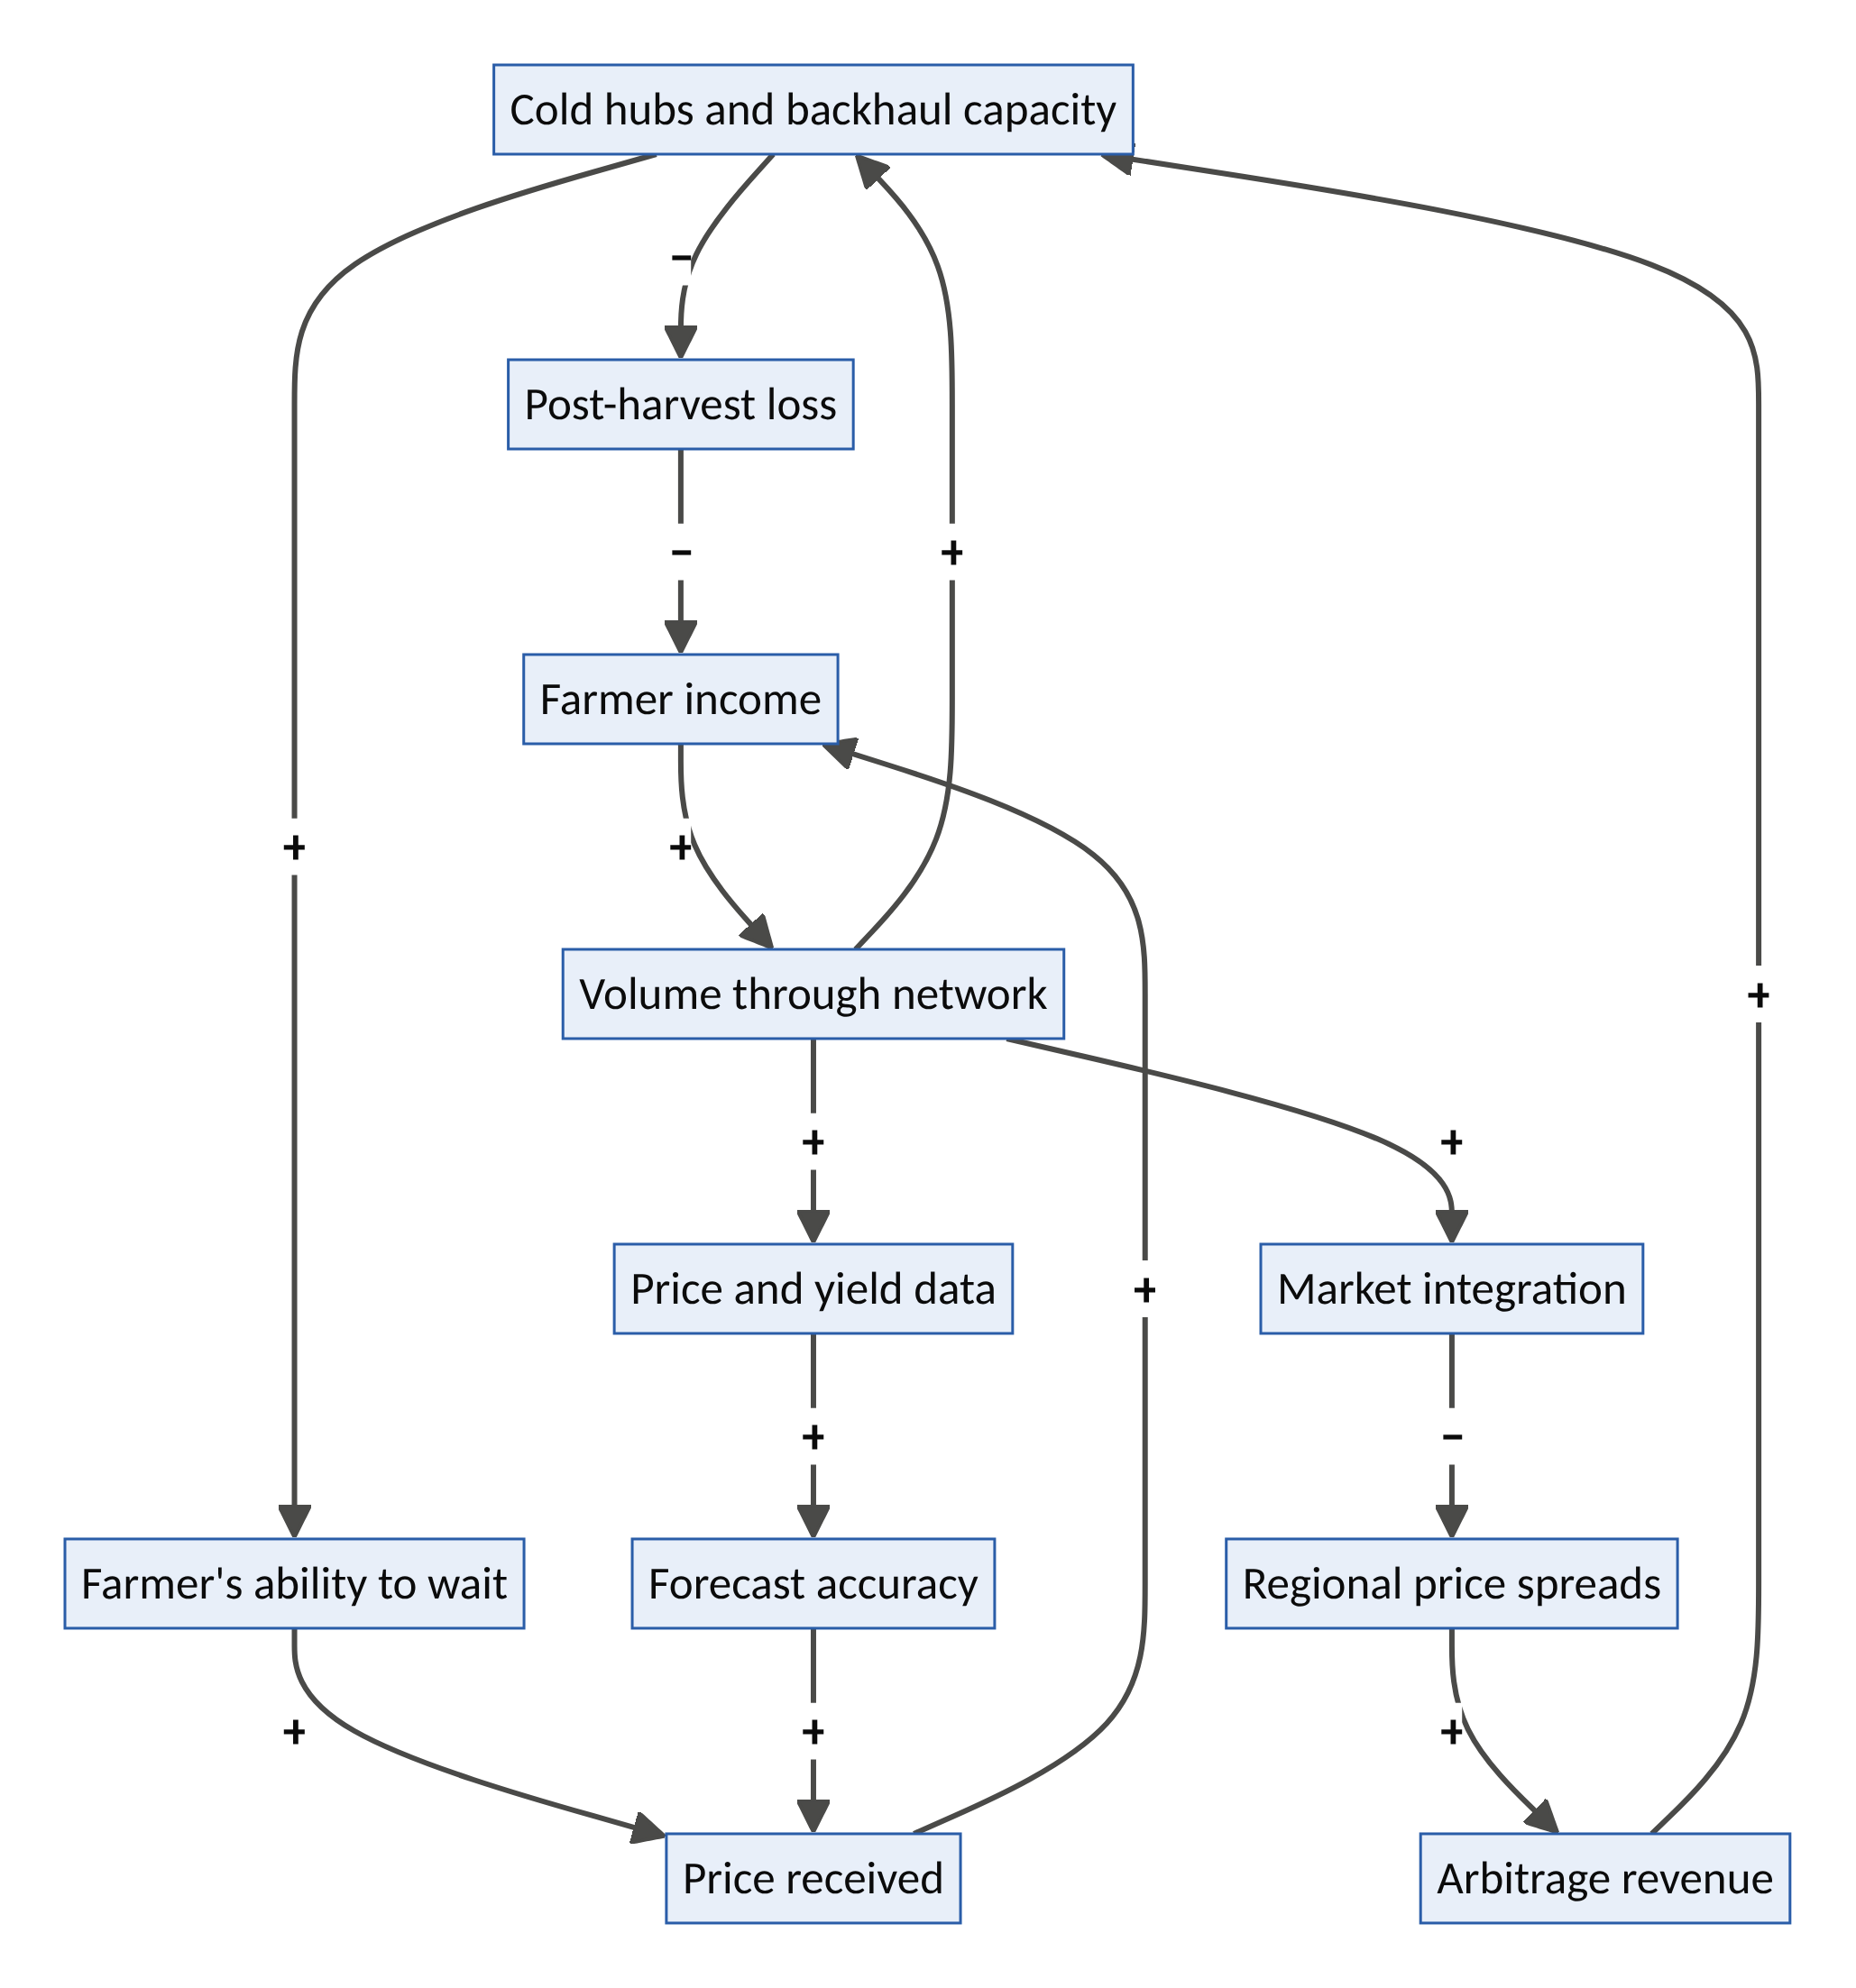
Figure 7. HarvestGrid’s income, data and arbitrage-closing loops.
System dynamics
- R1, the farmer-income loop: hubs → less loss and more patience → better prices → higher income → more volume → more hubs.
- R2, the data loop: volume → price and yield data → better forecasts → better prices.
- R3, the credit loop: receipts → finance → inputs → productivity → volume.
- B1, arbitrage closing: volume → market integration → narrower regional price gaps → less arbitrage revenue to fund hubs. Narrower gaps are good for society, so the business must earn from services (storage, logistics, finance, data), never from spreads.
- B2, infrastructure limits: roads, security and power constrain growth. Route selection and solar-first hubs help.
- B3, intermediary resistance: existing traders may resist. Recruit them as cold hosts and aggregators.
- Leverage point: rank 9 (delays: storage buys time, ending forced sales) and rank 6 (information: price transparency).
Design thinking
- Personas: Hajiya Amina, a tomato farmer and trader near Kano who watches a third of her harvest rot in glut season. Musa, an owner-driver whose truck returns empty from Lagos. Ngozi, a restaurant supplier in Lagos who cannot get consistent quality.
- How might a perishable harvest gain the patience of a durable good?
- Moment of truth: Amina stores her tomatoes for nine days and sells at twice the harvest-week price.
Business model. Storage fees; logistics take rate (around 10–15%); financing spread; buyer subscriptions for price and supply data; carbon credits for avoided food-waste methane, where credible.
Who is forced to transform. Informal wholesale chains, agro-lenders, food retailers’ sourcing and logistics companies.
Risk | Safeguard
Insecurity on routes | Route-risk intelligence; local partnerships; insurance (link to Bastion)
Currency volatility and inflation | Local-currency revenues; hedged hardware financing
Capital discipline (the sector has seen high-profile struggles) | Asset-light where possible; micro-franchised hubs; unit economics proven per corridor
Adoption | Voice-first, local-language design; trusted local agents; women-led cooperatives
First 100 days. Five hubs on the Kano–Lagos tomato corridor with 1,000 farmers, partnering with existing truckers for backhaul. Measure loss reduction, price uplift and loan repayment.
Decagon score: 44/50. V1 5 · V2 5 · V3 4 · V4 4 · V5 4 · V6 5 · V7 4 · V8 5 · V9 5 · V10 3

Venture 10: BASTION, a parametric resilience mutual and community resource network
Thesis. As insurers retreat from climate-exposed places, Bastion combines parametric micro-insurance (automatic payouts when a measured threshold is crossed), peer mutualism and a pre-registered community resource network of spare rooms, generators, boats, vehicles and skills. It is Airbnb.org’s emergency housing combined with Uber-style dispatch, organized as a 21st-century friendly society.
Layer | Foothold | Inherits from | Inverts
D: Planetary resilience | New-market (the uninsured); classic Christensen non-consumption | Airbnb.org’s emergency housing; Uber dispatch; platform insurance products | Platform owned by shareholders and paid after lengthy claims → member-owned mutual paying out automatically in days, rewarding prevention
The new problem (why now)
- The protection gap. Swiss Re estimates the global natural-catastrophe protection gap at about US$424 billion (2025). Of roughly US$220bn in 2025 economic losses, only about half was insured, and in emerging markets 80–90% of catastrophe losses are typically uninsured.
- Insurer retreat. In high-risk areas of wealthy countries, insurers are pulling back. In 2023, for example, State Farm stopped writing new homeowners’ policies in California.
- Disasters at scale. Nigeria’s 2022 floods displaced well over a million people and killed hundreds.
- Heat as an income shock. Extreme heat stops outdoor work, and informal workers lose income with no safety net. Parametric heat-income pilots for women informal workers in India (e.g., with SEWA, 2023–24) show automatic payouts are workable.
- Slow claims. Traditional claims take weeks or months, pushing families into debt or poverty traps.
The latent capacity. Community spare capacity in disasters (rooms, vehicles, boats, generators, tools, medical and construction skills); satellite and sensor data that make parametric triggers possible; centuries-old mutual-aid traditions (esusu and ajo rotating savings groups, burial societies, friendly societies); and prevention capacity, retrofits that cut losses.
How it works
- Membership. Households, small businesses, farmers and informal workers join individually or as groups (ajo-style group policies). Premiums are paid in micro-amounts by mobile money.
- Parametric triggers. Flood depth, rainfall, wind speed or heat index is measured by satellites and local sensors. When thresholds are crossed, payouts arrive automatically within about 48 hours.
- The pledge network. Members pre-register resources such as a spare room, a boat, a generator, a truck or a nursing skill. During an event, AI dispatch matches needs to pledges, and contributors earn premium credits.
- Prevention rewards. Retrofits such as raised plinths, roof straps, drainage and fire-safe zones are verified by photo and AI, and earn premium reductions.
- Capital stack. Member premiums, then reinsurance and catastrophe bonds, then public backstops.
- Early-warning commons. Bastion shares data with local governments and communities for early warning and planning.
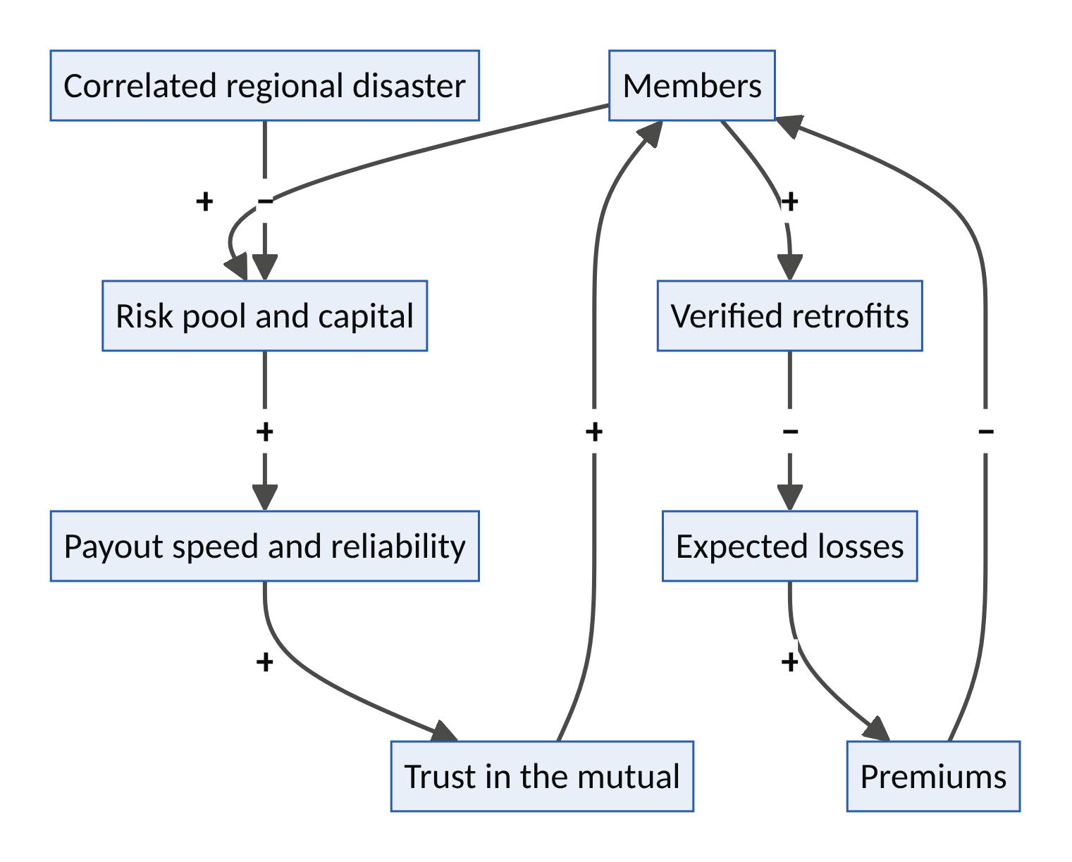
Figure 8. Bastion’s mutual-trust and prevention loops, with correlated-disaster shock.
System dynamics
- R1, the mutual-trust loop: members → pool → fast, reliable payouts → trust → more members.
- R2, the prevention loop: members → verified retrofits → lower expected losses → lower premiums → more members (and more retrofits).
- B1, correlated risk: a whole region hit at once depletes the pool. Reinsurance and catastrophe bonds absorb the tail.
- B2, basis risk: a trigger fires but a member wasn’t harmed, or vice versa. Hybrid triggers, local sensors and a small loss-adjustment fund reduce it.
- Leverage point: rank 9 (delays: paying in days rather than months prevents poverty traps), rank 5 (rules: mutual governance) and rank 6 (information: risk transparency).
Design thinking
- Personas: Blessing, a market trader in Lokoja, where the Niger and Benue meet, flooded out in 2022. Daniel and Maria, Sonoma County homeowners dropped by their insurer. Officer Bello, a local emergency coordinator with no idea which residents have boats.
- How might a community’s spare capacity become its first insurance?
- Moment of truth: the river crosses the threshold at 4 a.m., and by noon Blessing’s phone shows the payout and the address of a dry room two streets away.
Business model. Mutual structure: surplus returned to members or reserves. A managing-agent fee to the platform company; technology licensing to governments, insurers and development agencies; reinsurance commissions; resilience-data services.
Who is forced to transform. Traditional indemnity insurers, disaster-relief agencies and microfinance institutions.
Risk | Safeguard
Insurance regulation | Partner with licensed carriers; regulatory sandboxes; mutual licensing where available
Basis risk and perceived unfairness | Hybrid triggers; transparent trigger data; small discretionary fund
Capital adequacy | Reinsurance, catastrophe bonds, public backstops; conservative growth
Fraud in pledges or retrofits | Verification; reputation; spot audits
First 100 days. Parametric flood cover for 2,000 market traders in one flood-prone Nigerian state, a pledge-network pilot with 500 households, and a heat-income cover pilot for outdoor workers.
Decagon score: 45/50. V1 5 · V2 4 · V3 5 · V4 3 · V5 4 · V6 5 · V7 4 · V8 5 · V9 5 · V10 5

Part VIII: The Future Potential of the Ten Ventures (2026–2050)
“The best way to predict the future is to invent it.” (Alan Kay)
“Act so that the effects of your action are compatible with the permanence of genuine human life.” (Hans Jonas, The Imperative of Responsibility)
Part VII described each venture at launch. This part asks what each could become: how it might grow through three horizons, which further innovations it would spawn, what its potential is at maturity, and how it could fail. It then looks at what the ten could become together.

8.1 How to read the venture futures
Each venture is examined with the same template:
Element | Question it answers
2040 end-state | If everything goes right, what is this venture in 2040? (The preferable future.)
Three horizons | H1 (2026–2028): from pilot to proof. H2 (2028–2033): from proof to platform. H3 (2033–2040+): from platform to institution.
Spin-off innovations | Which new products, services or institutions does the venture make possible? These are its adjacent possible (Stuart Kauffman’s term for the set of next steps a system can reach).
Potential at maturity | An illustrative, assumption-based estimate of scale or impact. Every figure states its assumptions and none is a forecast.
Probable and failure futures | What is most likely to happen, and how the venture could die.
Triggers and signposts | What must happen in technology and policy, and what to watch.
Two cautions. First, potential is not probability: most ventures fail, and these are hypotheses. Second, the estimates use round numbers on purpose, to show orders of magnitude rather than false precision.

8.2 The forces behind the next 25 years
Eleven macro forces power the ten ventures. Each is backed by current evidence.
Force | Evidence | Ventures it powers
Agentic AI | McKinsey estimates AI agents could orchestrate roughly $0.9–1 trillion of US consumer retail revenue by 2030, and $3–5 trillion globally (goods only, excluding services) | Covenant, DataGuild
Demographic ageing | WHO: by 2050, people aged 60+ will reach 2.1 billion and those aged 80+ about 426 million (roughly triple 2020); two-thirds of over-60s will live in low- and middle-income countries | KinGrid, Agora, Hearth
Africa’s youth bulge | Africa’s population is projected to approach 2.5 billion by 2050 (UN) | Guildhall, HarvestGrid, DataGuild
AI and the first career rung | Early evidence of falling entry-level employment in AI-exposed jobs (Stanford Digital Economy Lab, 2025) | Guildhall
Electrification | Electric car sales passed 20 million in 2025, about a quarter of global sales, but only about 5% of the global car stock is electric (IEA), so most of the transition is still ahead | FluxCommons, CommonFleet
AI’s power demand | IEA: data-centre electricity use set to more than double to around 945 TWh by 2030 | FluxCommons
Grid flexibility | US DOE: 80–160 GW of virtual power plants by 2030 could meet 10–20% of peak demand and save about $10bn a year in grid costs | FluxCommons, CommonFleet
Autonomy | Waymo reached around 500,000 paid rides a week in early 2026; Uber has deals with 20–30+ AV companies | CommonFleet
The climate protection gap | Swiss Re: global natural-catastrophe protection gap of about $424bn (2025); 80–90% of catastrophe losses uninsured in emerging markets | Bastion, HarvestGrid
Loneliness | WHO: about 1 in 6 people lonely; linked to about 871,000 deaths a year | Agora, KinGrid
Diaspora capital | Officially recorded remittances to low- and middle-income countries reached an estimated $685bn in 2024 (World Bank) | KinGrid, Hearth, BuildBridge

8.3 Covenant: from agent passport to the trust protocol of the agentic economy
2040 end-state. Every transaction an AI agent makes, whether with a merchant, another agent, a government service or a robot at a building’s door, carries a verifiable identity, a signed mandate, a reputation and a guarantee. Covenant is to agentic commerce what card networks were to plastic: the rulebook and the trust layer, governed by its members.
Horizon | What it becomes | Key milestone | Scale signal
H1 (2026–28) | A vertical trust service for agent-made travel bookings | First insurer partner; 1,000 guaranteed bookings | Merchants accept agents without CAPTCHAs
H2 (2028–33) | A cross-industry agent passport integrated with payment networks and digital identity wallets | Interoperable with major agent-payment protocols; agent liability cover becomes a recognized insurance line | Millions of certified agents
H3 (2033–40+) | The commercial law of machines: agent-to-agent contracts, dispute resolution, and credentials for robots in the physical world | Courts and regulators recognize Covenant mandates as evidence of authority | A large share of agent transactions in member markets carry a Covenant mandate
Spin-off innovations
- Agent Ombudsman. Fast, AI-first dispute resolution for agent errors, with human appeal: a new kind of consumer-protection institution.
- Guardian mandates. Protective spending limits for elderly or vulnerable people, set with family or carers, to block financial abuse and scams.
- Robot entry credentials. Verifiable permissions that let delivery robots and autonomous vehicles enter buildings, lifts and loading bays.
- Provenance seals. Proof that a piece of content or a transaction came from a verified human or a verified agent acting for one.
Potential at maturity (illustrative). If agents orchestrate $3–5 trillion of global goods commerce by 2030 (McKinsey’s range) and that grows further with services, a trust layer touching even 5–10% of it would sit under $150–500bn of annual transactions. Revenue at fractions of a percent would be modest relative to that volume. The larger value is systemic: fraud prevented, disputes resolved quickly and commerce that would not happen at all without trust.
Probable future. Several competing trust schemes emerge, built by payment networks, AI firms and governments. Covenant’s realistic path is to become the neutral, interoperable layer between them rather than the only scheme.
Failure future. One dominant AI firm builds a closed trust system for its own agents and wins on convenience, or national schemes fragment into incompatible silos.
Triggers and signposts. Adoption of agent-payment protocols; digital identity wallets (e.g., the EU’s) accepting agent credentials; the first large agent-fraud scandal, which would accelerate demand; liability rulings on agent errors.

8.4 DataGuild: from one guild to the collective-bargaining institution of the AI age
2040 end-state. A global federation of data and knowledge cooperatives. Members earn royalties whenever AI systems use their knowledge, guilds co-own specialist AI models, and the world’s languages and professional know-how are preserved in machine-usable form under the control of the communities that hold them.
Horizon | What it becomes | Key milestone | Scale signal
H1 (2026–28) | One guild (West African languages and agriculture) | First quarterly royalties; published royalty formula | Repeat licences from the same buyers
H2 (2028–33) | A federation of 50+ guilds across professions and languages | Standard licence terms accepted by major AI developers; public-interest datasets for governments | Guild membership in the millions
H3 (2033–40+) | Guild-owned models and “knowledge pensions” | Members co-own specialist models (e.g., an African agriculture model) and royalties continue for life | Royalties a meaningful income line for members
Spin-off innovations
- Knowledge pensions. Royalty streams that continue into retirement and can be inherited.
- Language revival studios. Communities create speech and text resources for endangered languages, funded by licensing.
- Expert evaluation marketplace. Doctors, engineers and lawyers test AI systems for safety in their domains, a growing need as AI is used in high-stakes settings.
- Royalty-backed lending. Members borrow against future royalty streams at fair rates.
Potential at maturity (illustrative). If DataGuild reached 10 million members earning $100–500 a year in royalties, it would transfer $1–5bn a year to contributors. For members in lower-income economies, that is a meaningful supplementary income. Equally important is what money cannot easily measure: thousands of languages kept alive in the digital world.
Probable future. AI developers license from many sources, and DataGuild becomes one important supplier, strongest in domains and languages that are scarce elsewhere.
Failure future. Courts adopt very broad “fair use” for training, synthetic data substitutes for most human data, and buyers refuse collective terms.
Triggers and signposts. Copyright rulings and settlements; training-data transparency rules; prices in data-licensing deals; evidence on model collapse from synthetic data.

8.5 Guildhall: from ten pods to the world’s largest apprenticeship system
2040 end-state. A portable, outcome-verified alternative to the entry-level job. For a significant share of young people, especially in Africa and other youthful regions, the first rung of a career is a Guildhall pod, and lifelong guild membership supports re-skilling every few years.
Horizon | What it becomes | Key milestone | Scale signal
H1 (2026–28) | 10 pods → 200 pods in two cities and three domains | 70%+ of graduates placed within 90 days | SMEs return with second projects
H2 (2028–33) | National partnerships funded through training levies; 50+ domains, including energy-transition trades (EV, solar, heat pumps) and AI supervision work | Employers accept Guildhall portfolios in place of degrees for entry roles | Hundreds of thousands of apprentices a year
H3 (2033–40+) | Lifelong guild membership with portable benefits | Guilds become recognized professional bodies | Guild alumni are a measurable share of the workforce in partner countries
Spin-off innovations
- Proof-of-work credential exchange. Verified portfolios that employers anywhere can query, replacing CV screening.
- Retiree mentor marketplace. Paid, part-time mentoring careers for experienced professionals.
- “AI department as a service” for SMEs. Pods act as a small business’s ongoing AI and digital team.
- Guild mutual. Portable insurance, pensions and income smoothing for independent workers.
Potential at maturity (illustrative). If Guildhall trained one million apprentices a year by the late 2030s, each completing projects worth $5,000–10,000, it would deliver $5–10bn a year of real work for small businesses while building a skilled workforce. The larger impact is generational: a career ladder rebuilt for the AI age.
Probable future. Strong uptake in countries with training levies and youthful populations; slower uptake where degrees remain the dominant gatekeeper.
Failure future. The model drifts into cheap labour (the Eroding Goals archetype), or AI automates even supervised junior work so far that projects no longer teach.
Triggers and signposts. Entry-level hiring data; reform of apprenticeship and training levies; employer acceptance of portfolio credentials.

8.6 KinGrid: from one neighbourhood to the care infrastructure of ageing societies
2040 end-state. Every elder who wants one has a care circle, every helper builds care credit, and KinGrid is the “community layer” of health and social-care systems, working alongside hospitals, clinics and professional carers. Care credits work across borders, so a nurse in London can earn credit that pays for a parent’s care in Abeokuta.
Horizon | What it becomes | Key milestone | Scale signal
H1 (2026–28) | One neighbourhood → 20 neighbourhoods; diaspora pilot | Measured fall in avoidable hospital admissions | Municipal contract signed
H2 (2028–33) | Municipal and health-system partnerships; integration with hospital-at-home and social prescribing; human-supervised assistive robotics | Care credits backed by a mutual or public guarantee | Hundreds of thousands of elders served
H3 (2033–40+) | National and cross-border care-credit systems | Credits recognized like pension entitlements; diaspora care corridors | Care circles as standard in partner regions
Spin-off innovations
- Diaspora care corridors. Verified, coordinated care for parents in one country, paid for and overseen by children in another.
- Care-credit pensions. Time-credits as a formal pillar of retirement security.
- Dementia-friendly neighbourhoods. Certification and training for shops, transport and neighbours.
- Assistive robot leasing. Lifting, monitoring and medication robots deployed only with human oversight and the elder’s consent.
Potential at maturity (illustrative). WHO projects about 426 million people aged 80+ by 2050. If just 1% (about 4 million) had a KinGrid circle providing four hours a week of coordinated help, that would be roughly 830 million hours of care a year (4m × 4 × 52), equivalent to the annual hours of several hundred thousand full-time carers.
Probable future. Strongest uptake where public care systems are stretched and municipalities pay for prevention; diaspora corridors grow fastest in countries with large emigrant populations.
Failure future. A safeguarding scandal destroys trust; the credit system cannot honour its obligations (the “demographic Ponzi” risk described for KinGrid in Part VII); or sensing turns into surveillance.
Triggers and signposts. Long-term care funding reforms; care-workforce shortages; laws recognizing time-banking; outcomes data from hospital-at-home programmes.

8.7 Agora: from one city to social infrastructure as a service
2040 end-state. Every city has a “connection grid”: its idle spaces and hours woven into recurring small-group gatherings. Loneliness is measured and managed as a public-health indicator, like air quality, and Agora also serves civic purposes such as welcoming newcomers and hosting citizens’ assemblies.
Horizon | What it becomes | Key milestone | Scale signal
H1 (2026–28) | 1 city → 10 cities | Independent evaluation shows reduced loneliness | Health payers fund places
H2 (2028–33) | Reimbursed social prescribing; employer and university contracts; integration with KinGrid for elders | Social prescribing codes cover Agora cohorts | Millions of participants a year
H3 (2033–40+) | Civic infrastructure: newcomer integration, intergenerational bridging, deliberative democracy | Cities publish a connection index alongside health statistics | “Third places” designed into new housing (with Hearth)
Spin-off innovations
- Civic assemblies. Randomly selected citizens’ assemblies (sortition), hosted and facilitated through Agora’s venue and facilitator network.
- Newcomer circles. Integration groups for migrants, refugees and people who move for work.
- Workplace belonging. Cross-team cohorts for remote and hybrid workforces.
- Off-peak economy analytics. Data helping venues and cities fill dead hours.
Potential at maturity (illustrative). About 1 in 6 people worldwide, over a billion, experience loneliness (WHO). If Agora reached 10 million participants a year across 500 cities by the late 2030s, and validated scales showed a meaningful share moved out of chronic loneliness, the health and economic value would be substantial, given loneliness’s links to heart disease, diabetes, depression and early death.
Probable future. Strongest where governments already treat loneliness as policy. The UK appointed a minister for loneliness in 2018 and Japan in 2021.
Failure future. Agora drifts toward an engagement-maximizing events app; a safety incident; or no third party will pay.
Triggers and signposts. National loneliness strategies; social-prescribing reimbursement; venue economics after the pandemic.

8.8 Hearth: from homeshare to the engine of gentle density
2040 end-state. A distributed housing-supply engine. Millions of small homes are added within existing neighbourhoods: backyard homes, duplexes, courtyard clusters and converted upper floors. Homeshare is a normal option for under-occupied homes. Hearth’s homes are energy-positive (with FluxCommons), climate-adapted (with Bastion) and designed for intergenerational life (with KinGrid and Agora).
Horizon | What it becomes | Key milestone | Scale signal
H1 (2026–28) | Homeshare in one city; 10 backyard-home pilots | First rent-backed financing closed | Cities request pre-approved plans
H2 (2028–33) | Tens of thousands of units; rent-backed loans pooled and sold to institutional investors; in Africa, incremental building finance and verified diaspora building | A city or state adopts Hearth’s pre-approved plan library | Thousands of units a year per market
H3 (2033–40+) | “Gentle density as a service”: AI-designed neighbourhood infill, community land trusts, intergenerational villages | Hearth homes become a recognized housing category | A measurable contribution to housing supply in partner cities
Spin-off innovations
- Rent-backed home securities. Pools of backyard-home loans sold to pension funds, recycling capital into more homes.
- Pre-approved plan libraries. Cities adopt standard designs that can be permitted in days.
- Verified diaspora building. Escrowed milestones and photo or drone verification for families building at home from abroad (merging with the BuildBridge seed, Section 9.4).
- Community land trust toolkit. Software and legal templates for neighbourhoods that want to hold land in common to keep it affordable.
Potential at maturity (illustrative). California’s reforms took backyard-home permits from a few hundred a year to tens of thousands. If Hearth delivered 5,000 homes a year in one large market, that would be 50,000 homes in a decade, roughly a city’s worth. Replicated across ten markets, the order of magnitude becomes half a million homes.
Probable future. Fastest growth where “by-right” backyard-home and duplex laws exist; slow growth where zoning is restrictive or interest rates are high.
Failure future. Construction and interest-rate risk overwhelm thin margins; neighbourhood opposition; a homeshare safeguarding incident.
Triggers and signposts. The spread of by-right zoning reforms; modular-construction cost curves; interest rates; institutional appetite for rent-backed assets.

8.9 CommonFleet: from a driver co-op to the credit union of robot capital
2040 end-state. A federation of community-owned fleets owns a significant share of urban robotaxis and delivery robots. Dividends flow to former drivers, local savers and pension funds. The model has generalized beyond vehicles: communities co-own the robots that automate their work.
Horizon | What it becomes | Key milestone | Scale signal
H1 (2026–28) | A 50-vehicle human-driven EV co-op; a 10-vehicle AV pilot | First dividends paid | Driver waiting list for membership
H2 (2028–33) | Thousands of vehicles across several cities; pension-fund co-investment; transit contracts for night and suburban service; delivery-robot fleets | A city procurement rule favours community-owned fleets | Co-op fleets a visible share of robotaxis in partner cities
H3 (2033–40+) | Robot capital co-ops for warehouses, farms and buildings | “Universal basic capital” at local level: citizens own shares in automation | Robot dividends a meaningful income for members
Spin-off innovations
- Remote operations centres staffed by former drivers, supervising and assisting autonomous fleets.
- AV insurance mutual owned by fleet co-ops.
- Depot-as-energy-hub. Fleet depots that double as grid batteries and charging hubs (with FluxCommons).
- Robot ownership co-ops for other automated sectors.
Potential at maturity (illustrative). Assume a co-op fleet of 10,000 vehicles each generating $10,000–20,000 of net annual cash flow after costs and depreciation. That would distribute $100–200m a year to members. The per-vehicle figure is an assumption: robotaxi unit economics are not yet proven at scale.
Probable future. A mixed ownership landscape: AV makers own some fleets, platforms own some, and financial investors own most of the rest. Community ownership succeeds where cities and pension funds actively support it.
Failure future. AV makers refuse third-party ownership; hardware depreciates faster than expected; capital costs stay high; autonomy arrives later than planned.
Triggers and signposts. Rules for third-party fleet ownership; separable fleet-operations partnerships (as with Waymo and Moove); robotaxi unit economics; city procurement policies.

8.10 FluxCommons: from 200 homes to the neighbourhood as a power plant and data centre
2040 end-state. Every home with an EV, battery or heat pump can join a community virtual power plant. Computation runs where and when clean power is abundant and its heat warms homes, greenhouses and pools. Communities own a share of the grid-flexibility value they create.
Horizon | What it becomes | Key milestone | Scale signal
H1 (2026–28) | 200 homes, 20 compute boilers, one mini-grid in Accra | Households earn more from flexibility than they pay in charging fees | Utility partnership signed
H2 (2028–33) | 100,000+ homes; bidirectional (vehicle-to-grid) charging at scale; compute boilers in apartment blocks, pools and greenhouses | Admission to wholesale and local flexibility markets | Hundreds of megawatts aggregated
H3 (2033–40+) | Local energy markets with peer-to-peer trading; community-owned flexibility; grid-aware AI training | AI developers schedule training around renewable output via FluxCommons | Gigawatt-scale community flexibility
Spin-off innovations
- Compute-heated greenhouses producing food and computation from the same kilowatt-hour.
- Fleet-as-a-battery with CommonFleet depots.
- Neighbourhood energy co-ops with shared batteries and solar.
- Grid-aware AI scheduling API that lets any AI developer run interruptible jobs when and where power is clean and cheap.
Potential at maturity (illustrative). The US DOE sees 80–160 GW of virtual power plants by 2030 as achievable and valuable. One gigawatt of flexibility equals the output of a large power station. At 2.5–5 kW of flexible capacity per home, that would take 200,000–400,000 homes (1,000,000 kW ÷ 5 kW = 200,000; ÷ 2.5 kW = 400,000). Several gigawatts across multiple countries is a plausible 2040 ambition.
Probable future. Aggregators of many kinds (utilities, carmakers, energy retailers) compete. FluxCommons’ advantages are its community ownership model and the compute-heat stream, which competitors lack.
Failure future. Market rules exclude small aggregators; fear of battery wear; a security incident in distributed computing.
Triggers and signposts. Vehicle-to-grid standards; flexibility-market reform; data-centre grid-connection constraints; heat-pump adoption rates.

8.11 HarvestGrid: from one corridor to Africa’s perishable-food operating system
2040 end-state. Perishable-food corridors span the continent. Smallholders store, finance, insure and sell like commercial farms; post-harvest loss of perishables is halved on HarvestGrid corridors; and price and yield forecasts are a public good.
Horizon | What it becomes | Key milestone | Scale signal
H1 (2026–28) | Five hubs on the Kano–Lagos tomato corridor | Loss reduction and price uplift measured; loans repaid | Traders ask to become cold hosts
H2 (2028–33) | 500 hubs across ten corridors in several countries; cross-border trade under the African Continental Free Trade Area (AfCFTA); forward contracts and processing partnerships | Warehouse receipts accepted as collateral by banks | Hundreds of thousands of farmers
H3 (2033–40+) | Continental food intelligence; farmer-owned cold-chain cooperatives; climate-adaptive crop planning; export corridors | Price and yield forecasts published as a public good | Measurable fall in perishable losses on served corridors
Spin-off innovations
- Public agri-price forecasting API for governments, traders and researchers.
- Warehouse-receipt exchange for trading stored produce.
- Local manufacturing of solar cold rooms, creating jobs and cutting import costs.
- Food-waste upcycling network turning unsold produce into dried goods, paste and feed.
Potential at maturity (illustrative). Consider a corridor that handles 100,000 tonnes of perishables a year. Cutting losses from 40% to 20% saves 20,000 tonnes of food a year on that corridor alone. Across ten corridors, that is roughly 200,000 tonnes, enough to feed hundreds of thousands of people, while raising farmer incomes.
Probable future. Success corridor by corridor where security, roads and mobile money work; slower expansion elsewhere.
Failure future. Insecurity, currency crises, over-rapid capital-intensive expansion (the sector has seen high-profile struggles) or resistance from incumbent intermediaries.
Triggers and signposts. AfCFTA implementation; mobile-money interoperability; the cost of solar cold rooms; climate heat-stress trends.

8.12 Bastion: from 2,000 traders to a global network of resilience mutuals
2040 end-state. In every disaster-prone region there is a member-owned resilience mutual, a 21st-century friendly society, that pays out within days, rewards prevention and coordinates community resources when disaster strikes. Governments use Bastion triggers to scale social protection automatically.
Horizon | What it becomes | Key milestone | Scale signal
H1 (2026–28) | Flood cover for 2,000 traders; a 500-household pledge network; heat-income cover | First automatic payouts within 48 hours | Renewal rate above 80%
H2 (2028–33) | About a million members across several countries; catastrophe-bond reinsurance; integration with national social-protection systems and early-warning systems (the UN’s Early Warnings for All initiative aims to cover everyone by 2027) | Governments co-fund premiums for the poorest | Payouts trusted as fast and fair
H3 (2033–40+) | A resilience commons: parametric cover for income, homes, crops and health; support for climate relocation; verified adaptation credits | Mutuals federated across regions to share risk | Tens of millions covered
Spin-off innovations
- Heat-income protection for outdoor and informal workers.
- Climate relocation network offering pledged housing, jobs and support for families who must move.
- Resilience-retrofit marketplace connecting members with vetted builders for flood-proofing and heat-proofing.
- City disaster resource registry: a live map of community boats, generators, rooms and skills for emergency services.
Potential at maturity (illustrative). Swiss Re estimates the global protection gap at about $424bn. If Bastion mutuals covered 50 million people with an average sum insured of $500, that would be $25bn of protection for people who currently have none. Fast payouts prevent families from selling productive assets or falling into debt after a disaster.
Probable future. Growth through partnerships with governments, development agencies and licensed insurers, fastest where mobile money is widespread.
Failure future. A basis-risk scandal (people harmed but not paid); a correlated catastrophe exhausts capital; regulators block the model.
Triggers and signposts. Early-warning coverage; parametric insurance uptake; insurer retreats from high-risk areas; public co-funding of premiums.

8.13 Combinatorial innovation: what the ventures create together
W. Brian Arthur argues in The Nature of Technology that new technologies are mostly combinations of existing ones. The ten ventures follow that logic: their greatest future potential lies in what they create in combination. The ten fusions below are innovations that no single venture could build alone.
Fusion | New innovation | What it does
KinGrid × Hearth | Intergenerational villages | Clusters of small homes where younger residents pay lower rent in exchange for agreed help with older neighbours
FluxCommons × CommonFleet | The mobile grid | Community-owned autonomous fleets that serve as batteries when parked
Covenant × DataGuild | The consent and provenance layer for AI | Every training licence and every agent action carries verifiable consent and attribution
HarvestGrid × Bastion | Climate-resilient food corridors | Cold chains with parametric cover against heat, flood and route disruption
Guildhall × CommonFleet | Robot technician academies | Former drivers and young apprentices trained to operate and maintain autonomous fleets
Agora × KinGrid | Social prescribing for ageing | Clinicians prescribe Agora cohorts and KinGrid circles together for isolated older patients
DataGuild × HarvestGrid | An African agriculture foundation model | A farmer-owned AI model trained on local-language farming knowledge and HarvestGrid data
Covenant × Bastion | Verified mutual aid | Pledges, payouts and volunteer identities verified instantly during disasters, cutting fraud
Hearth × FluxCommons | Energy-positive backyard homes | Every new small home comes with solar, battery and flexibility income
Bastion × Hearth | Climate-adaptive housing | Homes designed and retrofitted to cut insured losses, with premiums reduced accordingly

8.14 The 2040 end-state: the Stewardship Stack
Taken together, the ten ventures form a layered infrastructure, which this paper calls the Stewardship Stack. Each layer serves those above it, and all are governed by the conscience vertices of the Decagon.
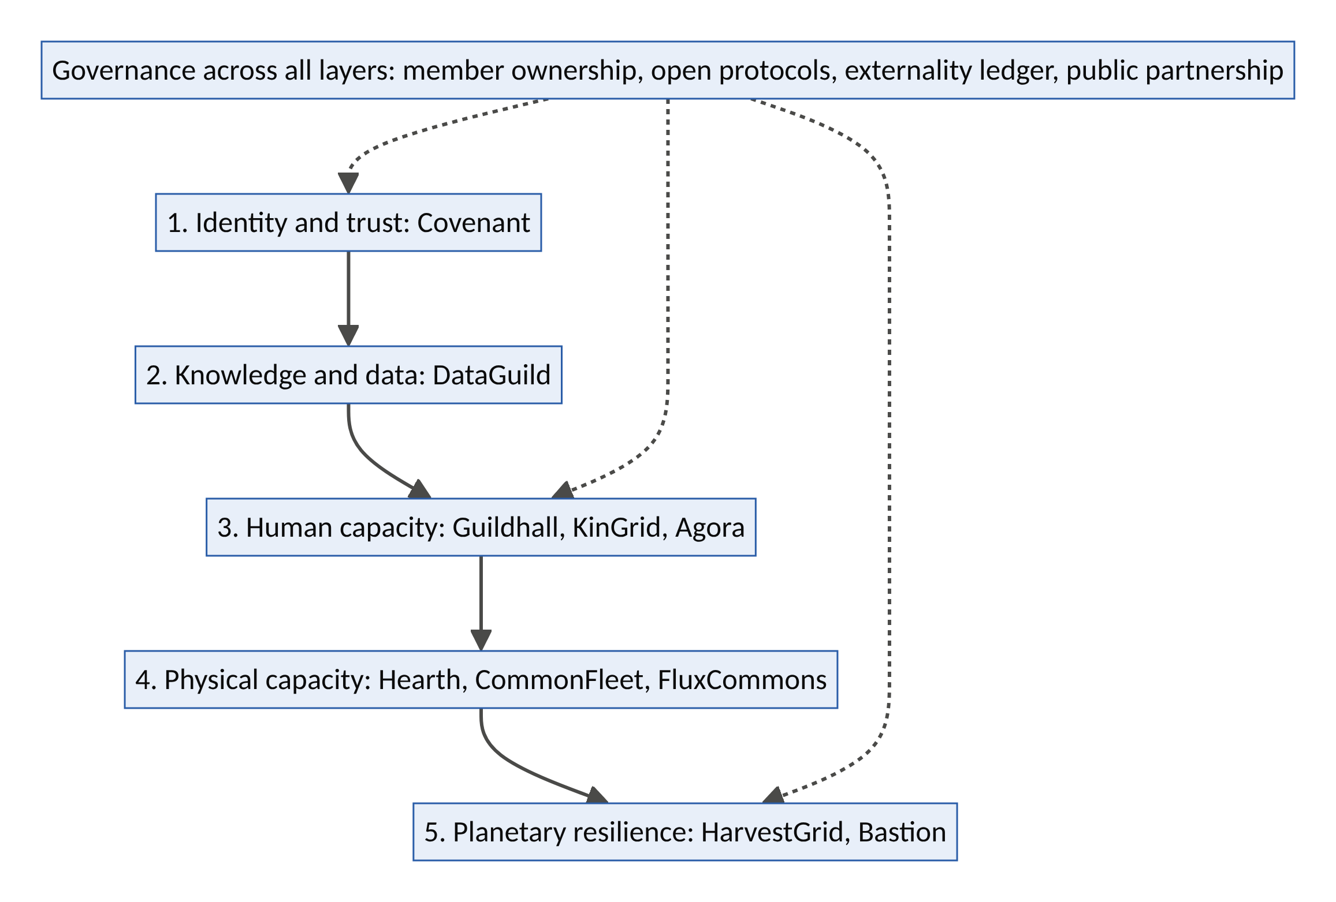
Figure 9. The Stewardship Stack: five layers the ten ventures could form by 2040, under shared governance.
Layer | Function | Ownership model | Key protocol or standard
1. Identity and trust | Who (or which agent) is acting, with what authority and what guarantee | Member-owned foundation plus operating company | Verifiable credentials; signed mandates
2. Knowledge and data | Who owns knowledge and how it is licensed | Data trusts and cooperatives | Machine-readable licences; provenance
3. Human capacity | Care, skill and connection | Cooperatives and social enterprises with public contracts | Portable credentials; care credits
4. Physical capacity | Housing, vehicles, energy, compute | Community and pension-fund ownership; co-ops | Open energy and mobility protocols
5. Planetary resilience | Food security and disaster protection | Mutuals with public backstops | Parametric triggers; open early-warning data
Why this matters. The first platform era produced vertically integrated platforms: each company owned its whole stack and captured its value. The Stewardship Stack is layered and interoperable. Different owners hold different layers under common protocols, as the internet itself was built. This structure makes the Protocol Commons scenario (Section 4.10) achievable rather than utopian.

8.15 Backcasting from 2040
Backcasting starts from a desired future and works backwards to the steps that make it reachable.
Year | Milestones required
2040 | The Stewardship Stack operates in dozens of countries; tens of millions of people are members of at least one Decagon network; externality ledgers are a standard reporting practice
2035 | Each venture operates at national scale in at least one country; at least three cross-venture fusions are live; governments contract for outcomes (care hours, homes added, losses avoided)
2030 | All ten ventures past proof of concept; shared trust and data layers in use by at least five ventures; first public outcome-based contracts renewed
2028 | Wave 1 ventures (Covenant, DataGuild, Guildhall, Agora) at proof; Wave 2 (KinGrid, HarvestGrid, Bastion, Hearth homeshare) piloting
2026–27 | Studio formed; Decagon Canvas and externality-ledger standard published; first pilots launched

8.16 The future-potential scorecard
Venture | Illustrative reach by 2040 (if successful) | Key impact metric | Biggest uncertainty | Potential | Difficulty
Covenant | $150–500bn of annual agent transactions under its trust layer | Fraud prevented; disputes resolved | Whether a dominant AI firm closes the market | Very high | High
DataGuild | 10m members; $1–5bn a year in royalties | Income to contributors; languages preserved | Copyright law; synthetic data | High | High
Guildhall | 1m apprentices a year | Placement and earnings of graduates | Employer acceptance | Very high | Medium
KinGrid | ~4m elders; ~830m care hours a year | Avoided admissions; wellbeing | Safeguarding; credit backing | Very high | High
Agora | 10m participants a year in 500 cities | Validated loneliness reduction | Who pays | High | Medium
Hearth | Hundreds of thousands of homes | Homes added; affordability | Interest rates; zoning | High | High
CommonFleet | Tens of thousands of community-owned vehicles | Dividends to former drivers | AV economics; ownership rules | High | Very high
FluxCommons | Gigawatt-scale community flexibility | Grid costs avoided; emissions | Market rules | Very high | High
HarvestGrid | Ten corridors; ~200,000 tonnes of food saved a year | Loss reduction; farmer income | Security; currency | Very high | High
Bastion | 50m members; $25bn of cover | Speed of recovery after disasters | Basis risk; capital | Very high | High
All reach figures are the illustrative estimates from Sections 8.3–8.12, with their stated assumptions.

8.17 The philosophy of the future: becoming good ancestors
Three ideas frame how these futures should be pursued.
- The future is designed, not predicted. Dator observes that “the future” cannot be predicted, but preferred futures can be envisioned, invented and evaluated. The ten ventures are deliberate attempts to invent a preferable future, not bets on a probable one.
- Responsibility grows with power. Hans Jonas argued that technological civilization requires a new ethic: because our actions now reach far into the future, we must act so that their effects are compatible with the permanence of genuine human life. Platforms are among the most powerful tools ever built for shaping everyday life, so their designers carry that responsibility.
- Be a good ancestor. Roman Krznaric’s The Good Ancestor calls for “cathedral thinking”: projects whose benefits will be enjoyed by people not yet born. Ubuntu teaches the same thing in relational terms: we are who we are through others, including those who come after us. The ultimate measure of the Decagon ventures is not their valuations in 2030 but whether people in 2050 are glad they were built.
The question for every founder: Will the people who inherit the system you are building thank you for it?

Part IX: Portfolio Synthesis, Roadmap and Closing Philosophy

9.1 The Decagon scoreboard
Venture | V1 Lat | V2 Fri | V3 Tru | V4 Liq | V5 Int | Engine | V6 Dis | V7 Leg | V8 Ste | V9 Mea | V10 Ant | Conscience | Total
1 Covenant | 4 | 5 | 5 | 3 | 5 | 22 | 4 | 4 | 4 | 3 | 4 | 19 | 41
2 DataGuild | 5 | 4 | 4 | 3 | 5 | 21 | 5 | 4 | 4 | 4 | 3 | 20 | 41
3 Guildhall | 5 | 4 | 4 | 3 | 4 | 20 | 4 | 4 | 4 | 5 | 4 | 21 | 41
4 KinGrid | 5 | 4 | 5 | 4 | 4 | 22 | 4 | 4 | 5 | 5 | 4 | 22 | 44
5 Agora | 5 | 4 | 4 | 4 | 4 | 21 | 4 | 4 | 4 | 5 | 3 | 20 | 41
6 Hearth | 5 | 4 | 4 | 3 | 4 | 20 | 4 | 5 | 5 | 4 | 3 | 21 | 41
7 CommonFleet | 4 | 3 | 4 | 4 | 4 | 19 | 5 | 5 | 5 | 5 | 3 | 23 | 42
8 FluxCommons | 5 | 4 | 4 | 4 | 5 | 22 | 4 | 4 | 5 | 4 | 4 | 21 | 43
9 HarvestGrid | 5 | 5 | 4 | 4 | 4 | 22 | 5 | 4 | 5 | 5 | 3 | 22 | 44
10 Bastion | 5 | 4 | 5 | 3 | 4 | 21 | 5 | 4 | 5 | 5 | 5 | 24 | 45
Ventures (average) | 4.8 | 4.1 | 4.3 | 3.5 | 4.3 | 21.0 | 4.4 | 4.2 | 4.6 | 4.5 | 3.6 | 21.3 | 42.3
Uber + Airbnb c.2012 (average) | 5.0 | 4.5 | 3.5 | 4.5 | 3.5 | 21.0 | 2.5 | 1.0 | 1.0 | 3.0 | 2.0 | 9.5 | 30.5
Design-intent scores (analytical judgement). Discount for execution risk.
What the scoreboard reveals:
- The engines are equally strong, but built differently. Both generations average 21 of 25 on the engine. The ventures are weaker on Liquidity (3.5 vs 4.5) and Friction (4.1 vs 4.5), and stronger on Trust (4.3 vs 3.5) and Intelligence (4.3 vs 3.5). The next generation substitutes trust and AI for raw liquidity.
- The conscience more than doubles (21.3 vs 9.5). This is the design choice the framework argues for.
- The stewardship premium is paid in liquidity and antifragility. Governance, safeguarding and fair distribution slow the cold start (V4) and add regulatory and capital exposure (V10). This is the honest cost of the approach. It is best managed with very small atomic networks, third-party payers (health systems, municipalities, insurers) who value the conscience vertices, and patient, blended capital.
- The highest scorers (Bastion, KinGrid, HarvestGrid) start from non-consumption. They serve people currently served by nothing, Christensen’s strongest foothold, where incumbents have the weakest motivation to respond.

9.2 Feasibility and sequencing
Venture | Capital intensity | Time to MVP | Regulatory complexity | Best first market | Wave
Covenant | Low | 3–6 months | Medium | Agent-made hotel and short-let bookings (US/EU) | 1
DataGuild | Low | 3–6 months | Medium | West African languages and agriculture | 1
Guildhall | Low | ~3 months | Low–Medium | SME digital operations (Lagos or Manchester) | 1
Agora | Low | ~3 months | Low | One mid-sized city with social prescribing | 1
KinGrid | Medium | ~6 months | High (safeguarding) | UK neighbourhood + Nigerian diaspora families | 2
HarvestGrid | Medium | ~6 months | Medium | Kano–Lagos tomato corridor | 2
Bastion | Medium (risk capital via reinsurance) | 9–12 months | High (insurance) | Flood-prone Nigerian state; heat cover pilot | 2
Hearth | Low (homeshare) → High (building) | 3 → 12 months | High | Homeshare first; ADUs where by-right laws exist | 2→3
FluxCommons | Medium–High | 6–9 months | High (market access) | Markets with flexibility programmes + Accra mini-grid | 3
CommonFleet | High | 6–12 months (EV co-op first) | High | One US city with AV deployment | 3
Sequencing logic. Wave 1 builds the shared infrastructure: trust (Covenant), knowledge (DataGuild) and talent (Guildhall). Agora is included because it is cheap, fast and generates evidence for health payers. Wave 2 builds human and food-system networks on that infrastructure. Wave 3 deploys capital-intensive physical networks once trust, talent and payer relationships exist.

9.3 The decagon as an ecosystem
The ten ventures are not separate bets. They form an ecosystem in which each venture’s output is another’s input, a reinforcing structure at the portfolio level.
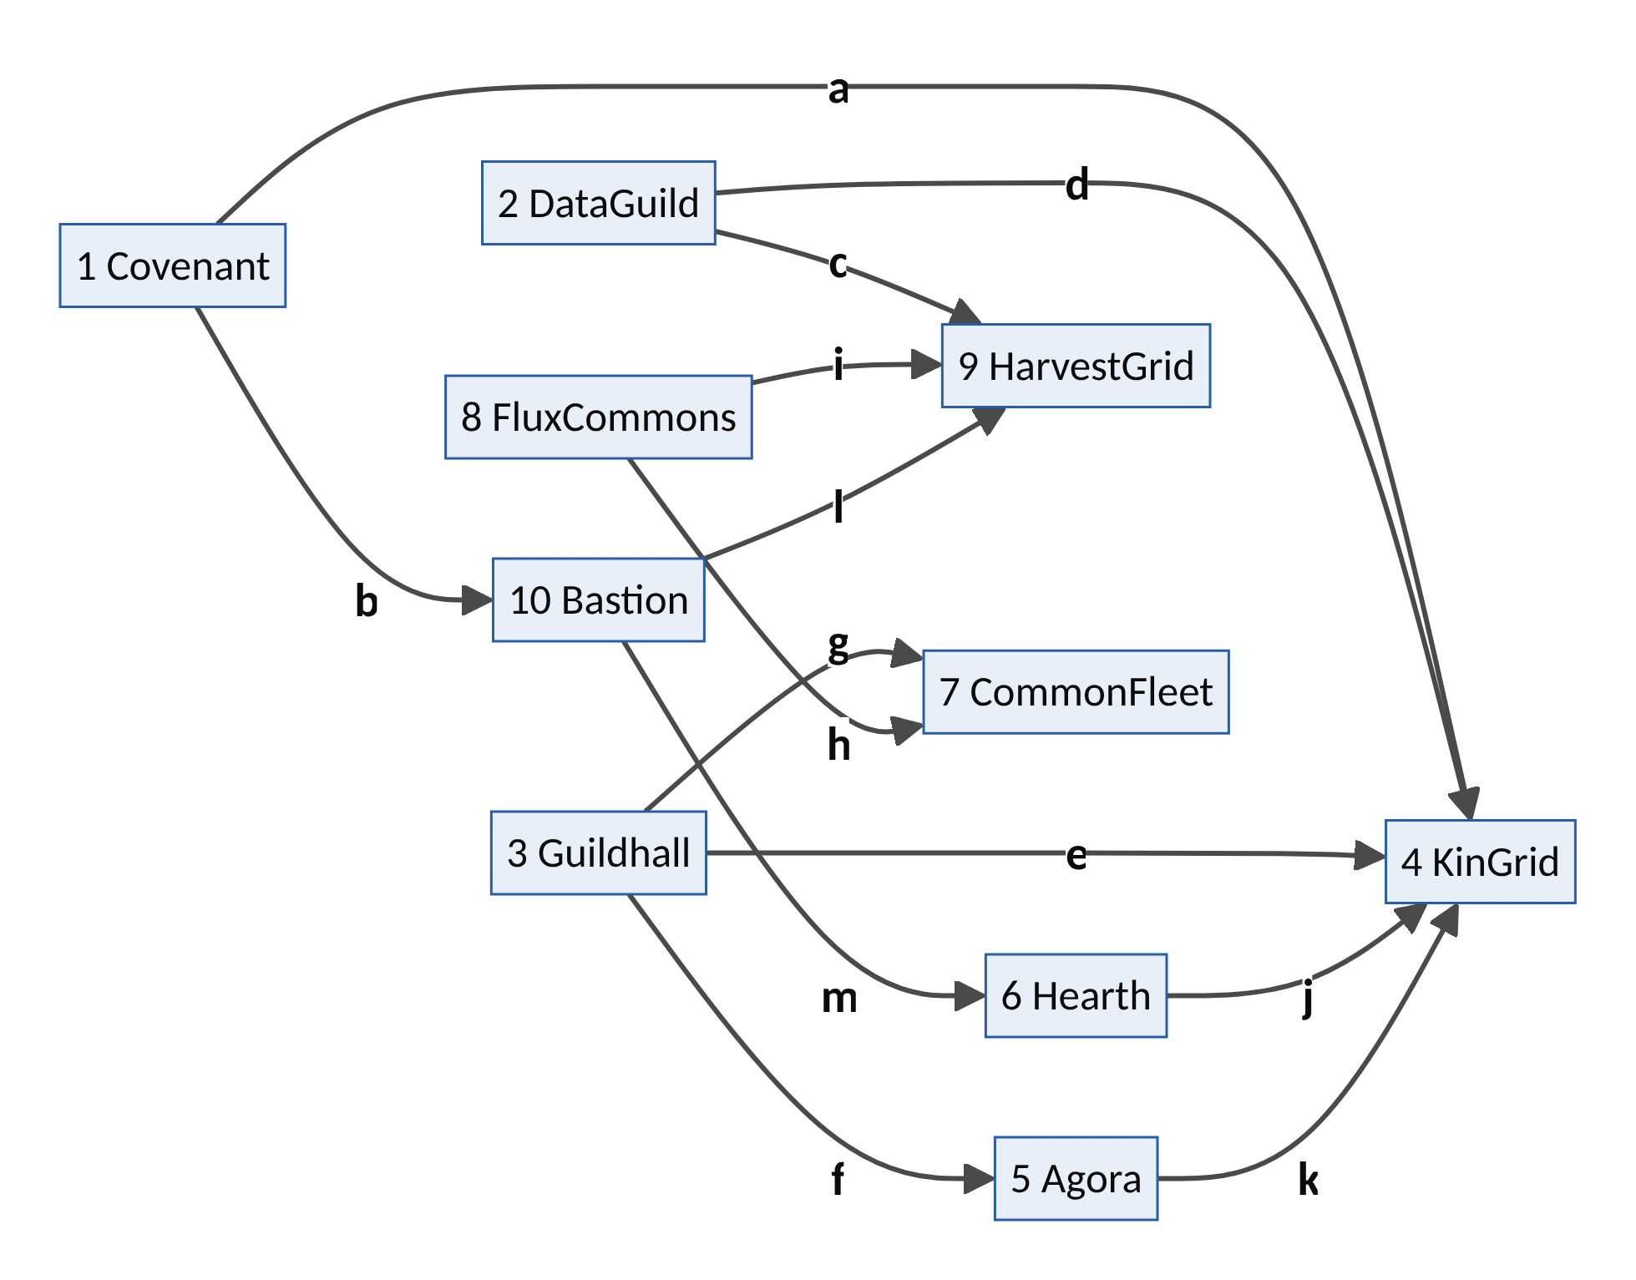
Figure 10. The ten ventures as an ecosystem. Letters refer to the table below.
Link | From → To | What flows
a | Covenant → KinGrid | Verified agents and helpers
b | Covenant → Bastion | Verified pledges and payouts
c | DataGuild → HarvestGrid | Local-language voice AI
d | DataGuild → KinGrid | Voice interfaces for elders
e | Guildhall → KinGrid | Trained carers
f | Guildhall → Agora | Trained facilitators
g | Guildhall → CommonFleet | Fleet technicians
h | FluxCommons → CommonFleet | Smart charging
i | FluxCommons → HarvestGrid | Solar and battery power for cold hubs
j | Hearth → KinGrid | Homeshare as informal care
k | Agora → KinGrid | Social connection for elders
l | Bastion → HarvestGrid | Cover for hubs and routes
m | Bastion → Hearth | Resilient homes
Implication: build a venture studio, not a single startup. A Decagon Studio would build shared services once: the trust stack, data trust, payments, safeguarding, regulatory affairs and a common externality ledger. It would then launch ventures on top of them. Recommended ownership and capital design:
- Steward-ownership or a golden share to lock in mission, so the conscience vertices survive an acquisition.
- “Exit to community” pathways that let providers and users accumulate ownership over time.
- Blended capital: grants and concessional capital for the stewardship premium, revenue-based financing for operating networks, and equity for software layers.
- Outcome-based contracts with governments, health systems and insurers that pay for conscience vertices (avoided admissions, housing added, losses avoided).

9.4 Ten more seeds beyond the Decagon
Seed | One-line concept
BuildBridge | Verified diaspora home-building: vetted contractors, escrowed milestones, drone and photo progress verification, against the fraud that plagues “building at home from abroad”
RepairCommons | Repair, reuse and resale marketplace built on digital product passports (EU ecodesign rules), unlocking products’ remaining useful life
TrialMatch Union | A patient data union that matches consenting patients to clinical trials and pays them for data and participation
SchoolHours | Idle school buildings in evenings, weekends and holidays for community learning, childcare and adult education
KitchenCommons | Idle commercial kitchens for community nutrition programmes and food startups
SkillsPassport | Verified, portable credentials for refugees and migrants, so their skills can be used on arrival
OpenRide | Open-protocol, low-commission mobility for informal transport (danfo, keke, okada, matatu) in the spirit of Namma Yatri
LandLedger | Satellite- and community-verified land-tenure records that reduce disputes and unlock credit
HabitatShare | Paying landowners for verified biodiversity stewardship (satellite plus environmental-DNA verification)
PeerCare Minds | Peer-support mental-health network with AI triage and clinical escalation

9.5 Implementation roadmap
Horizon | Milestones
0–12 months | Form the studio; build the shared trust stack (Covenant core) and data trust (DataGuild core). Launch Guildhall and Agora pilots. Publish the Decagon Canvas and the externality-ledger standard. Run system dynamics models for every Wave 2 venture.
1–3 years | Launch KinGrid, HarvestGrid, Bastion and Hearth homeshare. Secure the first outcome-based public contracts. Join regulatory sandboxes (insurance, energy, AI). Make Covenant interoperable with major agent protocols.
3–7 years | Launch FluxCommons and CommonFleet at city scale. Expand corridors and cities. Transition provider-members toward meaningful ownership. Publish independent impact evaluations.
7–15 years | A protocol-level ecosystem in the Protocol Commons scenario. Ventures become networks of networks, partly member-owned and interoperable with public digital infrastructure.

9.6 Closing philosophy: from the sharing economy to the stewardship economy
The first platform era called itself the “sharing economy”. It was more accurately an access economy. It shared access, not ownership; it monetized trust without returning it; and it commodified labour and land at the finest grain in history. Its achievements are real. Billions of journeys and nights were made possible, millions of people earned income, and the world learned to trust strangers at scale. Its costs are also real, and society has spent a decade reclaiming them through Polanyi’s double movement.
The next era can be a stewardship economy.
 | Era 1: the access economy (2008–2025) | Era 2: the stewardship economy (2026–2040)
Unit of value | The transaction | The relationship and the outcome
User | A human with an app | A human and their AI agents
Trust | Distributed (reviews) | Delegated and verifiable (credentials, mandates, guarantees)
Growth logic | Blitzscale, subsidize, outgrow the law | Loop-aware scaling: model, simulate, embed
Externalities | Exported to cities, workers and neighbours | Measured in an externality ledger and internalized
Providers | Contractors with ratings | Members with voice, upside and ownership pathways
Governance | Founder and shareholder control | Stakeholder, cooperative and steward-ownership hybrids
Capital | Venture subsidy (ZIRP) | Patient, blended, outcome-based
Regulatory stance | Arbitrage | Co-regulation and pre-embedded protections
Philosophy | Access over ownership | Liberation without enclosure
Three philosophical commitments underlie the framework:
- Kant: never merely as means. A platform must treat every participant, provider and bystander as an end in themselves. The rating system, the algorithm and the take rate are all tested against that principle.
- Rawls: the veil of ignorance. Design the rules you would accept without knowing whether you would be the rider or the driver, the guest or the neighbour, the elder or the carer, the farmer or the trader.
- Ubuntu: I am because we are. The highest-value problems of this century, such as care, loneliness, food and climate, are relational. Platforms that understand they are building relationships among people, not only transactions between strangers, will create the most enduring value.

9.7 Ten aphorisms for builders
- Every idle thing is a sentence waiting for a grammar. A platform is that grammar.
- Legibility is power; what you make visible, you make governable.
- Trust compounds; matching commoditizes.
- Every reinforcing loop carries a balancing loop. Find it in a model, not in a courtroom.
- What you commodify, society will one day protect. Protect it first.
- The scarce input flips: from labour to capital, from coordination to trust.
- Design for the agent at the door, and for the human behind it.
- A platform that shares the upside makes allies; one that only pays the wage makes adversaries.
- Measure dignity, or you will design it out.
- Liberate latent capacity without enclosing it.

Appendices

Appendix A: The Decagon Canvas
Use one canvas per venture concept. Complete it before building, then revise it after every turn of the Systemic Design Spiral.
Section | Prompt questions | Your answer
Problem (why now) | What new problem is emerging? What changed in technology, demography, climate or regulation?
V1 Latency | What is idle, invisible, untrusted or uncoordinated? How big is the pool, and is it growing?
V2 Friction | Which transaction costs collapse? From what to what?
V3 Trust | Identity, reputation, guarantees, escrow, recourse: for humans and agents?
V4 Liquidity | Atomic network? Local or global effects? Saturation point? Multi-homing risk?
V5 Intelligence | Which data loops? Which AI capabilities? Is it agent-ready?
V6 Distribution | Who captures surplus? Provider voice? Ownership pathway? Take rate and its legitimacy?
V7 Legitimacy | Legal status? Regulators engaged? Data sharing with public authorities?
V8 Stewardship | Which commons are affected? What is in the externality ledger? Which Ostrom principles apply?
V9 Meaning | Dignity, belonging, agency, accessibility for every participant? Veil-of-ignorance test result?
V10 Antifragility | Which shocks help or hurt? What is the release phase of this model, and the plan for it?
Key loops | R loops? B loops? Leverage point?
Personas and HMW | Who? What is the “How might we” question? What is the moment of truth?
Business model | Who pays? For what? Which third-party payers value the conscience vertices?
Disruption logic | Foothold (low-end, new-market, non-consumption)? Which incumbents are forced to transform?
First 100 days | The smallest atomic network you can serve by hand?
Decagon score | V1–V10 (0–5 each) = /50

Appendix B: Scoring rubric
Score each vertex 0–5. The anchors for 0, 1, 3 and 5 are below; use 2 and 4 for intermediate cases.
Vertex | 0 | 1 | 3 | 5
V1 Latency | No identifiable idle capacity | Small or shrinking pool | Large pool, partly visible already | Vast, growing, invisible pool with high idle time and low asset specificity
V2 Friction | No reduction in transaction cost | Marginal convenience | Major reduction in one cost (e.g., search) | Order-of-magnitude collapse across search, trust, contracting and coordination
V3 Trust | No trust mechanism | Basic ratings only | Identity, reputation and some guarantees | Full stack (identity, reputation, guarantees, escrow, recourse) for humans and agents
V4 Liquidity | No plausible path to a functioning market | Liquidity requires massive subsidy | A clear atomic network, slow expansion | Small atomic network, fast replication, durable network effects, low multi-homing
V5 Intelligence | No data loop | Static analytics | Data improves matching or pricing | Compounding AI loops across matching, pricing, prediction and support; agent-native
V6 Distribution | Value captured entirely by the platform | Opaque pay, no voice | Fair, transparent pay; some provider voice | Providers share upside (equity or royalties) and have formal governance voice
V7 Legitimacy | Illegal or open conflict | Operating in grey zones | Licensed in core markets | Co-designed rules; welcomed by regulators; public data partnerships
V8 Stewardship | Significant unmeasured negative externalities | Externalities acknowledged, not measured | Externalities measured and partly priced | Net-positive externality ledger; commons governance in place
V9 Meaning | Degrades dignity of some participants | Neutral; purely transactional | Good experience for main users | Enhances dignity, agency and belonging for all; passes the veil-of-ignorance test
V10 Antifragility | One shock would end it | Fragile to likely shocks | Survives likely shocks | Gains from shocks; modular; has planned the release phase of its own model

Appendix C: Glossary
Term | Meaning
Adaptive cycle (panarchy) | Holling and Gunderson’s model of systems moving through exploitation, conservation, release and reorganization
Agent-native | Designed so AI agents can discover, verify, transact and be held accountable
Atomic network | The smallest network that is self-sustaining (Andrew Chen)
Balancing loop (B) | A feedback loop that resists change and seeks equilibrium
Basis risk | In parametric insurance, the mismatch between the trigger and actual loss
Double movement | Polanyi: society’s protective response to the commodification of labour, land and money
Externality ledger | A public account of a venture’s second-order effects on commons (e.g., housing units, emissions)
Fictitious commodity | Polanyi: something treated as a commodity though not produced for sale (labour, land, money)
Latency | Capacity that exists but is invisible, untrusted, untransactable or uncoordinated
Latency compiler | A platform that converts latent capacity into transactable supply
Leverage point | Meadows: a place in a system where a small shift produces large change
Parametric insurance | Insurance that pays automatically when a measured index (e.g., rainfall) crosses a threshold
POSIWID | “The purpose of a system is what it does” (Stafford Beer)
Reinforcing loop (R) | A feedback loop that amplifies change (growth or collapse)
Requisite variety | Ashby: a controller needs at least as much variety as the disturbances it faces
Standing-reserve | Heidegger: the world revealed as resources on call
Stewardship premium | The liquidity and speed a venture gives up by designing in governance, safety and fair distribution
Verifiable credential | A cryptographically signed, privacy-preserving digital claim (identity, skill, permission)
Viable System Model | Beer’s model of the five functions any viable system needs

Appendix D: Sources and further reading
Company and market data
- Uber Technologies, Uber Announces Results for Fourth Quarter and Full Year 2025 (4 Feb 2026): Business Wire; FY2025 annual report: SEC
- Airbnb Q4 and FY2025 results (12 Feb 2026), as reported in: Finviz/Zacks, Short Term Rentalz. Verify against Airbnb’s shareholder letter at investors.airbnb.com.
- TechCrunch, Uber’s autonomous vehicle deal tracker (Aug 2026): link; Transport Topics on Uber–Lucid–Nuro: link
- Bloomberg, Waymo Co-CEO Outlines Path to 1 Million Weekly Trips in 2026 (Feb 2026): link; Claims Journal: link
- CX Today, AI Agents Handle 30% of Airbnb Customer Support Tickets: link; Constellation Research, Airbnb: A look at its AI strategy: link
- TechCrunch, Uber is building a fleet of gig workers to label data for AI models (Nov 2024): link
- Uber Technologies, Q1 2026 results (8-K): SEC
- Airbnb Q2 2026 results, as reported by PhocusWire and Nasdaq
Problem evidence
- WHO, Social connection linked to improved health and reduced risk of early death (30 Jun 2025): link
- IEA, Energy and AI (Apr 2025): link
- Swiss Re Institute, 2025 natural catastrophe losses: link; protection gap: Insurance Business
- World Bank, Is post-harvest loss significant in sub-Saharan Africa?: link; IIR, Reducing post-harvest food losses in sub-Saharan Africa: link
- Littler, EU Platform Work Directive: uncertainty ahead of implementation deadline (Directive (EU) 2024/2831): link
- Barron, K., Kung, E. and Proserpio, D. (2021). The Effect of Home-Sharing on House Prices and Rents: Evidence from Airbnb. Marketing Science 40(1).
- San Francisco County Transportation Authority (2018). TNCs and Congestion.
- Brynjolfsson, E., Chandar, B. and Chen, R. (2025). Canaries in the Coal Mine? Six Facts about the Recent Employment Effects of Artificial Intelligence. Stanford Digital Economy Lab.
- Shumailov, I. et al. (2024). AI models collapse when trained on recursively generated data. Nature 631.
- Villalobos, P. et al. (2024). Will we run out of data? Limits of LLM scaling based on human-generated data. Epoch AI.
- Hall, J. (2019). How many hours does it take to make a friend? Journal of Social and Personal Relationships 36(4).
- Hall, J., Horton, J. and Knoepfle, D. Labor Market Equilibration: Evidence from Uber (working paper).
- Imperva (2025). Bad Bot Report.
- McKinsey (2025). The agentic commerce opportunity: How AI agents are ushering in a new era for consumers and merchants: link
- WHO, Ageing and health fact sheet (Oct 2025): link
- World Bank, In 2024, remittance flows to low- and middle-income countries are expected to reach $685 billion: link
- IEA, Global EV Outlook 2026: link
- US Department of Energy (2023). Pathways to Commercial Liftoff: Virtual Power Plants: link
Systems theory, design and innovation
- Ashby, W.R. (1956). An Introduction to Cybernetics.
- Beer, S. (1972). Brain of the Firm.
- von Bertalanffy, L. (1968). General System Theory.
- Checkland, P. (1981). Systems Thinking, Systems Practice.
- Forrester, J. (1961). Industrial Dynamics. Sterman, J. (2000). Business Dynamics.
- Gunderson, L. and Holling, C.S. (2002). Panarchy.
- Meadows, D. (1999). Leverage Points: Places to Intervene in a System; (2008) Thinking in Systems.
- Senge, P. (1990). The Fifth Discipline. Kim, D. (1994). Systems Archetypes.
- Design Council (2005). The Double Diamond. Brown, T. (2009). Change by Design.
- Christensen, C., Raynor, M. and McDonald, R. (2015). What Is Disruptive Innovation? Harvard Business Review, December.
- Chen, A. (2021). The Cold Start Problem.
- Parker, G., Van Alstyne, M. and Choudary, S. (2016). Platform Revolution.
- Rochet, J.-C. and Tirole, J. (2003). Platform Competition in Two-Sided Markets. JEEA 1(4).
- Taleb, N.N. (2012). Antifragile.
Futures studies
- Arthur, W.B. (2009). The Nature of Technology: What It Is and How It Evolves.
- Dator, J. (2009). Alternative Futures at the Manoa School. Journal of Futures Studies 14(2).
- Hancock, T. and Bezold, C. (1994). Possible futures, preferable futures. Healthcare Forum Journal 37(2).
- Inayatullah, S. (1998). Causal Layered Analysis: Poststructuralism as Method. Futures 30(8).
- Jonas, H. (1984). The Imperative of Responsibility.
- Kauffman, S. (2000). Investigations.
- Krznaric, R. (2020). The Good Ancestor.
- Perez, C. (2002). Technological Revolutions and Financial Capital.
- Sharpe, B. (2013). Three Horizons: The Patterning of Hope.
- Voros, J. (2003). A generic foresight process framework. Foresight 5(3).
Economics, political economy and philosophy
- Benkler, Y. (2006). The Wealth of Networks.
- Botsman, R. and Rogers, R. (2010). What’s Mine Is Yours; Botsman, R. (2017). Who Can You Trust?
- Coase, R. (1937). The Nature of the Firm. Economica.
- Doctorow, C. (2025). Enshittification.
- Han, B.-C. (2015). The Burnout Society.
- Hayek, F. (1945). The Use of Knowledge in Society. American Economic Review.
- Heidegger, M. (1954). The Question Concerning Technology.
- Hock, D. (1999). Birth of the Chaordic Age.
- Illich, I. (1973). Tools for Conviviality.
- Oldenburg, R. (1989). The Great Good Place.
- Ostrom, E. (1990). Governing the Commons.
- Polanyi, K. (1944). The Great Transformation.
- Pollman, E. and Barry, J. (2017). Regulatory Entrepreneurship. Southern California Law Review 90.
- Rawls, J. (1971). A Theory of Justice.
- Rifkin, J. (2000). The Age of Access; (2014) The Zero Marginal Cost Society.
- Rosenblat, A. and Stark, L. (2016). Algorithmic Labor and Information Asymmetries: A Case Study of Uber’s Drivers. International Journal of Communication 10.
- Scholz, T. (2016). Platform Cooperativism.
- Shoup, D. (2005). The High Cost of Free Parking.
- Srnicek, N. (2016). Platform Capitalism.
- Zuboff, S. (2019). The Age of Surveillance Capitalism.
This working paper is a framework for exploration. Venture concepts are hypotheses to be tested with real users, regulators and communities, not investment advice.

